Appendix A. Technical Background
The purpose of this appendix is to provide an understanding of the methodology used to develop the Biosolids Tool (BST) and to present an overview of the models used in the BST. The BST leverages the existing modeling framework of the probabilistic multimedia, multipathway, multireceptor risk assessment methodology that has been used by the U.S. Environmental Protection Agency’s (EPA’s) Office of Water to conduct biosolids risk assessments since 2003 (U.S. EPA, 2003a). This modeling framework is consistent with approaches applied in other EPA offices (such as the Office of Resource Conservation and Recovery and the Office of Research and Development), including the Science Advisory Board–reviewed Multimedia, Multipathway, Multireceptor Exposure and Risk Assessment (3MRA) methodology (U.S. EPA, 2003b) and the Human Health Risk Assessment Protocol (HHRAP, U.S. EPA, 2005).

A.1 Conceptual Model Details
The BST modeling domain for land application consists of four distinct areas:
- An 80-acre square field where biosolids are applied, and which is used to grow crops (crop scenario) or to pasture cattle (pasture and reclamation scenarios).
- A 13-acre index reservoir that drains an adjacent regional watershed serves as an alternative source of drinking water for the farm family (their primary drinking water source is assumed to be groundwater).
- A 10-meter buffer exists between the field and the index reservoir; the farm family is assumed to live in the buffer.
- A 2.5-acre farm pond is immediately adjacent to the field, where the farm family fish and where all aquatic ecological exposures occur.
For the landfill scenario, the family lives adjacent to at the edge of the landfill and obtain drinking water from groundwater impacted by the landfill. For surface disposal, the modeling domain is focused on the receptor location associated with maximum inhalation exposure from contaminants that volatilize or are airborne (i.e., at edge of the disposal unit).
Figures A-1 and A-2 depict the overall conceptual models for human and ecological exposure, respectively, implemented in the BST for the land application unit. Figure A-3 depicts the conceptual model for human exposure for surface disposal. The conceptual models are simplified representations of the land application and surface disposal scenarios that illustrate the relationships among the sources, environmental compartments, and human and ecological receptors evaluated in the BST.
The conceptual models show how pollutants in biosolids move in the environment, from their release and transport through various environmental compartments, to contact with or consumption of environmental media (e.g., groundwater, soil) or dietary items (e.g., milk, produce) by human and ecological receptors. These patterns of movement are called pathways, and the pathways modeled in the BST generally correspond to the pathways modeled in the original 1992 risk assessment used to support the Section 503 biosolids regulation (U.S. EPA, 1992), with a few additions and minor modifications. The numbers at the right side of Figures A-1 through A-3 are the corresponding pathway number(s) from the 1992 assessment (note that the land application and surface disposal units have independent pathway numbering; thus, both have a pathway 1 and this is not necessarily the same pathway).
For this model, some pathways from the original biosolids conceptual model 1992 assessment that are highly likely to co-occur have been consolidated into a single pathway; for example, ingestion of beef and milk from cows exposed through eating plants (Pathway 4) and eating soil (Pathway 5) have been combined into one pathway in which the cows eat both plants and soil, because cows ingest soil incidental to foraging. In addition, four new pathways have been added: a shower inhalation pathway for humans Minor differences between the current pathways and the 1992 assessment pathways are noted at the bottom of each figure. Table A-1 shows which of the 1992 pathways (rows) are incorporated into each of the BST pathways (light blue headings) for the land application unit (LAU); the surface disposal mapping is not shown as there are only two common pathways and they map directly.

                - 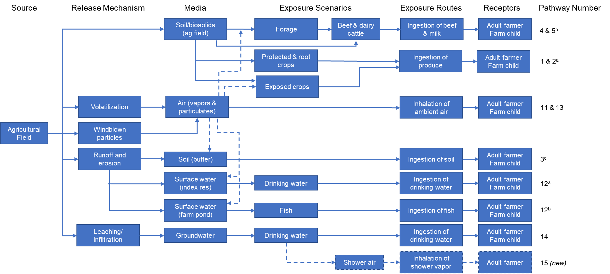
Dashed arrows and box outlines indicate a pathway or route that has been added since 1992.
ª Originally, Pathways 1 and 2 differed only in that they were modeled for two different scenarios (1, general population and 2, home gardener). In the current model, this pathway is modeled for only one scenario, a farm family (adult farmer and farm child).
^{b} Originally, Pathways 4 (cattle eat contaminated plants) and 5 (cattle eat contaminated soil) were modeled separately. In the current model, these pathways have been combined to reflect that when cattle eat forage, they ingest soil as well. The overall cattle diet is assumed to be 95% forage and 5% soil.
^{c} Originally, Pathway 3 modeled a receptor eating soil/biosolids from the field where biosolids are applied. In the current model, the receptors are assumed to eat soil from the buffer, following erosion and runoff from the field.
Figure A-1. Conceptual Model for Human Exposures: Land Application.

                - 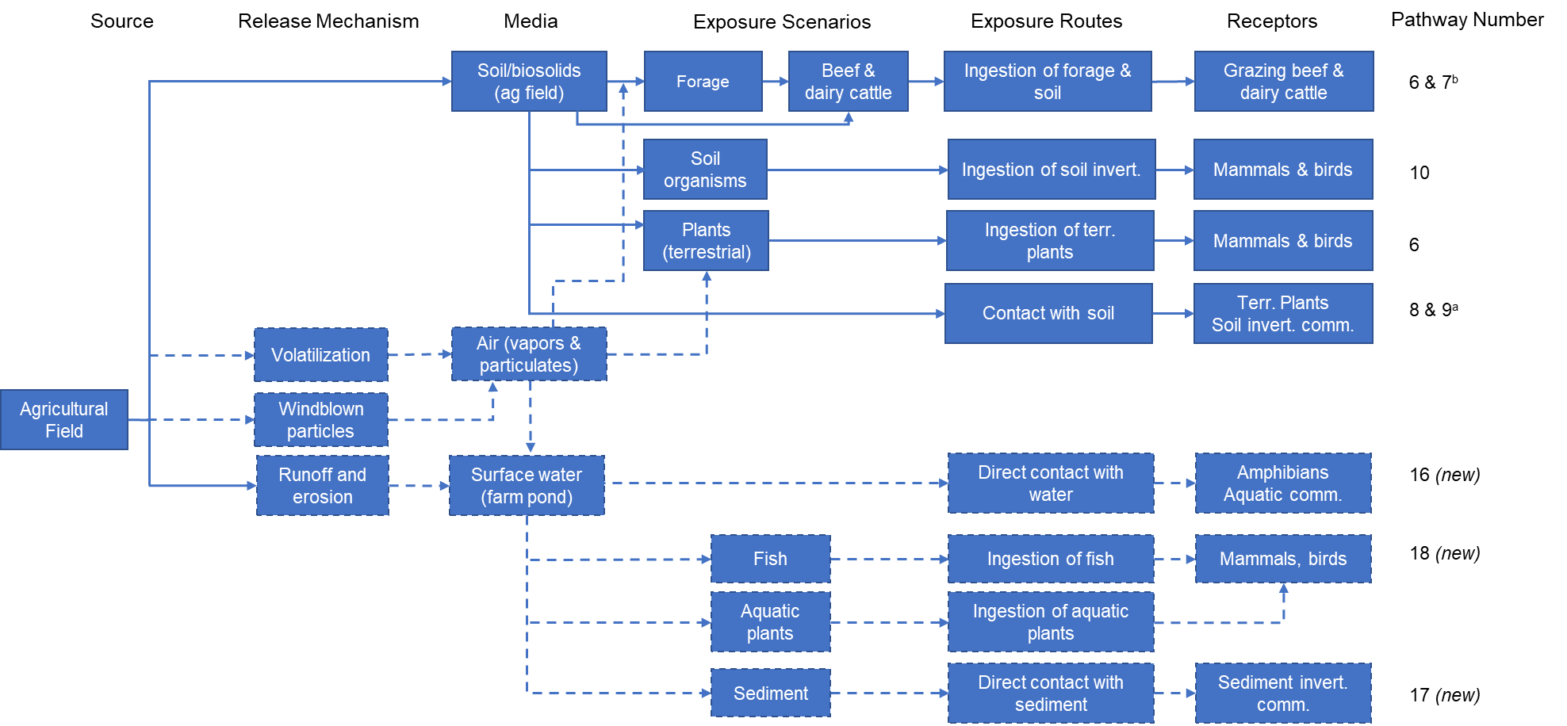
Dashed arrows and box outlines indicate a pathway or route that has been added since 1992.
ª Pathway 8 is terrestrial plants, and Pathway 9 is soil organisms.
^{b} Originally, Pathways 4 (cattle eat contaminated plants) and 5 (cattle eat contaminated soil) were modeled separately.
* In the current model, these pathways have been combined to reflect that when cattle eat forage, they ingest soil as well. The overall cattle diet is assumed to be 95% forage and 5% soil. Includes beef and dairy cattle exposures through forage and soil ingestion while grazing on a pasture or reclamation site.
Figure A-2. Conceptual Model for Ecological Exposures: Land Application.

                - 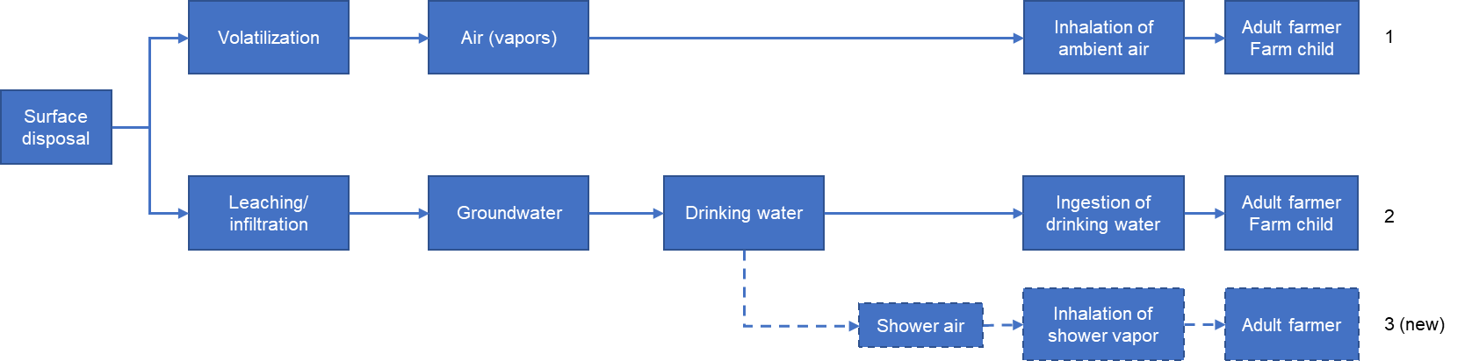
Dashed arrows and box outlines indicate a pathway or route that has been added since 1992.
Figure A-3. Conceptual Model for Human Exposures: Surface Disposal.

Table A-1. Biosolids Tool Pathways Mapped to Original 1992 Land Application Pathways
Pathway |  | Description*
Indirect Soil Pathways
Ingestion of Exposed, Protected, and Root Vegetables, and Exposed and Protected Fruit (Human)
1† | Biosolids→ Soil→ Plant→ Human | Human (general population) lifetime ingestion of plants grown in biosolids-amended soil
2 | Biosolids→ Soil→ Plant→ Human | Human (home gardener) lifetime ingestion of plants grown in biosolids-amended soil
Ingestion of Beef and Milk (Human)
4† | Biosolids→ Soil→ Plant→ Animal→ Human | Human (adult) lifetime ingestion of animal products (beef and milk) from animals raised on forage grown on biosolids-amended soil [Note pathways 4 and 5 are combined in the BST]
5† | Biosolids→ Soil→ Animal→ Human | Human (adult) lifetime ingestion of animal products (beef and milk) from animals that ingest biosolids directly [Note pathways 4 and 5 are combined in the BST]
Ingestion of Terrestrial Biota (Eco)
6 | Biosolids→ Soil→ Plant→ Animal | Animal (mammal or bird) ingestion of plants grown on biosolids-amended soil
10 | Biosolids→ Soil→ Organism→ Animal | Animal (mammal or bird) ingestion of soil organisms that have been exposed (through direct contact) to biosolids-amended soils
Direct Soil Pathways
Direct Ingestion of Soil (Human)
3† | Biosolids→ Human | Human (child) lifetime ingestion of biosolids
Direct Ingestion of Soil (Eco)
7 | Biosolids→ Soil→ Animal | Animal (beef or dairy cattle) ingestion of biosolids
Direct Contact with Soil (Eco)
8 | Biosolids→ Soil→ Plant | Plant toxicity due to taking up biosolids pollutants when grown in biosolids-amended soils
9 | Biosolids→ Soil→ Soil Organism | Soil organism ingesting or in direct contact with biosolids-amended soil
Direct Air Pathways
Inhalation of Ambient Air (Human)
11 | Biosolids→ Soil→ Airborne Dust→ Human | Human (adult) lifetime inhalation of particles (dust) (e.g., tractor driver tilling a field)
13 | Biosolids→ Soil→ Air→ Human | Human (adult) lifetime inhalation of pollutants in biosolids that volatilized (ambient air)
Surface Water Pathways
Ingestion of Drinking Water (Human)
12a | Biosolids→ Soil→ Surface Water→ Human | Human (adult) lifetime drinking surface water containing pollutants in biosolids (from erosion or deposition)
Ingestion of Fish (Human)
12b† | Biosolids→ Soil→ Surface Water→ Fish→ Human | Human (adult) lifetime ingesting fish exposed through direct contact with surface water containing pollutants in biosolids (from erosion or deposition)
Groundwater Pathway
Ingestion of Drinking Water (Human)
14† | Biosolids→ Soil→ Groundwater→ Human | Human (adult) lifetime drinking well water containing pollutants from biosolids that leached from soil to groundwater
* From 1993, with minor additions. All receptors modeled in 1993 were general population unless otherwise noted. In all cases, the BST evaluates both adult and child farmers.
† The total ingestion pathway is the sum of the risks or HQs from these pathways (all ingestion pathways except surface water).
Whereas the conceptual model shows the processes and environmental compartments that are in the modeling domain, a modeling scenario defines the attributes of a specific simulation that are relevant to the decision-making process. For example, the results of a simulation for barium released from land application followed by the ingestion of contaminated groundwater by children represents a specific modeling scenario.

A.2 Model Implementation
The modeling framework developed for the BST consists of a series of modules that are executed in a specific order to estimate risk; inputs for these modules may be found in Appendix B (non-chemical specific), Appendix C (chemical specific), and Appendix D (toxicity values):
- Source modeling simulates the release of pollutants from a source—in this case, a land application unit or surface disposal unit—to the environment (i.e., soil, groundwater, surface water, air) (Section A.2.1).
- Environmental fate and transport modeling simulates the movement of chemicals through the environment to estimate concentrations in environmental media (e.g., soil, groundwater, surface water, ambient air) and dietary items (e.g., milk, produce) (Section A.2.2).
- Exposure modeling takes the media concentrations from the fate and transport modeling and estimates dose or exposure concentration for each receptor (Section A.2.3).
- Risk modeling uses the exposure concentration or dose to estimate cancer risk or noncancer hazard quotient (HQ) for human receptors, and HQ for ecological receptors. (Section A.2.4).
The subsections noted above briefly describe the major functionality of the models implemented in the BST.

A.2.1 Source Models

A.2.1.1 Land Application Unit
The BST uses a modified version of the land application unit (LAU) source model developed by EPA’s Office of Resource Conservation and Recovery and Office of Research and Development as part of the 3MRA Modeling System to estimate releases from waste management units for the identification of hazardous wastes (U.S. EPA, 2003b). This model has been peer reviewed and used extensively to support regulatory risk assessments conducted for EPA’s Office of Resource Conservation and Recovery and Office of Water. The following is an overview of the model; more detail can be found in U.S. EPA (1999 and 2003b).
As part of the 3MRA modeling system, the LAU source module was developed to estimate annual average surface soil constituent concentrations and constituent mass emission rates to air, downslope land, and groundwater. These estimates are used in an integrated, multipathway module linking source modules with environmental fate and transport and exposure/risk modules. Additionally, LAU source emission modules were combined with a local watershed module (a “local” watershed is a sheet-flow-only watershed containing the LAU) to provide estimates of constituent mass flux rates from runoff and erosion to a downslope waterbody, as well as surface soil constituent concentrations in downslope buffer areas. Because the LAU source is assumed here to interact hydrologically with the local watershed of which it is an integral part, it is termed a “land-based” unit.
A soil column model, the Generic Soil Column Module (GSCM), was developed to describe the dynamics of constituent mass fate and transport within LAUs and near-surface soils in watershed subareas. (The term “soil” is used loosely here to refer to a porous medium, whether it is biosolids in the LAU or near-surface soil in a watershed subarea.) Governing equations for the GSCM are similar to those used by Jury et al. (1983, 1990) and Shan and Stevens (1995). However, the analytical solution techniques used by these authors were not applicable to the source emission module developed here because they did not consider the periodic addition of constituent mass and enhanced constituent mass loss rates in the surface soil from volatilization, runoff, wind and water erosion, leaching, and mechanical processes. The GSCM provides a new solution technique that is computationally efficient and sufficiently flexible to allow consideration of the LAU within a screening environment. It allows the following:
- Constituent mass balance
- Biosolids additions and removals to simulate active facilities
- Joint estimation of constituent mass losses due to a variety of mechanisms, including
- Volatilization of gas-phase constituent mass from the surface to the air
- Leaching of aqueous-phase constituent mass by advection or diffusion from the bottom of the waste management unit (WMU) or vadose zone
- First-order losses, which can include
Abiotic and biodegradation
Suspension of constituent mass adsorbed to surface particles due to wind action and vehicular activity
Suspension of constituent mass adsorbed to surface particles due to water erosion
Surface runoff of aqueous-phase constituent mass.
Thus, the LAU model accounts for releases from the agricultural field via leaching, volatilization, particulate emissions, runoff, and erosion. It can also account for hydrolysis and biodegradation, but these are set to zero as a conservative assumption. The model also accounts for deposition onto the plants on the field, but not back onto the soil of the agricultural field or buffer, so soil concentrations in these areas may be slightly underestimated.
Because the biosolids matrix is organic and decomposes, the annual applications for the non-reclamation scenarios do not result in significant buildup of the soil surface, nor does erosion significantly degrade the soil surface. Thus, the soil column is modeled as a constant depth. As a result, there is no naturally occurring limit to the modeled concentration (other than the limit that prevents non-aqueous phase liquids from occurring), and the modeled chemical concentration in the soil column could exceed the concentration in the biosolids over time, although this is only likely to occur for highly immobile constituents as the biosolids matrix decomposes and leaves behind the constituent to concentrate over multiple applications.
The LAU model was modified to accommodate scenarios in which biosolids are spread on the soil surface but not tilled into the soil (although mixing with the top 2 cm of soil is assumed to occur by bioturbation). To reflect the untilled scenarios (pasture and reclamation), the modeled depth of the soil column was increased by the depth of biosolids applied. Thus, a biosolids application in this conceptualization reflects an updating of the above-soil-surface model layers, rather than a “tilling” into the soil depth. This new soil column consists of the actual soil underneath the spread biosolids plus the depth of the biosolids layer lying on top, two zones with nonhomogeneous physical properties. This leads to a shortcoming of the LAU model: it was designed for a single soil column zone with homogeneous properties. Thus, for both tilled and untilled scenarios, the soil properties are set to those of the surrounding soil for the entire soil column. Thus, to the extent that the properties of the underlying soil are different from the properties of biosolids, some error is introduced into the results by this simplifying assumption. Despite this limitation, the LAU model was considered the most appropriate model to be used for the untilled scenarios.
The time stepping algorithm for fate and transport in the LAU model was also modified from an annual timestep to an adaptive sub-year time step. The algorithm selects and limits time step length according to the rate of dissolved contaminate movement in the soil column to prevent numerical instability and permitting finer time resolution for estimating daily media concentrations required for evaluating ecological exposures in surface water.
Finally, the LAU model was modified to check that solubility limits were not exceeded. If the equilibrium concentration in soil pore water based on the predicted total soil concentration is greater than the solubility limit for the chemical, the model caps the total soil concentration at a level that keeps the equilibrium pore water concentration at the solubility limit. A warning is output when this occurs.
The specific inputs and the data used in the LAU source model are presented in Appendix B. The LAU model runs for 150 years, starting with the year of first application, and outputs a time series of annual average soil concentrations for the field and the buffer, leachate concentrations, and air emission rates (vapor and particulate).

A.2.1.2 Surface Disposal Unit
A surface disposal unit of the type used to manage biosolids can be represented as a surface impoundment for modeling purposes. The BST uses a surface impoundment model (SI Module) initially developed for the 3MRA modeling system (U.S. EPA, 2003b) to estimate releases to the environment through the emission of volatile pollutants to the air and through the leaching of soluble pollutants to the groundwater.
This model predicts emissions under normal operating conditions; it does not estimate emissions due to overflows or structural failures of the unit. Emissions are assumed to occur only while the unit is operational. Consistent with the 2003 assessment (U.S. EPA, 2003a), the surface disposal unit is assumed to operate for a period of 50 years, after which time it is closed. Only the active life (50 years) is modeled.
The SI Module was developed to simulate both aerated and quiescent surface impoundments. Consequently, the SI Module contains both the well-mixed, steady-state mass balance solution and a time-dependent mass balance solution for simulating plug-flow, batch, or disposal surface impoundments. The surface disposal unit here is modeled as a quiescent impoundment.
Mass transport equations are used to describe volatile contaminant losses from surface impoundments. A surface impoundment may have some degree of solids settling, although solids settling and accumulation is more significant for quiescent units. When significant solid accumulation occurs, the surface impoundment must be cleaned or dredged to remove the accumulated solids. In addition, there is leaching loss from bottom of the surface impoundment.
The following assumptions are used in the development of the SI Module solution:
- Three-compartment model: each compartment has a fixed volume for a given monthly solution; volumes readjusted to account for solids accumulation
- Well-mixed and time-dependent solutions
- First-order kinetics for volatilization in liquid compartment
- First-order kinetics for hydrolysis in both liquid and sediment compartment
- First-order kinetics for biodegradation with respect to both contaminant concentration and biomass concentration in liquid compartment
- First-order kinetics for biodegradation in sediment compartment
- Darcy’s law for calculating the infiltration rate
- First-order kinetics for solids settling
- Monod kinetics for biomass growth rate with respect to total biological oxygen demand (BOD) loading
- First-order biomass decay rate within the accumulating sediment compartment
- No contaminant in precipitation/rainfall
- Linear contaminant partitioning among adsorbed solids, dissolved phases, and vapor phases.
The percent solids in the surface disposal unit is assumed to be 10% (see Appendix C, Section C.3), making this a dilute aqueous waste most appropriately modeled using Henry’s law partitioning coefficients and first-order kinetics for biodegradation, as is done in this module. Daughter products are not included in the module, so any contaminant emissions or leachate generated as a reaction intermediate or end product from either biodegradation or hydrolysis is not included in the module output.
The SI Module functionality as implemented in the BST may be summarized as follows:
- Mass balance approach taking into consideration contaminant removal by volatilization, biodegradation, hydrolysis, leaching, and partitioning to solids
- Estimation of volatilization rates for a quiescent surface
- Estimation of infiltration rate and contaminant leachate flux rates
- Estimation of suspended solids removal (settling) efficiency.

A.2.2 Fate and Transport Models
Fate and transport models are a series of computer-based algorithms that solve, either numerically or analytically, the underlying equations that predict chemical movement due to natural forces. These fate and transport models integrate information on a site’s geology, hydrology, and meteorology with chemical, physical, and biological processes that take place in the environment. The result is a simulation of chemical movement in the environment and a prediction of the concentration of a chemical in environmental media (e.g., soil, groundwater, surface water, ambient air) and in dietary items (e.g., milk, produce) at specified exposure locations, given the outputs of the source model.
The fate and transport models output a time series of annual average concentrations over 150 years for the LAU (starting the year of the first application) or 50 years for the surface disposal unit. For the LAU, this time period was chosen based on professional judgment to ensure that ample time is allowed following the 40-year operating life of the unit for strongly sorbing chemicals to migrate off the watershed to the surface waterbodies and thus to capture maximum concentrations and exposures. For the surface disposal unit, the 50-year operating life was used because only air and groundwater are considered; air concentration drops off when operation ends, and groundwater is estimated using a dilution attenuation factor that applied to the leachate concentration, which will also drop off when the unit closes.
The annual average time series data are then summarized somewhat differently depending on the type of pathway:
- Cancer risks (ingestion or inhalation) were estimated using annual concentrations averaged over the exposure duration and centered around the year of with the maximum annual exposure concentration. So, for example, for a 48-year exposure duration and a peak exposure concentration in year 40, the model uses the average from year 16 to year 64. If the maximum year falls closer to year 1 or the last year modeled than half the exposure duration (e.g., 48 year exposure duration with a peak in year 10), then it averages over the first (or last) 48 years.
- Noncancer hazard quotients (ingestion or inhalation) were estimated based on maximum annual ambient air concentration or exposure concentration.
Different types of chemicals may require different fate and transport algorithms and, in some cases, different data. The algorithms in the BST are broadly applicable for most organics and inorganics; they can also be used for mercury with some specialized inputs to appropriately speciate mercury in different pathways. The underlying data structure supports both most organics and inorganics. However, the algorithms included in the BST are not appropriate for dioxin-like compounds (i.e., dioxins, furans, and PCBs), nor can the underlying data structure support the different data needs for evaluating dioxin-like compounds (such as toxicity equivalence factors that relate the toxicity of different congeners to that of 2,3,7,8-tetradibenzo-p-dioxin. See also the Limitations section in the front matter for other chemicals that cannot be modeled.
The following types of fate and transport model are used by the BST and discussed in the referenced section:
- Air dispersion and deposition modeling (Section A.2.2.1)
- Watershed and waterbody modeling (Section A.2.2.2)
- Groundwater and shower modeling (Section A.2.2.3)
- Food chain modeling (Section A.2.2.4).

A.2.2.1 Air Dispersion and Deposition Modeling
Air dispersion and deposition modeling consists of a computer-based set of calculations to estimate ambient ground-level pollutant concentrations associated with pollutant releases from biosolids management practices. The air model uses information on meteorology (e.g., windspeed, wind direction, air temperature) to estimate the movement of pollutants through the atmosphere. Movement downwind is largely determined by windspeed and wind direction. Dispersion around the centerline of the plume is estimated using empirically derived dispersion coefficients that account for movement of pollutants in the horizontal and vertical directions that are perpendicular to the wind direction. In addition, pollutant movement from the atmosphere to the ground is modeled to account for deposition processes driven by gravitational settling and removal by precipitation.
The air model used in support of the BST is AERMOD (U.S. EPA, 2022), which is the EPA’s recommended dispersion model. AERMOD is a steady-state Gaussian plume model used for modeling concentration, dry deposition, and wet deposition from point, area, volume, and open-pit sources. AERMOD was designed primarily to support EPA’s regulatory modeling programs.
AERMOD was run externally for each of the three representative locations using 10 years of meteorological data for both the land application and surface disposal scenarios (see Appendix B for a discussion of the meteorological data used in the BST). A unit emission rate (1 µg/s-m²) approach was used to generate annual average unitized air concentrations (e.g., µg/m³ per unit emission rate of 1 mg/m²-s) and unitized deposition rates (e.g., g/m²-yr per unit emission rate of 1 mg/m²-s) to allow the dispersion and deposition results to be applied within the BST for all chemicals. Representative median values were selected for AERMOD-required chemical-specific input parameters for simulating dry and wet deposition of gaseous pollutants. These parameters include diffusivity in air (Da, cm²/s), diffusivity in water (Dw, cm²/s) and Henry's law constant (Pa-m3/mol) for the pollutant being modeled, and the cuticular resistance to uptake by lipids (rcl) for individual leaves (s/cm). Receptor locations were defined using a 16-pronged radial grid with discrete receptor points being specified as follows.
- For the land application scenario, the receptor locations of interest were specified as the edge of field, in the center of the buffer, and the edge of the index reservoir and farm pond.
- For the surface disposal, the receptor location of interest for inhalation exposures was specified as the edge of the surface disposal unit.
The AERMOD outputs were processed to extract the maximum annual unitized air concentration values for both management unit scenarios. Maximum annual unitized deposition rates were also extracted for the land application scenario. These values are stored in the BST for each met station, management scenario, and receptor location. The BST multiplies these values by the chemical-specific annual emission rates predicted and output by the source models to calculate chemical-specific vapor- and particle-phase air concentrations, wet deposition rates of vapors and particles, and dry deposition rate of particles for each year simulated.
The equations used to integrate AERMOD outputs into the BST are provided in Attachment A1; these equations use AERMOD outputs to calculate total air concentration, vapor air concentration, particulate deposition, and vapor-phase deposition.

A.2.2.2 Watershed and Waterbody Modeling
Pollutants may reach the waterbody via two mechanisms:
- Runoff and erosion: Contaminants can enter the waterbodies via runoff and erosion from the biosolids-amended field, the buffer, and the watershed. For the index reservoir, runoff and erosion occur from the field to the buffer and then from the buffer to the reservoir; for the farm pond, runoff and erosion occur directly from the field to the pond. Runoff and erosion from the upstream watershed occur for the index reservoir only.
- Direct Deposition and diffusion: Air-borne particles and vapors can deposit directly on the index reservoir and farm pond via dry deposition (due to gravitational settling) and wet deposition (due to scavenging by precipitation) and vapors can diffuse into the waterbodies.

Soil Concentrations
Annual average soil concentrations for the agricultural field are output from the LAU model. Soil concentrations for the buffer are based on runoff and erosion from the field (estimated by the LAU model). Soil concentrations for the regional watershed are based on deposition from the agricultural field (from the air model) and by biosolids applications onto a portion of the regional watershed (estimated using output from the LAU model).

Surface Water Concentrations
The BST uses the Variable Volume Water Model (VVWM) to model surface water. VVWM was developed by U.S. EPA’s Office of Pesticide Programs (OPP) to estimate pesticide exposure in surface waters resulting from pesticide applications to agricultural fields (U.S. EPA, 2019, 2020). In this case, biosolids containing the contaminants are applied to a standard 80 -acre field that drains into a 13-acre index reservoir and a 2.5-acre farm pond adjacent to the field. The farm pond would not in most cases be considered a “water of the United States”, therefore, no buffer is simulated for the farm pond. A 10-meter buffer exists between the field and the index reservoir, consistent with the CWA Part 503 requirement that “bulk sewage sludge shall not be applied to agricultural land, forest, or a reclamation site that is 10 meters or less from waters of the United States.” The farm family is assumed to live adjacent to the reservoir.
VVWM simulates both the U.S. EPA standard waterbodies (i.e., the farm pond and index reservoir used here) as well as user-defined waterbodies. Inputs include daily contaminant loadings in dissolved and particulate forms, runoff from the adjacent field, and daily meteorological data. The simulation uses two fully mixed compartments, one for the water column and one for the benthic region. These compartments are coupled by a turbulent-mixing, first-order mass-transfer process. Degradation of the contaminant through metabolism, hydrolysis, photolysis, and volatilization is governed by first-order kinetics. Benthic burial is accounted for, and VVWM maintains a mass balance within the waterbody.
Outputs include daily, multiday (e.g., 4-day), and annual average values for dissolved water column concentration and benthic pore water concentration, both in µg/L. The FORTRAN code was modified to calculate and output additional values needed by the BST (total water column concentration and total bed sediment concentration) and to convert all outputs needed to mg/L or, for total sediment, mg/kg. Those calculations are provided in Attachment A1.
Meteorological inputs: These are taken directly from the standard ‘.wea’ weather files used for OPP’s models (U.S. EPA, 2015) and the source models incorporated in the BST. As indicated by the name, VVWM allows for daily variations in water body volume due to runoff, precipitation, and evaporation as input by these files. However, with the selection of either a farm pond or index reservoir simulation within VVWM, the volume is held constant, with washout and overflow occurring when the maximum waterbody volume is exceeded on any given day. The weather file used as input to VVWM also controls the length of simulation for the waterbody model. For use with the BST, the latest 10 years were selected from each weather file corresponding to the locations used for the wet (Charleston, SC), dry (Boulder, CO), and average (Chicago, IL) climate sites. These 10 years were then repeated fifteen times to create a simulation length of 150 years to match the source models within the BST (see Appendix B for a discussion of the meteorological data used in the BST).
Erosion and runoff loadings: These are generated by the LAU source model within the BST. The daily runoff, sediment loading due to erosion, and contaminant load in runoff are converted to the necessary units for VVWM and normalized over the watershed area (for the reservoir) or the field area (for the farm pond). The contaminant concentration in runoff generated by the LAU model includes erosion (so, contaminants in both particulate and dissolved form). This is used as the daily mass loading due to runoff in VVWM, and the VVWM input for daily mass loading due to erosion is set to zero. This formulation holds because VVWM combines those two mass inputs into a single mass loading to the water column each day. Therefore, no source or loading information is lost.
Diffusion and deposition loadings: These loadings are calculated from dispersion model outputs using equations provided in Attachment A1. They are incorporated into VVWM using the VVWM input for spray drift. This input is a time series of daily loadings that can account for spray drift occurring only on selected days (identified using the Julian day number) and is input through a comma separated list within the input control file. The BST computes diffusion and deposition load to a waterbody on an annual (rather than daily) basis. Therefore, to integrate this load into VVWM, assumptions had to be made on the timing of these loads. In keeping with the screening nature of the BST, the diffusion and deposition load was incorporated into the waterbody using the conservative assumption that the entire annual loading would occur on a single day (April 1 of each year, to represent a time near the beginning of the growing season). This assumption was tested for four representative chemicals (one inorganic, arsenic, and three organics, 4-chloroaniline, pyrene, and triclosan) to confirm that deposition and diffusive loads were accounted for within the waterbody loading without confounding impacts due to this assumption. Using the Crop scenario in the wet climate, a 30-year model run without spray drift (i.e., diffusion and deposition) and a second 30-year run with spray drift applied in all 30 years were conducted and the farm pond results reviewed. Differences in daily spray drift loadings between these two runs confirmed that the diffusion and deposition loads were accounted for within the waterbody and took a number of days to equilibrate within the water column. In addition, the daily spray drift loadings, representing diffusion and deposition, were two to four orders of magnitude smaller than the total runoff loads. As a result, despite the differences in daily loading and equilibration time, the peak daily concentration of each constituent tested was unaffected. Therefore, the effects of diffusion and deposition can be assessed within the different daily summarizations of water column and sediment region concentrations used in the risk screening assessments using the conservative incorporation assumption chosen. VVWM requires a text input file containing waterbody and chemical parameters, spray drift loadings, and links to where to store outputs. The BST creates this file, executes the VVWM program, and reads the output files to process the daily concentration data for risk assessments. Within the core waterbody simulation, the processes and calculations remain as formulated for VVWM. Description of these processes and calculations can be found within Revision B of the User Manual (U.S. EPA, 2019). The resulting water column and sediment concentrations are used in the food chain and exposure models; see Section A.2.2.4.

A.2.2.3 Groundwater and Shower Modeling
Groundwater well concentrations are estimated by applying a dilution-attenuation factor (DAF) to the simulated leachate concentrations from the land application or surface disposal unit. In general, a DAF is the ratio of pollutant concentration as it enters an environmental medium (here, the soil below a waste management unit) to the maximum predicted concentration observed at some later point on the fate and transport migration pathway (here, a drinking water well). The role of the DAF is to capture the relative diminution of dissolved pollutants that occurs as they migrate from the source through the soil column below the disposal unit to the water table and then through the groundwater to a drinking water well.
To establish appropriate DAFs for use in the BST, EPACMTP (U.S. EPA, 2003d, e) was used to generate groundwater well concentrations for five representative organic chemicals. These chemicals were chosen to capture a broad range of sorption behavior, with log K_{oc} values ranging from -2.7 to 6.2. Monte Carlo simulations consisting of 10,000 fate and transport realizations were conducted for each pollutant for the following environmental settings:
- National distributions of 311 land application units compiled from the 1986 Industrial D Survey (U.S. EPA, 1997) and 503 surface disposal units compiled from the 2001 Surface Impoundment Survey (U.S. EPA, 2001)
- Location-adjusted environmental conditions for the three representative locations selected for use in the BST: Charleston, SC, representing a wet climate; Chicago, IL, a moderate climate; and Boulder, CO, a dry climate.
Subsurface properties for these sites were modeled probabilistically based on the respective hydrogeologic environment (Charleston—coastal beaches; Chicago—limestone; Boulder—bedded sedimentary rocks). The drinking water well was placed 5 m from the downgradient edge of the LAU or surface disposal unit (in the middle of the 10-m buffer area), consistent with the BST conceptual site layout. The well depth was constrained to be within the top 10 m of the saturated zone.
DAFs were calculated for all Monte Carlo simulations and the 10th percentile value was extracted for each combination of chemical, environmental setting, unit type, and, for impoundments, liner type. The 10th percentile was selected to capture 90 percent of the possible dilution and attenuation in predicted groundwater exposures. From these values, the median across the three environmental settings for each disposal method and liner combination were extracted. Those values are shown in Table A-2.
Table A-2. Summary of Median 10th Percentile DAFs for all Disposal Scenarios
Pollutant | Log K_{oc} | Land Application | Surface Disposal
 |  |  | Unlined | Clay-lined | Composite-lined
Formic acid | -2.7 | 1 | 1 | 2 | 4E+07
1,2-Epoxybutane | 0.9 | 1 | 1 | 2 | 1E+07
Carbon disulfide | 1.8 | 1 | 1 | 2 | 1E+07
Tris (2,3-dibromopropyl) phosphate | 3.2 | 2 | 1 | 4 | 1E+14
Aldrin | 6.2 | 9E+05 | 68 | 1E+08 | 1E+30
For all unit/liner types, the values are similar for the three lowest Koc chemicals, rise somewhat for the chemical with the second highest Koc, and sharply for the chemical with the highest Koc. Note that lower DAF values reflect less dilution and attenuation and thus higher well concentrations given the same initial leachate concentration. For each management unit/liner, we selected the DAF associated with the three lower Koc chemicals. For LAUs and unlined surface disposal units, the DAF is set to 1; for clay-lined surface disposal, the DAF is set to 2, and for composite lined surface disposal, to 1E+7. If specific chemicals pose risks via the groundwater pathway above the risk management criteria, especially if they have higher log Koc values, those can be evaluated in EPACMTP using this same approach to determine a more suitable chemical-specific DAF. That more specific DAF can be used to adjust the risk results before deciding if the chemical should be carried forward to a more detailed probabilistic assessment. This would be accomplished by multiplying the groundwater pathway risk or HQ by the ratio of the DAF used to the more specific DAF. So, for example, if further analysis suggests a DAF of 100 for a clay-lined surface impoundment, the HQ would be multiplied by 0.02 (original DAF of 2 divided by more refined DAF of 100). If the original HQ was 100, this would reduce it to 2, still above the management criterion of 1. However, if the original HQ was 20, this would reduce it to 0.4, below the management criterion.
Average shower air concentrations of volatile contaminants during a shower and bathroom air immediately after a shower are estimated using a set of differential equations presented in McKone (1987) and Little (1992a,b). The differential equations were solved using finite difference numerical integration. EPA has used this shower model in a number of previous risk analyses. The equations used to integrate the shower model into the BST are provided in Attachment A1.

A.2.2.4 Food Chain Modeling
After the fate and transport models have predicted concentrations of pollutants in air, soil, water, and sediment, the food chain models calculate pollutant concentrations in food items. Pollutants pass from contaminated soil, water, sediment, and air through the food chain to the farm family and ecological receptors. For example, pollutants in air may be deposited on plants growing in the agricultural field (but not soil). Simultaneously, these plants may take up pollutants from the soil and accumulate pollutants from both routes in the fruits and vegetables consumed by the farm family and ecological receptors. In addition, beef and dairy cattle, as well as wildlife receptors, may consume forage and silage that are grown in biosolids-amended pasture soil. Subsequently, the farm family may consume home-produced beef and dairy products from these animals. Similarly, pollutants applied to the agricultural land may erode and run off into a farm pond and accumulate in fish and other aquatic biota. The fish in the farm pond may be caught and consumed by members of the farm family, and aquatic biota, including fish, may be consumed by wildlife receptors.
BCFs/BAFs
The food chain modeling quantifies the movement of chemicals from a surrounding medium (air, soil, sediment, water) into living organisms using a variety of factors. These may include bioaccumulation, bioconcentration, biomagnification, and biotransfer factors. However, the terminology used by environmental toxicologists for these factors continues to evolve. Because of this, and because this Users Guide is written for a varied audience, this Guide uses BCFs/BAFs for such factors. The more specific terms are used when referring to a factor calculated for a specific situation by a specific formula.
This section presents the methodology used to calculate pollutant concentrations for each of the diet items in the farm food chain (human receptors), terrestrial food chain (ecological receptors), and aquatic food web. The equations used are provided in Attachment A1.

Farm Food Chain
The farm food chain model estimates the accumulation of a pollutant in the edible parts of food crops eaten by the farm family and follows the guidance in HHRAP (U.S. EPA, 2005). The model calculates concentrations not for specific crops (e.g., cucumbers) but for the following five categories of crops:
- Protected fruits: these are fruits with a rind or other protective covering that shields the edible portion from the atmosphere (e.g., oranges). Protected fruits can only be contaminated via root uptake from soil.
- Exposed fruits: these are fruits without a protective covering (e.g., apples), making them susceptible to contamination via deposition and vapor transfer, in addition to root uptake.
- Protected vegetables: same as protected fruit, only aboveground vegetables (e.g., corn)
- Exposed vegetable: same as exposed fruit, only aboveground vegetables (e.g., tomatoes),
- Root vegetables: these are vegetables where the edible portion grows underground (e.g., potatoes) and is thus protected from the atmosphere. Root vegetables can only be contaminated via root uptake from soil, but the mechanism of root uptake from soil is modeled somewhat differently than for aboveground vegetables.
In addition, the farm family is assumed to raise beef and dairy cattle on pasture farms. The cattle forage on the pasture and consume associated soil. The farm food chain model estimates the concentration in forage (as well as in grain for ecological receptors); the concentration in soil is estimated by the LAU model.

Terrestrial Food Chain
The terrestrial food chain model predicts the accumulation of a pollutant in terrestrial vegetation and prey items consumed by ecological receptors. These items include
- Worms and other soil invertebrates
- Herbivorous and omnivorous vertebrates
- Birds, mammals, and herpetofauna
- Exposed fruits and vegetables, and root vegetables
- Forage and grain.
Concentrations in terrestrial prey items are calculated by applying chemical-specific bioaccumulation factors (BAFs) to the modeled soil concentrations. Concentrations in terrestrial vegetation are calculated in the farm food chain model as described above. BAFs for terrestrial prey items are lacking for many chemicals; when this is the case, a default value of 1 is used. You can, however, change this if you have additional data.

Aquatic Food Chain
The aquatic food chain model predicts the accumulation of a pollutant in aquatic vegetation and prey items consumed by ecological receptors (and, for fish, human receptors) in the farm pond. These items include
- Aquatic plants
- Benthic filter feeders
- Fish (T3 and T4).
The concentrations in fish and aquatic plants are calculated by applying chemical-specific BAFs to the water concentration. BAF values for both T3 and T4 fish may be for filet or whole fish. The filet concentrations are used for human fish consumptions, and the whole fish concentrations for wildlife fish consumption. The concentrations in benthic filter feeders are calculated by applying a BAF to the sediment concentration. The BST does not include the capability to use a biota-sediment accumulation factor (BSAF). BAFs for aquatic plants and benthic filter feeders are lacking for many chemicals; when this is the case, if a BAF for T3 fish is available, that is used, otherwise a default value of 1 is used. You can, however, change this if you have additional data.

A.2.3 Exposure Models
The pollutant concentrations in soil, groundwater, surface water, sediment and various food chain/prey items are used to estimate exposure to various receptors. Exposure modeling relies heavily on default assumptions concerning population activity patterns, mobility, dietary habits, body weights, and other factors. This section presents key assumptions associated with the applied modeling approach for human (Section A.2.3.1) and ecological receptors (Section A.2.3.2). Sections B.4 and B.5 of Appendix B contain details on the inputs used in, respectively, the human and ecological exposure models. The equations used to estimate both human and ecological exposure are provided below.

A.2.3.1 Human Exposure Model
The human exposure model calculates receptor-specific estimates of exposure based on the potential dose ingested. These average daily dose estimates are used as input to the risk model. For inhalation exposures, risks are evaluated using air concentrations from the fate and transport models, and no exposure modeling is needed. The equations used are provided in Attachment A1.

Receptors
The human receptors modeled for the LAU are an adult farmer and a farm child, who are assumed to be exposed to contaminants through the application of biosolids to their own farm. For the surface disposal unit, the human receptors modeled are an adult and child living adjacent to the surface disposal unit. Adult receptors are assumed to be at least 20 years old when exposure begins. Child receptors are assumed to be 1 year old when exposure begins; the model then ages the child over the modeling period using age-specific consumption rates and body weights. The start age of 1 year may result in an overestimation of exposure for older children and an underestimation of exposure for infants (which are not modeled).

Pathways
Human receptors are exposed through the following pathways:
- Drinking water ingestion: For the LAU, both groundwater and surface water (using the index reservoir) are evaluated as a drinking water source. For the surface disposal unit, only groundwater is evaluated as a drinking water source.
- Soil ingestion: The farm family is assumed to be exposed through incidental consumption of contaminated soil from the field. Note this does not include pica behavior.
- Fish ingestion: The farm family is assumed to catch fish recreationally from the farm pond but is not expected to have a higher fish intake than the general population. For this pathway, the fish tissue concentrations are based on filet BAFs, because people do not typically eat the whole fish, but a filet. Both trophic level 3 and 4 fish are consumed if filet BAFs are available for both. If one of these BAFs is missing, then exposure only for the other trophic level is used (e.g., if there is a BAF for T3 fish filet but not for T4 fish filet, then the fish exposure will include only exposure from T3 fish).
- Inhalation of ambient air: The farm family (for the LAU) is exposed to contaminants in ambient air on the field. The adult and child receptors for the surface disposal unit are exposed to ambient air on their property adjacent to the surface disposal unit.
- Inhalation of shower air: Organic contaminants in groundwater can volatilize in the shower, leading to inhalation exposure. This pathway was evaluated for adults only: the available data on times spent showering do not different for adults and children, and the only difference in the calculations for children would be the shorter exposure duration. Hence, adult shower exposures are always more conservative. In addition, very young children are more likely to take baths rather than showers. This pathway is considered for both the LAU and the surface disposal unit.
- Ingestion of produce: For the LAU crop scenario, the farm family is assumed to be exposed by consuming contaminated produce grown on the farm; produce types include exposed and protected fruit, exposed and protected vegetables, and root vegetables. This route is not simulated for the surface disposal unit scenario.
- Ingestion of beef and milk: For the LAU pasture and reclamation scenarios, the farm family is assumed to be exposed by consuming contaminated beef and milk produced on the farm, where cattle are exposed by consuming contaminated forage and soil in the biosolids-impacted pasture. This route is not simulated for the surface disposal unit scenario.
In addition to these pathways, total ingestion dose is calculated by summing all ingestion pathways evaluated for each selected scenario (LAU only; surface disposal includes only one ingestion pathway); however, surface water exposures are omitted from total ingestion estimates because groundwater is the most likely source of drinking water for the family farm. Thus, surface water exposures are presented separately to avoid double counting.
Dermal pathways were not considered. The Superfund Risk Assessment Guidance (RAGS) Part E, Dermal (U.S. EPA, 2004) compares dermal doses for adults showering for 35 min/day (a fairly high-end duration) to oral doses for adults drinking 2 L/day of water and found that dermal doses for most constituents are considerably lower than oral doses.

Exposure Factors
- Exposure duration: The exposure duration is set to the 90th percentile (13 years for children, 48 years for adults). The exposure period is assumed to occur around the time of maximum media concentrations within the modeling period (so, if the peak media concentration occurs in year 30, the 48-year exposure duration for adults would run from year 6 to year 54).
- Exposure frequency: Receptors are assumed to live and work on the farm or at their residence during the period that exposure is evaluated; this assumption may result in an overestimate of exposure for children who attend school or daycare off the farm.
- Consumption rates: Consumption rates for soil (LAU only) and drinking water reflect the 90th percentile. For produce and animal products in the LAU scenarios, consumption data specific to homegrown products (based on the 2011 Exposure Factors Handbook [U.S. EPA, 2011] and subsequent chapter-specific updates; these are the most current EPA guidance on exposure) was used where available. If homegrown data were not available, then general population data were used instead. In both cases, consumption rates reflect the 90th percentile of consumption.
- Fraction contaminated (LAU only): Because the consumption rates are specific to home-produced foods, it is reasonable to assume that 100 percent of those home-produced foods are contaminated (U.S. EPA, 2005).

A.2.3.2 Ecological Exposure Model
The ecological exposure model draws directly upon the approach used in 3MRA (U.S. EPA, 2003b). Ecological exposures may occur through either ingestion of contaminated media or prey items or through direct contact with contaminated media. For direct contact pathways, no exposure or dose is calculated; rather, the media concentration output from the fate and transport modeling is compared directly to a concentration-based toxicity value to estimate risk. The LAU model outputs annual average soil concentrations; thus, all terrestrial contact exposures are based on an annual average. The surface water model (VVWM), outputs surface water exposure concentrations for 1 day, 4 days, and 365 days (the most common averaging times for ecotoxicity studies), and the averaging time that corresponds to the averaging period associated with each concentration-based toxicity value is used.
The rest of this section deals with ingestion exposures. Ingestion exposures apply to the following receptors (which are a subset of those considered in 3MRA):
Birds  American kestrel  American robin  American woodcock  Belted kingfisher  Canada goose  Cooper’s hawk  Great blue heron  Green heron | Mallard duck  Northern bobwhite  Red tailed hawk  Spotted sandpiper  Tree swallow  Western meadowlark | Mammals  Black bear  Coyote  Deer mouse  Eastern cottontail  Least weasel  Little brown bat  Long tailed weasel  Meadow vole | Mink  Muskrat  Prairie vole  Raccoon  Red fox  Short-tailed shrew  Short-tailed weasel  White tailed deer
Exposure dose is calculated as a function of the concentrations in each diet item in a receptor’s diet (as described for the terrestrial and aquatic food chains in Section A.2.2.4), and receptor-specific exposure factors and diet fractions. The BST includes 24 different diet items, grouped into four categories: terrestrial prey, aquatic prey, vegetation, and environmental media:
Terrestrial Prey | Aquatic Preyª | Vegetation | Media
Worms  Other soil invertebrates  Small mammals  Small birds  Small herpetofauna  Herbivorous vertebrates  Omnivorous vertebrates | Benthic filter feeders  Trophic level 3 fish^{b}  Trophic level 4 fish^{b} | Aquatic plants  Exposed fruits  Exposed vegetables  Forage  Roots  Silage  Grains | Soil  Sediment  Surface water
ª As noted earlier, very few fish fall into trophic level 2, which would indicate they eat only plants; most fish are omnivores, making them at least trophic level 3. Therefore, T2 fish are not included for simplicity.
^{b} Fish tissue concentration for ecological receptors is based on whole fish BAFs.
Ecological receptors are assumed to get 100% of their diet from the farm pond or the farm field where biosolids are applied. The default dietary composition provided in the BST was drawn from 3MRA (U.S. EPA, 2003b,c) based on species-specific data on foraging and feeding behavior, and reflects a year-round adult diet in a waterbody margin habitat. These defaults are intended to be broadly representative. Table A-3 shows an example of how the default diet fractions were derived from the available dietary data using the American robin as an example.
Table A-3. Dietary Composition Example for American Robin: Default Diet Included in the BST
Diet Items Consumed by American Robin | Dietary Data from 3MRA |  |  | Diet Derived for BST
 | Minimum Percent of Diet | Maximum Percent of Diet | Average Percent of Diet | Added to Diet | Cumulative Percent
Soil invertebrates (other than earthworms) | 8% | 93% | 50.5% | 50.5% | 50.5%
Fruits | 7% | 92% | 49.5% | 49.5% | 100%
Earthworms | 15% | 27% | 21% | 0% | –
Forage | 0% | 24% | 12% | 0% | –
First, the table lists only the diet items (from the list of 24 diet items above) that the receptor in question (here, the America robin) might consume. Then, for each of these, the data provide a minimum and maximum percent of the diet that each item might account for. Averages of the minimum and maximum were calculated; however, these averages sum to more than 100 percent, because some of the minimum to maximum ranges are wide, reflecting significant variability in diet. To ensure that the modeled diet did not exceed 100%, the diet items were sorted from highest to lowest average percentage (as shown in Table A-3), and diet items added to the diet starting at the top of the list and using the average percent until a full diet (100 percent) was accumulated. If the last prey item to be included has an average percent that would put the total over 100%, the diet fraction for that item was set to the value that would bring the total to exactly 100%. Thus, the default diet for the American robin diet would consist of 50.5 percent soil invertebrates and 49.5 percent fruits. This approach follows that of 3MRA but is by no means the only way to construct a realistic diet; thus, these dietary percentages can be changed in the BST, with only the limitation that they must sum to 100 percent.
In addition to the diet fractions, exposure factors for each receptor include
- Body weight (average adult for both sexes)
- Food ingestion rate (total diet; the diet fractions are applied to this)
- Water ingestion rate
- Soil and sediment ingestion rates expressed as a fraction of total diet.

The species-specific exposure factors (ingestion rates and body weights) were taken primarily from EPA’s Wildlife Exposure Factors Handbook (U.S. EPA, 1993) and Sample et al. (1997); see Appendix B, Section B.5, for details.
The equations used to calculate receptor-specific estimates of exposure based on the potential dose ingested for use in the ecological effects model are provided in Attachment A1.

A.2.4 Risk Models

A.2.4.1 Human Health Risk Model
Human health effects modeling is performed to estimate cancer and noncancer health effects. A constituent’s ability to cause an adverse health effect depends on the toxicity of the constituent, the route of exposure to an individual (ingestion or inhalation), the duration and magnitude of exposure, and the resulting dose that an individual receives. The BST combines estimates of toxicity with estimates of exposure doses or exposure concentrations (described in Section A.2.3.1) to calculate individual excess lifetime carcinogenic risk estimates and noncancer HQs.
This module uses human toxicity values developed by EPA and other authoritative, peer-reviewed sources (ATSDR, Health Canada, etc.) for the purposes of assessing chronic risks for noncancer and cancer endpoints associated with long-term exposures to chemical constituents. Oral cancer slope factors (CSFs) and inhalation unit risks (IURs) are used to produce risk estimates for carcinogens. Reference Concentrations (RfCs) and Reference Doses (RfDs) are used to produce HQs for noncarcinogens. If a formal health assessment with toxicity values is not available for a particular chemical, EPA will rely on available in vivo (i.e., laboratory animal) toxicity data and/or human epidemiological data to determine a point of departure (POD) and apply uncertainty factors according to Agency guidance. Lacking in vivo data, EPA will explore the possibility of using new approach methodologies (NAMs) such as bioactivity assays or quantitative structure-activity relationships (QSAR) to develop a surrogate toxicity value.
Noncancer hazard is characterized by calculating an HQ based on the maximum one-year average daily dose (ADD) for ingestion exposures and the maximum one-year average air concentration for inhalation exposures. The HQ is used to establish a threshold of concern for a specific health effect. Unlike cancer risk estimates, HQs are not probability statements; rather, the RfD and RfC represent a daily exposure that is likely to be without appreciable risk of deleterious noncancer effects during a lifetime.
Cancer risk is characterized by estimating the lifetime excess cancer risk, representing the increased probability of developing cancer over a lifetime as a result of exposure to the pollutants. To evaluate oral exposures to carcinogens, the lifetime average daily dose (LADD) is used; this is based on the ADD averaged over the exposure duration (centered around the year of maximum exposure; see Section A.2.2), the exposure duration, and the lifetime (assumed to be 70 years). To evaluate inhalation exposures to carcinogens, the air concentration averaged over the exposure duration (again, centered around the year of maximum exposure) is used.
The equations used to estimate human risk are provided in Attachment A1.

A.2.4.2 Ecological Effects Model
Ecological risk, like human health risk, is expressed in terms of HQs. For the direct contact exposure pathway, HQs are calculated as the ratio of the exposure concentration to the relevant ecological toxicity value. For example, the HQ for fish is calculated as the ratio of the surface water concentration to the fish toxicity value (which is concentration based). For the ingestion pathway, the HQs are the ratio of the exposure dose to the relevant dose-based ecological toxicity value.
Ecological exposure is based on (1) predicted chemical concentrations in environmental media (e.g., water, soil, sediment), or (2) predicted exposure doses for specific species of birds and mammals. The predicted dietary chemical concentrations are compared to either an environmental quality criterion (e.g., Ambient Water Quality Criterion) or concentration-based toxicity value for certain receptors (e.g., early life-stage lethality to fish in direct contact with contaminated water). The predicted doses are compared to dose-based toxicity values (in mg/kg-day) to estimate potential ecological hazard to these receptor species. For each type of ecological toxicity value (concentration- or dose-based), Table A-4 lists the receptors, as well as the pathway, exposure medium if relevant, and the location of exposure.
The fate and transport models calculate media and prey concentrations for averaging times of 1 day, 4 days, and 365 days over the modeling period. These different averaging periods enable comparisons for the wide variety of ecological receptors to be made on a time scale appropriate to the receptor. The exposure concentrations used are then the maximum of the time series for the desired averaging time.
Ecological risks are calculated only for chemical-receptor combinations for which the BST contains an ecological toxicity value. If a chemical has no ecological toxicity value for any receptor, then ecological risk in the BST will be zero, which means that the chemical was not assessed as opposed to concluding that the receptor has no ecological risk.
The equations used to estimate ecological risk are provided in Attachment A1.
Table A-4. Type of Ecological Toxicity Value by Receptor
Receptor | Receptor Category | Pathway | Exposure Medium | Location of Exposure
Concentration-based Toxicity Values
Amphibians | Amphibian | Direct contact | Surface water | Farm pond
Aquatic community | Community | Direct contact | Surface water | Farm pond
Aquatic invertebrates | Community | Direct contact | Surface water | Farm pond
Aquatic plants | Plant | Direct contact | Surface water | Farm pond
Birds (unspecified) | Bird | Ingestion* | Soil | Agricultural field
Fish | Fish | Direct contact | Surface water | Farm pond
Mammals (unspecified) | Mammal | Ingestion* | Soil | Agricultural field
Sediment biota | Community | Direct contact | Sediment | Farm pond
Soil invertebrates | Community | Direct contact | Soil | Agricultural field
Terrestrial plants | Plant | Direct contact | Soil | Agricultural field
Dose-based Toxicity Values
American kestrel | Bird | Ingestion | Soil, surface water | Agricultural field, farm pond
American robin | Bird | Ingestion | Soil, surface water | Agricultural field, farm pond
American woodcock | Bird | Ingestion | Soil, surface water | Agricultural field, farm pond
Belted kingfisher | Bird | Ingestion | Surface water, sediment | Agricultural field, farm pond
Black bear | Mammal | Ingestion | Soil, surface water | Agricultural field, farm pond
Canada goose | Bird | Ingestion | Soil, surface water | Agricultural field, farm pond
Cooper’s hawk | Bird | Ingestion | Soil, surface water | Agricultural field, farm pond
Coyote | Mammal | Ingestion | Soil, surface water | Agricultural field, farm pond
Deer mouse | Mammal | Ingestion | Soil, surface water | Agricultural field, farm pond
Eastern cottontail | Mammal | Ingestion | Soil, surface water | Agricultural field, farm pond
Great blue heron | Bird | Ingestion | Surface water, sediment | Agricultural field, farm pond
Green heron | Bird | Ingestion | Surface water, sediment | Agricultural field, farm pond
Least weasel | Mammal | Ingestion | Soil, surface water | Agricultural field, farm pond
Little brown bat | Mammal | Ingestion | Surface water | Agricultural field, farm pond
Long tailed weasel | Mammal | Ingestion | Soil, surface water | Agricultural field, farm pond
Mallard duck | Bird | Ingestion | Surface water, sediment | Agricultural field, farm pond
Meadow vole | Mammal | Ingestion | Soil, surface water | Agricultural field, farm pond
Mink | Mammal | Ingestion | Surface water, sediment | Agricultural field, farm pond
Muskrat | Mammal | Ingestion | Soil, surface water, sediment | Agricultural field, farm pond
Northern bobwhite | Bird | Ingestion | Soil, surface water | Agricultural field, farm pond
Prairie vole | Mammal | Ingestion | Soil, surface water | Agricultural field, farm pond
Raccoon | Mammal | Ingestion | Surface water, sediment | Agricultural field, farm pond
Red fox | Mammal | Ingestion | Soil, surface water | Agricultural field, farm pond
Red tailed hawk | Bird | Ingestion | Soil, surface water | Agricultural field, farm pond
Short-tailed shrew | Mammal | Ingestion | Soil, surface water | Agricultural field, farm pond
Short-tailed weasel | Mammal | Ingestion | Soil, surface water | Agricultural field, farm pond
Tree swallow | Bird | Ingestion | Soil, surface water | Agricultural field, farm pond
Western meadowlark | Bird | Ingestion | Surface water | Agricultural field, farm pond
White tailed deer | Mammal | Ingestion | Soil, surface water | Agricultural field, farm pond
* Even though unspecified birds and mammals are ingestion exposures, the toxicity values are Eco-SSLs (ecological soil screening levels), which are concentration-based, not dose-based, but account for ingestion of prey items and plants.

A.3 References
Jury, W. A., W. F. Spencer, and W. J. Farmer. 1983. Behavior assessment model for trace organics in soil: I. Model description. Journal of Environmental Quality 12(4):558-564. October.
Jury, W. A., D. Russo, G. Streile, and H. El Abd. 1990. Evaluation of volatilization by organic chemicals residing below the soil surface. Water Resources Research 26(1):13-20. January.
Little, J.C. 1992a. Applying the two-resistance theory to contaminant volatilization in showers. Environmental Science and Technology 26:1341-1349.
Little, J.C. 1992b. Correspondence. Comment on "Human exposure to volatile organic compounds in household tap water: the indoor inhalation pathway." Environmental Science and Technology 26(4):836-837.
McKone, T.E. 1987. Human exposure to volatile organic compounds in household tap water: the indoor inhalation pathway. Environmental Science and Technology 21:1194–1201.
Sample, B.E., J.J Beauchamp, R.A. Efroymson, G.W. Suter, II, and T.L. Ashwood. 1997. Development and Validation of Bioaccumulation Models for Earthworms, ES/ER/TM 220, Oak Ridge Natl. Lab, Oak Ridge, Tenn.
Shan, C., and D. B. Stephens. 1995. An analytical solution for vertical transport of volatile chemicals in the vadose zone. Journal of Contaminant Hydrology 18:259-277.
USDA (U.S. Department of Agriculture). 2014. 2012 Census of Agriculture. United States Summary and State Data. Volume 1-Geographic Area Series-Part 51. May.
U.S. EPA (Environmental Protection Agency). 1992. Technical Support Document for Land Application of Sewage Sludge. Volume I. EPA 822/R-93-001a. Office of Water, Washington, DC. November.
U.S. EPA (Environmental Protection Agency). 1993. Wildlife Exposure Factors Handbook. Volumes I and II. EPA/600/R-93/187. Office of Health and Environmental Assessment and Office of Research and Development, Washington, DC. December.
U.S. EPA (Environmental Protection Agency). 1997. Analysis of Subtitle D Waste Management Facility Databases Used in Groundwater Pathway Analysis of HWIR. Office of Solid Waste. Washington DC. September.
U.S. EPA (Environmental Protection Agency). 1999. Source Modules for Nonwastewater Waste Management Units (Land Application Units, Wastepiles, and Landfills): Background and Implementation for the Multimedia, Multipathway, and Multireceptor Risk Assessment (3MRA) for HWIR99. U.S. Environmental Protection Agency, Office of Solid Waste. Washington DC. October.
U.S. EPA (Environmental Protection Agency). 2001. Industrial Surface Impoundments in the United States. U.S. EPA Office of Solid Waste. Washington, DC. USEPA 530-R-01-005.
U.S. EPA (Environmental Protection Agency). 2003a. Technical Background Document for the Sewage Sludge Exposure and Hazard Screening Assessment. U.S. EPA, Office of Water, Washington, DC. EPA-822-B-03-001. December 19.
U.S. EPA (Environmental Protection Agency). 2003b. Multimedia, Multipathway, and Multireceptor Risk Assessment (3MRA) Modeling System. Volume I: Modeling System and Science. SAB Review Draft. Office of Research and Development (Athens, GA) and Office of Solid Waste (Washington, DC). July.
U.S. EPA (Environmental Protection Agency). 2003c. Multimedia, Multipathway, and Multireceptor Risk Assessment (3MRA) Modeling System. Volume II: Data Collection. SAB Review Draft. Office of Research and Development (Athens, GA) and Office of Solid Waste (Washington, DC). July.
U.S. EPA (Environmental Protection Agency). 2003d. EPA’s Composite Model for Leachate Migration with Transformation Products (EPACMTP): Technical Background Document. Office of Solid Waste, Washington, DC. April.
U.S. EPA (Environmental Protection Agency). 2003e. EPA’s Composite Model for Leachate Migration with Transformation Products (EPACMTP): Parameters/Data Background Document. Office of Solid Waste, Washington, DC. April.
U.S. EPA (Environmental Protection Agency). 2004. Risk Assessment Guidance for Superfund (RAGS), Volume 1: Human Health Evaluation Manual (Part E, Supplemental Guidance for Dermal Risk Assessment). Final. Office of Superfund Remediation and Technology Innovation. Washington, DC. July.
U.S. EPA (Environmental Protection Agency). 2005. Human Health Risk Assessment Protocol for Hazardous Waste Combustion Facilities. EPA/530/R-05/006. Office of Solid Waste and Emergency Response, Washington, DC.
U.S. EPA (Environmental Protection Agency). 2009a. Targeted National Sewage Sludge Survey Sampling and Analysis Technical Report. EPA-822-R-08-016. Office of Water, Office of Science and Technology, Washington, DC. Available at http://water.epa.gov/‌scitech/wastetech/‌biosolids/‌biosolids_index.cfm.
U.S. EPA (Environmental Protection Agency). 2009b. Targeted National Sewage Sludge Survey Statistical Analysis Report. EPA/822/R-08/018. Office of Water, Office of Science and Technology, Washington, DC. Available at http://water.epa.gov/scitech/wastetech/biosolids/‌biosolids_index.cfm.
U.S. EPA (Environmental Protection Agency). 2011. Exposure Factors Handbook: 2011 Edition. EPA/600/R-090/052F. National Center for Environmental Assessment, Office of Research and Development, Washington, DC. September. Available at http://www.epa.gov/ncea/efh/pdfs/efh-complete.pdf
U.S. EPA (Environmental Protection Agency). 2015. Models for Pesticide Risk Assessment. US Environmental Protection Agency, 9 Dec 2015. http://www.epa.gov/pesticide-science-and-assessing-pesticide-risks/models-pesticide-risk-assessment#aquatic.
U.S EPA (Environmental Protection Agency). 2019. The Variable Volume Water Model, Revision B. U.S. Environmental Protection Agency, Office of Pesticide Programs, Washington DC. September. USEPA/OPP 734S16002. Available at https://www.epa.gov/pesticide-science-and-assessing-pesticide-risks/models-pesticide-risk-assessment
U.S. EPA (Environmental Protection Agency). 2020. Pesticide in Water Calculator (PWC), Version 2.00. U.S. Environmental Protection Agency, Office of Pesticide Programs, Washington DC. September. Available at https://www.epa.gov/pesticide-science-and-assessing-pesticide-risks/models-pesticide-risk-assessment
U.S. EPA (Environmental Protection Agency). 2021. Targeted National Sewage Sludge Survey: Summary Statistics and Estimates of 95th Percentiles for 84 Additional Analytes. EPA822-R-21-003. EPA Office of Water, Washington, DC. April.
U.S. EPA (Environmental Protection Agency). 2022. User's Guide for the AMS/EPA Regulatory Model (AERMOD). EPA-454/B-22-007. Office of Air Quality Planning and Standards. June.

Attachment A1. Fate, Transport, and Risk Equations
A1.1 Air Concentrations and Deposition Rates A1-2
Air Concentrations A1-2
Deposition Rates A1-3
A1.2 Surface Water Loadings A1-4
Additional Output Concentrations A1-4
Deposition Load A1-4
Diffusion Load A1-5
A1.3 Groundwater Concentrations A1-6
A1.4 Shower Air Concentrations A1-6
A1.5 Terrestrial Food Chain Concentrations A1-9
Aboveground Vegetation A1-9
Belowground Vegetation A1-10
Beef and Milk A1-11
A1.6 Aquatic Food Chain Concentrations A1-12
A1.7 Dose and Risk A1-13
Human Dose A1-13
Human Risk A1-14
Human Hazard Quotient A1-14
Ecological Dose A1-15
Ecological Hazard Quotient A1-16

References
Little, J.C. 1992a. Applying the two-resistance theory to contaminant volatilization in showers. Environmental Science and Technology 26:1341-1349.
Little, J.C. 1992b. Correspondence. Comment on "Human exposure to volatile organic compounds in household tap water: the indoor inhalation pathway." Environmental Science and Technology 26(4):836-837.
U.S. EPA (Environmental Protection Agency). 2005. Human Health Risk Assessment Protocol for Hazardous Waste Combustion Facilities. EPA/530/R-05/006. Office of Solid Waste and Emergency Response, Washington, DC.

A1.1 Air Concentrations and Deposition Rates
Air concentrations and deposition rates are calculated averaged over different areas (i.e., field, buffer, watershed, index reservoir, or farm pond), depending on the pathway they will be used in. The applicable locations and associated pathways are shown. The dispersion factors used here come from AERMOD and are normalized to a unit emission rate and averaged over the different relevant locations. The same equations are used for organics and inorganics, but vapor phase components are zero for inorganics.

Air Concentrations
Equation A1-1. Total Air Concentration, C_{air} (μg/m³)
Location: buffer |  | Use: air inhalation pathway (human)
$$C_{air}=Q×[F_{v}×C_{yv}+(1-F_{v})×C_{yp}]$$
Name | Description |  | Value
Q | Emission rate from source (g/m²-s) |  | From source model
Fv | Fraction of emission rate in vapor phase (unitless) |  | From source model
C_{yv} | Normalized vapor-phase air concentration averaged over applicable location ([μg/ m³]/[g/m²-s]) |  | From dispersion model
C_{yp} | Normalized particulate air concentration averaged over applicable location ([μg/ m³]/[g/m²-s]) |  | From dispersion model
Source: Adapted from HHRAP (U.S. EPA, 2005); HHRAP expresses emission rates and air concentrations not normalized to source area; here, these are normalized to source area.

Equation A1-2. Vapor-phase Air Concentration, C_{vapor} (μg/m³)
Location: index reservoir |  | Use: waterbody concentration for drinking water ingestion pathway (human)
Location: farm pond |  | Use: waterbody concentration for fish ingestion pathway (human), ecological pathways
Location: field |  | Use: air to plant uptake plants (human)
$$C_{vapor}=Q×F_{v}×C_{yv}$$
Name | Description |  | Value
Q | Emission rate from source (g/m²-s) |  | From source model
Fv | Fraction of emission rate in vapor phase (unitless) |  | From source model
C_{yv} | Normalized vapor-phase air concentration averaged over applicable location ([μg/ m³]/[g/m²-s]) |  | From dispersion model
Source: Adapted from HHRAP (U.S. EPA, 2005), Table B-2-8 (incorporated into equation for air-to-plant transfer); HHRAP expresses emission rates and air concentrations not normalized to source area; here, these are normalized to source area.

Deposition Rates
Equation A1-3. Total Deposition Rate, D_{total} (g/m²-yr)
Location: index reservoir |  | Use: waterbody concentration for drinking water ingestion pathway (human)
Location: farm pond |  | Use: waterbody concentration for fish ingestion pathway (human), ecological pathways
Location: watershed |  | Use: erosion and runoff to the index reservoir
$$D_{total}=Q×[Fv × {(D}_{ydv}+D_{ywv})+ (1-Fv)× {(D}_{ydp}+D_{ywp})]$$
Name | Description |  | Value
Q | Emission rate from source (g/ m²-s) |  | From source model
Fv | Fraction of emission rate in vapor phase (unitless) |  | From source model
D_{ydv} | Normalized dry vapor-phase deposition rate averaged over applicable location ([g/m²-yr]/[g/m²-s]) |  | From dispersion model
D_{ywv} | Normalized wet vapor-phase deposition rate averaged over applicable location ([g/m²-yr]/[g/m²-s]) |  | From dispersion model
D_{ydp} | Normalized dry particulate deposition rate averaged over applicable location ([g/m²-yr]/[g/m²-s]) |  | From dispersion model
D_{ywp} | Normalized wet particulate deposition rate averaged over applicable location ([g/m²-yr]/[g/m²-s]) |  | From dispersion model
Source:HHRAP (U.S. EPA, 2005); Table B-4-8.

Equation A1-4. Particulate-phase Deposition Rate, D_{p} (mg/m²-yr)
Location: field |  | Use: plant concentration due to deposition
$$D_{p}=Q×\left(1-F_{v}\right)×\left(D_{ydp}+\left(F_{w}×D_{ywp}\right)\right)×1000 mg/g$$
Name | Description |  | Value
Q | Emission rate from source (g/m²-s) |  | From LAU model*
F_{v} | Fraction of emission rate in vapor phase (unitless) |  | From LAU model**
F_{w} | Fraction of wet deposition adhering to plant surface (unitless) |  | 0.6
D_{ydp} | Normalized dry particulate deposition rate averaged over applicable location ([g/m²-yr]/[g/m²-s]) |  | From dispersion model
D_{ywp} | Normalized wet particulate deposition rate averaged over applicable location ([g/m²-yr]/[g/m²-s]) |  | From dispersion model
Source: HHRAP (U.S. EPA, 2005), Table B-2-7 (incorporated into equation for plant uptake from deposition).

A1.2 Surface Water Loadings
Surface water loadings are calculated for both the index reservoir and the farm pond and used as inputs to VVWM. Erosion and runoff load is handled within VVWM using inputs from the LAU model. VVWM outputs concentrations averaged over various time frames (for use in different pathways) for the dissolved water column and benthic pore water; additional concentrations are calculated as shown below for total water column and total bed sediments.

Additional Output Concentrations
Note that these equations can be used with concentrations for any averaging period. VVWM outputs in µg/L, but in addition to the below calculations, the concentrations are also converted to mg/L
Equation A1-5. Total Water Column Concentration, C_{wcTot} (mg/L)
$$C_{wcTot}=\frac{C_{wcD}}{f_{diss}}$$
Name | Description | Value
C_{wcD} | Dissolved water concentration in the littoral region (mg/L) | Calculated by VVWM (AqConc1); converted from µg/L
f_{diss} | Fraction of contaminant that is dissolved (fraction) | Calculated by VVWM (fw1)

Equation A1-6. Total Bed Sediment Concentration, C_{wbsTot} (mg/kg)
$$C_{wbsTot}=C_{wbsPore}×BCF$$
Name | Description | Value
C_{wbsPore} | Dissolved pore water concentration in the benthic region (mg/L) | Calculated by VVWM (AqConc2); converted from µg/L
BCF | Benthic conversion factor (L/kg) | Calculated by VVWM and equivalent to Kd
Source: consultation with EPA VVWM modeling lead.

Deposition Load
Equation A1-7. Deposition Load to Waterbody, L_{dep} (g/yr)
Location: index reservoir |  | Use: waterbody concentration for drinking water ingestion pathway (human)
Location: farm pond |  | Use: waterbody concentration for fish ingestion pathway (human), ecological pathways
$$L_{dep}=D_{total}×Area$$
Name | Description |  | Value
D_{total} | Total deposition rate (g/m²-yr) |  | Calculated; see Equation A1-3
Area | Surface area of waterbody (m²) |  | Site Data; See Appendix B
Source:HHRAP (U.S. EPA, 2005); Table B-4-8.

Diffusion Load
Equation A1-8. Diffusion Load to Waterbody, L_{dif} (g/yr)
Location: index reservoir |  | Use: waterbody concentration for drinking water ingestion pathway (human)
Location: farm pond |  | Use: waterbody concentration for fish ingestion pathway (human), ecological pathways
$$L_{DIF}=\frac{C_{vapor}×Area×{10}^{-6} g/μg}{\frac{HLC}{R×T_{w}}}×K_{v}$$
Name | Description |  | Value
C_{vapor} | Vapor-phase air concentration (μg/m³) |  | Calculated, see Equation A1-3
Area | Surface area of waterbody (m²) |  | Site Data; See Appendix B
HLC | Henry's law constant (atm-m³/mole) |  | Chemical data; See Appendix C
R | Ideal gas constant (atm-m³/K-mole) |  | 8.205E-05
T_{w} | Temperature of the waterbody (K) |  | Site Data; See Appendix B
K_{V} | Overall transfer rate coefficient (m/yr) |  | Calculated; see Equation A1-9
Source: HHRAP (U.S. EPA, 2005), Table B-4-12.

Equation A1-9. Overall Transfer Rate Coefficient, Kv (m/yr)
$$K_{V}={[K_{L}^{-1}+{{(K}_{G}∙\frac{HLC}{R∙T_{w}})}^{-1}]}^{-1}×θ^{(T_{w}-293)}$$
$$K_{L}= ({C_{d}}^{0.5}×u_{w}) ×{\left(\frac{ρ_{a}}{ρ_{w}}\right)}^{0.5}×\frac{k^{0.33}}{L_{2}}×{\left(\frac{μ_{w}}{ρ_{w}×D_{w}}\right)}^{-0.67}× 31,536,000 s/yr$$
$$K_{G}= ({C_{d}}^{0.5}×u_{w}) ×\frac{k^{0.33}}{L_{2}}×{\left(\frac{μ_{a}}{ρ_{a}×D_{a}}\right)}^{-0.67}× 31,536,000 s/yr$$
Name | Description | Value
K_{L} | Liquid-phase transfer coefficient (m/yr) | Calculated
K_{G} | Gas-phase transfer coefficient (m/yr) | Calculated
HLC | Henry's law constant (atm-m³/mole) | Chemical data; See Appendix C
R | Ideal gas constant (atm-m³/K-mole) | 8.205E-05
T_{w} | Temperature of the waterbody (K) | Site Data; See Appendix B
θ | Temperature correction (unitless) | 1.026
C_{d} | Drag coefficient (unitless) | 0.0011
u_{w} | Mean annual wind speed (m/sec) | Site Data; See Appendix B
k | von Karman’s constant (unitless) | 0.4
L₂ | Viscous sublayer thickness (unitless) | 4
ρ_{w} | Density of water (g/cm³) | 1.0
ρ_{a} | Density of air (g/cm³) | 0.0012
μ_{w} | Viscosity of water (g/cm-s) | 0.0169
μ_{a} | Viscosity of air (g/cm-s) | 0.000181
D_{w} | Diffusivity in water (cm²/s) | Chemical data; See Appendix C
D_{a} | Diffusivity of chemical in air (cm²/s) | Chemical data; See Appendix C
Source: HHRAP (U.S. EPA, 2005), Tables B-4-19 to B-4-21.

A1.3 Groundwater Concentration
Groundwater concentrations are calculated using a simple dilution-attenuation factor approach.
Equation A1-10. Concentration in Groundwater at the Drinking Water Well, C_{well} (mg/L)
$$C_{leachate}=\frac{LeachFlux}{AnnInfil}×\frac{1000 mg/g}{1000 L/m^{3}}$$

$$C_{well}=\frac{C_{leachate}}{DAF}$$

Name | Description | Value
LeachFlux | Flux of chemical in leachate out of source (g/m²-day) | From source model
AnnInfil | Annual infiltration rate through source (m/day) | From source model
C_{leachate} | Concentration in leachate (mg/L) | Calculated
DAF | Dilution attenuation factor (unitless) | Fate & transport data; See Appendix B

A1.4 Shower Air Concentrations
Shower air concentrations are calculated only for volatile chemicals that have an inhalation toxicity value. The algorithms are based on the work of Little (1992a,b).
Equation A1-11. Average Daily Concentration in Indoor Air, C_{indoor} (mg/m³)
$$C_{indoor}=\frac{\left(C_{shower,avg}×T_{shower}\right)+\left(C_{bath,avg}×T_{bath}\right)}{1440 min/day}$$

$$C_{shower,avg}=\frac{1}{n_{s}}×\sum_{ts=1}^{n_{s}}{{(y}_{s,t avg}×1000 L/m^{3})}$$

$$C_{bath,avg}=\frac{1}{n_{b}}×\sum_{ts=n_{s}}^{n_{s}+n_{b}}{{(y}_{b,t avg}×1000 L/m^{3})}$$

Name | Description | Value
C_{shower,avg} | Average air concentration in shower over time of shower (mg/m³) | Calculated
C_{bath,avg} | Average air concentration in bathroom over time in bathroom after shower (mg/m³) | Calculated
T_{shower} | Time in shower (min) | Exposure data; see Appendix B
T_{bath} | Time in bathroom after shower (min) | Exposure data; see Appendix B
ts | Time step (min) | 0.2 min
n_{s} | Number of time steps to model time in shower (unitless) | T_{shower}/ts
n_{b} | Number of time steps to model time in bathroom after shower (unitless) | T_{bath}/ts
y_{s,t avg} | Average air concentration in shower over the time step starting at time t (mg/L) | Calculated, see Equation A1-10; average of the concentration at the beginning and end of the time step
y_{b,t avg} | Average air concentration in bathroom over the time step starting at time t (mg/L)
Calculates time-weighted daily average indoor air concentration; assumes exposures are zero outside the shower or bathroom.

Equation A1-12. Vapor-phase Contaminant Concentration in the Shower and Bathroom at Time t (mg/L)
$$y_{s,t+ts}=y_{s,t}+\frac{E_{s}-\left[Q_{sb}×(y_{s,t}-y_{b,t})×ts\right]}{V_{s}×1000 L/m^{3}}$$

$$y_{b, t+ts}=y_{b,t}+\frac{\left[Q_{sb}×\left(y_{s,t+ts}-y_{b,t}\right)-Q_{bh}×\left(y_{b,t}-y_{h,t}\right)\right]×ts}{V_{b}×1000 L/m^{3}}$$

Name | Description | Value
y_{s,t} | Vapor-phase constituent concentration in shower at time t (mg/L) | Calculated; y_{s,0} = 0
y_{b,t} | Vapor-phase constituent concentration in bathroom at time t (mg/L) | Calculated; y_{b,0} = 0
y_{h,t} | Vapor-phase constituent concentration in the house at time t (mg/L) | Assumed 0 throughout
ts | Time step (min) | 0.2 min
E_{s} | Mass emitted in shower for a given time step (mg) | Calculated, see Equation A1-13
Q_{sb} | Volumetric exchange rate between shower and bathroom (L/min) | Exposure data; see Appendix B
Q_{bh} | Volumetric exchange rate between bathroom and house (L/min) | Exposure data; see Appendix B
V_{s} | Volume of shower stall (m³) | Exposure data; see Appendix B
V_{b} | Volume of bathroom (m³) | Exposure data; see Appendix B
Source: Little (1992a, b)

Equation A1-13. Contaminant Mass Emitted in Shower for the Time Step Starting at Time t, E_{s,t} (mg)
$$E_{s,t}=\min{of}\left\{\begin{aligned}E_{p,t}=C_{in}×ShowerRate×ts×f_{em,t} \\ \\ E_{max,t}=\left(y_{eq}-y_{s,t}\right)×V_{s}×1000 L/m^{3}\end{aligned}\right.$$

$$f_{em,t}=(1-\frac{y_{s,t}}{y_{eq}})×(1-e^{-N})$$

Name | Description | Value
E_{p},_{t} | Potential mass of constituent emitted from shower during the time step starting at time t (mg) | Calculated
E_{max,t} | Maximum possible mass of constituent emitted from shower during the time step starting at time t (mg) | Calculated
f_{em,t} | Fraction of constituent emitted from a droplet in time step starting at time t (unitless) | Calculated
C_{in} | Constituent concentration in incoming water (mg/L) | = C_{well} (Equation A1-10)
ShowerRate | Rate of flow from showerhead (L/min) | Exposure data; see Appendix B
ts | Time step (min) | Set to 0.2
y_{eq} | Vapor-phase contaminant concentration in equilibrium  between water and air (mg/L) | =C_{in} x H’ (H’= dimensionless Henry’s law constant; Chemical data, see Appendix C)
y_{s,t} | Vapor-phase constituent concentration in shower at time t (mg/L) | y_{s,0} = 0
V_{s} | Volume of shower stall (m³) | Exposure data; see Appendix B
N | Dimensionless overall mass transfer coefficient | Calculated; see Equation A1-14
Source: Little (1992a, b)

Equation A1-14. Dimensionless Overall Mass Transfer Coefficient, N (unitless)
$$N=K_{ol}×AVRatio×DropResTime$$
$$K_{ol}=β×{\left(\frac{2.5}{D_{w}^{2/3}}+\frac{1}{D_{a}^{2/3}×H^{'}}\right)}^{-1}$$
$$AVRatio=\frac{6}{DropDiam}$$
$$DropResTime=\frac{NozHeight×100 cm/m}{DropVel}$$

Name | Description | Value
Kol | Overall mass transfer coefficient (cm/s) | Calculated
AVRatio | Area-to-volume ratio for a sphere (cm²/cm³) | Calculated
DropResTime | Residence time for falling drops (s) | Calculated
β | Proportionality constant (cm-s)^{-1/3} | 216
D_{w} | Diffusivity of chemical in water (cm2/s) | Chemical data; see Appendix C
D_{a} | Diffusivity of chemical in air (cm2/s) | Chemical data; see Appendix C
H’ | Dimensionless Henry's law constant (unitless) | Chemical data; see Appendix C
DropDiam | Drop diameter (cm) | Exposure data; see Appendix B
NozHeight | Nozzle height (m) | Exposure data; see Appendix B
DropVel | Drop terminal velocity (cm/s) | Exposure data; see Appendix B
Source: Based on Little (1992a, b)

A1.5 Terrestrial Food Chain Concentrations

Aboveground Vegetation
Concentrations in aboveground vegetation are calculated separately for six types of aboveground plants: exposed fruits, exposed vegetables, protected fruits, protected vegetables, forage, and silage. Fruits and vegetables (both exposed and protected) are consumed by humans; forage and silage are consumed by cattle; and all many be consumed by specific ecological receptors.
The concentration in aboveground vegetation is the sum of three contributions: particle deposition to plants, vapor uptake from air, and root uptake from soil. These are calculated on a dry weight basis, as shown in Equations A1-15 to A1-17. For human and ecological exposure, the consumption rates of aboveground vegetation are provided on a whole weight basis, so the contributions are summed and converted to whole weight basis (Equation A1-18). For beef and milk cattle, however, the consumption rates for forage and silage are provided on a dry weight basis, so the total concentration in forage and silage is also calculated on a dry weight basis by omitting the moisture adjustment term in Equation A1-18.
All area-averaged inputs are averaged over the field.
Equation A1-15. Aboveground Vegetation Concentration Due to Particulate Deposition, Pd (mg/kg DW)
Exposed Fruits, Vegetables, Forage, and Silage |  | Protected Fruits and Vegetables
$$P_{d}=\frac{D_{p}×R_{p}\left(1-e^{\left(-K_{pPar}×Tp\right)}\right)}{Y_{p}×K_{pPar}}$$ |  | $$P_{d}=0$$
Name | Description | Value
D_{p} | Particle-phase deposition term for plants (mg/m²-yr) | See Equation A1-4; averaged over field
R_{p} | Interception fraction (unitless) | Biota data; see Appendix B
K_{pPar} | Plant surface loss coefficient, particulates (1/yr) | Chemical data; see Appendix C
T_{p} | Length of plant exposure to deposition (yr) | Biota data; see Appendix B
Y_{p} | Crop yield (kg DW/m²) | Biota data; see Appendix B
Source: HHRAP (U.S. EPA, 2005), Table B-2-7 (that table includes the calculation of Dp, which we show separately here in Equation A1-4).

Equation A1-16. Aboveground Vegetation Concentration Due to Air-to-Plant Transfer, Pv (mg/kg DW)
Exposed Fruits, Vegetables, Forage, and Silage |  | Protected Fruits and Vegetables
$$P_{v}=\frac{C_{vapor}×B_{v}×VG_{ag}}{ρ_{air}}$$ |  | $$P_{v}=0$$
Name | Description |  | Value
C_{vapor} | Vapor-phase air concentration (μg/m³) |  | Calculated, see Equation A1-2; averaged over field
VG_{ag} | Empirical correction factor for aboveground plants (unitless) |  | Biota data; see Appendix B
B_{v} | Air-to-plant biotransfer factor ([μg/g DW plant]/[μg/g air]) |  | Chemical data; see Appendix C
ρ_{air} | Density of air (g/m³) |  | 1200
Source: HHRAP (U.S. EPA, 2005), Table B-2-8 (that table includes the calculation of C_{vapor}, which we show separately here in Equation A1-2).

Equation A1-17. Aboveground Vegetation Concentration Due to Root Uptake from Soil, Pr (mg/kg DW)
All Aboveground Vegetation
$$P_{r}=C_{soil,da}×B_{r}$$
Name | Description | Value
C_{soil,da} | Concentration of contaminant in soil, averaged over tilling depth (mg/kg) | From LAU model averaged over field
Br | Soil-to-plant bioconcentration factor (mg/kg DW plant / mg/kg soil) | Chemical data; see Appendix C
Source: HHRAP (U.S. EPA, 2005), Table B-2-9

Equation A1-18. Total Aboveground Vegetation Concentration, Pag (mg/kg WW)
$$P_{ag}=\left(P_{d}+P_{v}+P_{r}\right)×\left(\frac{100-MAF}{100}\right)$$
Name | Description | Value
Pd | Aboveground vegetation concentration due to particulate deposition (mg/kg DW) | Calculated; see Equation A1-14
Pv | Aboveground vegetation concentration due to air-to-plant transfer (mg/kg DW) | Calculated; see Equation A1-15
Pr | Aboveground vegetation concentration due to root uptake (mg/kg DW) | Calculated; see Equation A1-16
MAF | Plant tissue-specific moisture adjustment factor to convert DW concentration into WW (percent) | Biota data; see Appendix B
100 | Conversion factor from percent to fraction (unitless)
Source: HHRAP (U.S. EPA, 2005), plus conversion to whole weight.

Belowground Vegetation
Concentrations in root vegetables are calculated differently for organics and inorganics; the latter are calculated as for root uptake by aboveground vegetables and converted to whole weight basis using the moisture adjustment factor, while the former use a different uptake factor, the root concentration factor, which results in a whole weight concentration without conversion.
Equation A1-19. Root Vegetable Concentration, Pbg (mg/kg WW)
Organics |  | Inorganics
$$P_{bg}=\frac{C_{soil,da}×RCF×VG_{bg}}{{Kd}_{soil}}$$ |  | $$P_{bg}=C_{soil,da}×Br_{root}×\left(\frac{100-MAF_{bg}}{100}\right)$$
Name | Description |  | Value
C_{soil,da} | Concentration of contaminant in soil averaged over tilling depth (mg/kg) |  | From LAU model averaged over field
RCF | Root concentration factor ([mg/kg WW]/[mg/L soil water]) |  | Chemical data; see Appendix C
VG_{bg} | Empirical correction factor for below ground (root) vegetables (unitless) |  | Biota data; see Appendix B
Kd_{soil} | Soil-water partition coefficient (L/kg) |  | Chemical data; see Appendix C
Br_{root} | Soil-to-plant bioconcentration factor for roots ([mg/kg DW plant]/[mg/kg soil]) |  | Chemical data; see Appendix C
MAF_{bg} | Moisture percentage for root vagetables (percent) |  | Biota data; see Appendix B
100 | Conversion factor from percent to fraction (unitless)
Source: HHRAP (U.S. EPA, 2005), Table B-2-10.

Beef and Milk
Concentration is calculated separately in beef and milk; the values for BAF and various diet quantities (Q) differ for beef cattle and dairy cattle. Note that the total diet includes grain, but this is assumed to be obtained off-site and uncontaminated, so is not otherwise included in the calculation.
Equation A1-20. Concentration in Animal Products, A (mg/kg WW)
$$A=\frac{BCF}{Q_{total}}×\left[\left({C_{soil,ss}×Q}_{soil}×Bs\right)+\left(P_{forage} ×Q_{forage}×F_{forage}\right)+\left(P_{silage} ×Q_{silage}×F_{silage}\right)\right]$$

Name | Description | Value
BCF | Bioconcentration factor for beef or milk ([mg/kg beef or milk WW]/[mg/kg food DW]) | Chemical data; see Appendix C
Q_{total} | Total cattle diet (forage + silage + grain + soil) (kg DW/day) | Biota data; see Appendix B
C_{soil,ss} | Average concentration in surficial soil (mg/kg) | From LAU model averaged over field
Q_{soil} | Quantity of soil consumed per day (kg/day) | Biota data; see Appendix B
Bs | Bioavailability factor in soil (fraction) | Chemical data; see Appendix C
P_{xxx} | Average concentration in forage or silage (mg/kg DW) | Calculated; see Equation A1-16
Q_{xxx} | Quantity of forage or silage consumed (kg DW/day) | Biota data; see Appendix B
F_{xxx} | Fraction of forage or silage grown in contaminated soil (unitless) | Biota data; see Appendix B
Source: HHRAP (U.S. EPA, 2005), Table B-3-10 (beef) and B-3-11 (milk); these provide the same equation, only inputs differ.

A1.6 Aquatic Food Chain Concentrations
Fish concentrations are calculated for trophic level 3 and 4 fish; these are combined in a weighted average for humans and kept separate for ecological receptors. For human consumption, concentration in the filet is calculated. For ecological receptors, concentration in whole fish is calculated.
Equation A1-21. Concentration in Fish Filet, C_{filet} (mg/kg)
$$C_{filet}=C_{wc}× \left(F_T3×BCF_T3F+F_T4×BCF_T4F\right)$$

Name | Description | Value
C_{wc} | Concentration in water the water column (dissolved for organics, total for inorganics) (mg/L) | Waterbody model*
F_T3 | Fraction of fish consumed that is trophic level 3 (unitless) | Exposure data; see Appendix B
F_T4 | Fraction of fish consumed that is trophic level 4 (unitless) | Exposure data; see Appendix B
BCF_T3F | Bioconcentration/Bioaccumulation factor for filet for trophic level 3 fish (L/kg) | Chemical data; see Appendix C
BCF_T4F | Bioconcentration/Bioaccumulation factor for filet for trophic level 4 fish (L/kg) | Chemical data; see Appendix C
Source: HHRAP (U.S. EPA, 2005), Table B-4-26.
For mercury, the dissolved water concentration must be multiplied by 0.15, the fraction of dissolved concentration assumed to be methylmercury. The BCF/BAF for mercury is specific to methyl mercury. This follows the guidance in HHRAP (U.S. EPA, 2005).

Equation A1-22. Concentration in Whole Fish, C_{T3} and C_{T4} (mg/kg)
$$C_{T3}=C_{wc}× BCF_T3W$$

$$C_{T4}=C_{wc}× BCF_T4W$$

Name | Description | Value
C_{wc} | Concentration in water the water column (dissolved for organics, total for inorganics) (mg/L) | Waterbody model
BCF_T3W | Bioaccumulation/Bioconcentration factor for whole fish for trophic level 3 fish (L/kg) | Chemical data; see Appendix C
BCF_T4W | Bioaccumulation/Bioconcentration factor for whole fish for trophic level 4 fish (L/kg) | Chemical data; see Appendix C
Source: HHRAP (U.S. EPA, 2005), Table B-4-26.

A1.7 Dose and Risk

Human Dose
Note that Appendix B gives consumption rates in mg/day (soil and fish), mL/day (drinking water), or mg/kg-day (all other foods); all have been converted to kg or L for use here.
Equation A1-23. Human Average Daily Dose, ADD (mg/kg-day)
$$ADD_{soil}=\frac{C_{soil}×CR_{s}×Bs×F_{soil}}{BW}$$
$$ADD_{dw}=\frac{C_{water}×CR_{dw}×F_{dw}}{1000 mL/L}$$
$$ADD_{fish}=\frac{C_{fish}×CR_{fish}×F_{fish}}{BW×1000 g/kg}$$
$$ADD_{food}=C_{i}×CR_{i}×F_{i}×\left(1-L_{i}\right)$$
Name | Description | Value
C_{soil,ss} | Concentration of contaminant in surface soil (mg/kg) | From LAU model; averaged over field
F_{soil} | Fraction of contaminated soil that is ingested (unitless) | Exposure data; see Appendix B
CR_{s} | Soil ingestion rate (kg/day) | Exposure data; see Appendix B
Bs | Bioavailability factor in soil (fraction) | Chemical data; see Appendix C
BW | Body weight (kg) | Exposure data; see Appendix B
C_{water} | Total concentration in drinking water (dissolved) (mg/L) | C_{well} or from surface water model
F_{dw} | Fraction of drinking water ingested that is contaminated (unitless) | Exposure data; see Appendix B
CR_{dw} | Consumption rate of drinking water (mL/kg-day) | Exposure data; see Appendix B
C_{fish} | Concentration of contaminant in fish (mg/kg WW) | Calculated; see farm food chain
F | Fraction of fish consumed that is contaminated (unitless) | Exposure data; see Appendix B
CR_{fish} | Daily human consumption rate of fish (g WW/day) | Exposure data; see Appendix B
C_{i} | Concentration of contaminant in food product (mg/kg WW) | Calculated; see farm food chain
F | Fraction of food product consumed that is contaminated (unitless) | Exposure data; see Appendix B
L | Contaminant loss factor from food prep, cooking, or post-cooking (unitless) — does not apply to fish | Exposure data; see Appendix B
CR_{i} | Daily human consumption rate of food product (kg WW/kg BW/day) | Exposure data; see Appendix B
ADD is calculated separately for each type of food product (beef, milk, exposed vegetables, etc) for each chemical.
Source: Adapted from HHRAP (U.S. EPA, 2005), Tables C-1-1 (soil), C-1-2 (produce), C-1-3 (beef and milk), C-1-4 (fish), and C-1-5 (water); equations for produce, beef and milk have an added food prep, cooking, or post-cooking loss factor.

Human Risk
Equation A1-24. Human Cancer Risk (unitless)
Ingestion Exposures |  | Inhalation Exposures
$$Risk_{oral}=\frac{ADD×ED×EF}{AT×365 day/y}×CSF_{oral}$$ |  | $$Risk_{air}=\frac{C_{air}×ED×1000 μg/mg}{AT}×IUR$$
Name | Description |  | Value
ADD | Average daily dose (mg/kg-day) |  | Calculated
ED | Exposure duration (yr) |  | Human exposure data; see Appendix B
EF | Exposure frequency (day/yr) |  | Human exposure data; see Appendix B
AT | Averaging time (yr) |  | Human exposure data; see Appendix B
CSF_{oral} | Oral cancer slope factor (mg/kg-day)⁻¹ |  | Tox Data; see Appendix D
C_{air} | Total concentration in air (μg/m³) |  | Calculated, see Equation A1-1
IUR | Inhalation unit risk factor (μg/m³)⁻¹ |  | Tox Data; see Appendix D
Source: Adapted from HHRAP (U.S. EPA, 2005)

Human Hazard Quotient
Equation A1-25. Human Hazard Quotient, HQ (unitless)
Ingestion Exposures |  | Inhalation Exposures
$$HQ_{oral}=\frac{ADD}{RfD}$$ |  | $$HQ_{air}=\frac{C_{air}}{RfC}$$
Name | Description |  | Value
ADD | Average daily dose (mg/kg-day) |  | Calculated
RfD | Noncancer reference dose (mg/kg-day) |  | Tox Data; see Appendix D
C_{air} | Total concentration in air (mg/m³) |  | Calculated, see Equation A1-1
RfC | Noncancer reference concentration (mg/m³) |  | Tox Data; see Appendix D
Source: Adapted from HHRAP (U.S. EPA, 2005)

Ecological Dose
Equation A1-26. Overall Ecological Dose, Dose_{total} (mg/kg-day)
$$Dose_{total}=\frac{{Dose}_{diet}+{Dose}_{sw}+{Dose}_{sed}+{Dose}_{soil}}{BW}$$
Diet |  | Other Media
$$Dose_{diet}=\sum{\left(C_{diet,i}×IR_{food}×DF_{diet,i}\right)}$$  $$C_{diet,i}=\left\{\begin{aligned}C_{sw}×BAF_{aq,i} \\ C_{sed}×BAF_{sed,i} \\ C_{soil,ss}×BAF_{terr,i}\end{aligned}\right.$$ |  | $$Dose_{sw}=C_{sw}×IR_{sw}$$  $$Dose_{sed}=C_{sed}×IR_{food}×f_{sed}$$  $$Dose_{soil}=C_{soil,ss}×IR_{food}×f_{soil}$$
Name | Description |  | Value
BW | Body Weight (kg) |  | Eco Exposure data; see Appendix B
C_{diet,i} | Concentration of contaminant in aquatic, sediment, or terrestrial diet item i (mg/kg WW) |  | Calculated; from terrestrial or aquatic food chain model
C_{sw} | Concentration of contaminant in surface water (mg/L) |  | Calculated from waterbody model
C_{sed} | Concentration of contaminant in sediment (mg/kg) |  | Calculated from waterbody model
C_{soil,ss} | Concentration of contaminant in surficial soil (mg/kg) |  | From LAU model; averaged over field
BAF_{aq,i} | Bioaccumulation factor for aquatic diet item (mg/kg WW)/(mg/kg ) |  | Eco BAF; see Appendix B
BAF_{sed,i} | Bioaccumulation factor for sediment diet item (mg/kg WW)/(mg/kg sediment) |  | Eco BAF; see Appendix B
BAF_{terr,i} | Bioaccumulation factor for terrestrial diet item (mg/kg WW)/(mg/kg soil) |  | Eco BAF; see Appendix B
IR_{sw} | Ingestion rate of surface water (L/d) |  | Eco Exposure data; see Appendix B
IR_{food} | Intake rate of food (kg/d) |  | Eco Exposure data; see Appendix B
f_{soil} | Fraction of intake rate of food that is soil (unitless) |  | Eco Exposure data; see Appendix B
f_{sed} | Fraction of intake rate of food that is sediment (unitless) |  | Eco Exposure data; see Appendix B
DF_{diet,i} | Fraction of diet composed of diet item i (unitless) |  | Eco Exposure data; see Appendix B
Ecological dose is calculated separately for each receptor for each chemical.

Ecological Hazard Quotient
Equation A1-27. Ecological Hazard Quotient, HQ (unitless)
Concentration-based exposures |  | Dose-based exposures
$${HQ}_{i}=\left\{\begin{aligned}\frac{C_{sw}}{{BMC}_{aq,i}} \\ \frac{C_{sed}}{{BMC}_{sed,i}} \\ \frac{C_{soil,ss}}{{BMC}_{soil,i}}\end{aligned}\right.$$ |  | $${HQ}_{i}=\frac{{Dose}_{total,i}}{{BMD}_{i}}$$
Name | Description |  | Value
C_{sw} | Concentration of contaminant in surface water (mg/L) |  | From waterbody model
C_{sed} | Concentration of contaminant in sediment (mg/kg) |  | From waterbody model
C_{soil,ss} | Concentration of contaminant in surficial soil (mg/kg) |  | From LAU model; averaged over field
BMC_{media} | Benchmark concentration for relevant medium (mg/kg or mg/L) |  | Tox data; see Appendix D
Dose_{total} | Total dose (mg/kg-day) |  | Calculated; see Equation A1-22
BMD | Benchmark dose (mg/kg-day) |  | Tox data; see Appendix D
Ecological HQ is calculated separately for each receptor for each chemical.
Surface water concentrations (Csw) were averaged over time periods corresponding to respective benchmark exposure durations, as shown in Appendix C.

Appendix B. Non-Chemical-Specific Parameters
The Biosolids Tool (BST) database provides default non-chemical-specific waste-, site-, and human and ecological exposure-specific parameters needed as inputs to the model, as well as general fate and transport parameters. As discussed in Section 3.5, you can view and export the non-chemical-specific inputs; however, with few exceptions (discussed later), you cannot modify them. This appendix documents those values in the database for non-chemical-specific properties (waste, site, other fate and transport, human exposure, and ecological exposure parameters). Chemical-specific properties are covered in Appendix C, and human and ecological benchmarks are covered in Appendix D. Please note that some values in the following tables have been rounded for presentation purposes, whereas numeric precision has been preserved in the BST.

B.1 Waste Data
Table B-1 shows the general (non-chemical-specific) biosolids characteristics needed for the BST, and the values used. Waste concentrations are chemical-specific and are covered in Appendix C. The percent solids for land application can be changed on the scenario configuration screen; the fraction of solids in biosolids for surface disposal is fixed.
Table B-1. Waste Characteristics of Biosolids
ModelCode | Description | Value | Reference
BDwaste | Dry bulk density for waste solids (g/cm³) | 0.7 | Gunn et al. (2004)
foc_biosolids | Fraction organic carbon of waste solids (fraction) | 0.4 | Biosolids 2003 (U.S. EPA 2003a)
fwmu | Fraction of waste in WMU (fraction) | 1 | Assumption
%solid | Percent solids for land-applied biosolids (mass percent) | 5–50  (default = 40) | Biosolids 2003 (U.S. EPA 2003a)
Sw | Silt content of waste (mass percent) | 10 | AP-42 (U.S. EPA, 1995)
TSS(SI) | Fraction of total suspended solids in surface disposed biosolids (volume fraction, kg/L) | 0.1 | Estimate

B.2 Site Data
The BST uses three types of site-specific data:
- Site layout data for the land application unit (Table B-2): These parameters describe general site characteristics applicable to crop, pasture, and reclamation land application scenarios and are based on median national values developed as part of various Federal agency missions (e.g., USDA national farm field sizes) or in support of other pollutant evaluations for EPA, except where noted. Median values were chosen as opposed to high end values to reduce the likelihood of screening results being overly conservative and less useful.
- Soils data at the land application field (Table B-3): These parameters describe general soil properties in the field and surrounding watershed used in the LAU model for overland flow and transport calculations. Median values selected from national distributions developed in support of other pollutant evaluations for EPA, except where noted. Median values were chosen as opposed to high end values to reduce the likelihood of screening results being overly conservative and less useful.
- Source data for the surface disposal model (Table B-4): These input parameter values are used to model air emissions and leachate fluxes from biosolids surface disposal lagoons, along with a description, units, and a data source for each variable. Data from EPA’s Surface Impoundment Study (U.S. EPA, 2001) survey was used to select representative values for many of the variables needed to run the surface impoundment model.
- Meteorological and hydrological data at the land application and surface disposal sites (Table B-5): The BST provides air model outputs and the meteorological and hydrological data for three representative climate locations where biosolids applications are known to occur. You may choose a location representing average precipitation (Chicago, IL), dryer than average (Boulder, CO), or wetter than average (Charleston, SC) for a simulation. For land application, unitized particulate and vapor concentrations and particulate and vapor deposition rates predicted with AERMOD (U.S. EPA, 2022) using meteorological data from each of the three climate locations are also included in the BST to address air pathway exposures. For surface disposal, unitized vapor concentrations are available to address inhalation exposures.
To capture variability in weather conditions, modeling under the land application and surface disposal scenarios are conducted using ten years of data. AERMOD modeling was conducted using National Weather Station surface and upper air data for
- Denver, CO, (used as a surrogate for Boulder, CO, in the absence of 10 years of data) for 2004–2013 (data for 2014 missing)
- Chicago, IL, for 2005–2014
- Charleston, SC, for 2005–2014.
Data formatted for the land application source model, surface disposal source model, and surface water model (the Variable Volume Water Model, VVWM) were obtained directly from .wea files available for VVWM (U.S. EPA, 2015) or derived from data contained in those files. These data are available on a 0.25×0.25–degree grid covering the contiguous United States; the data included in the BST correspond to grid points closest to the National Weather Service meteorological stations for Boulder, Chicago, and Charleston. Data for the most recent and complete 10-year span were used and replicated to cover the simulation timeframe for each unit type (typically 150 years).
To support source modeling of the land application and surface disposal units, data from these files were used to create meteorologic datasets conforming to 3MRA model standards as described in Section 4.0 of U.S. EPA (2003b). Some data were used directly (e.g., daily precipitation, daily average air temperature) while other data were used to calculate longer term averages (e.g., monthly or annual averages of air temperature, wind speed, precipitation) or derive other required parameters (e.g., monthly average of daily evaporation from reference evapotranspiration).
Table B-2. Site Data for the Land Application Unit
ModelCode | Description | Value | Reference | Comments
Area_field | Area (agricultural field) (m²) | 3.2E+05 | USDA (2014) | 80 acres
Area_buffer | Area (buffer) (m²) | 5.7E+03 | Calculated as length of source x buffer width; length is 569 m, width is 10 m per Part 503 Biosolids rule; ~1.4 acres
asdm | Mode of the aggregate size distribution (mm) | 0.5 | TSDF Fugit. Air (U.S. EPA, 1989b)
ConVs | Settling velocity of suspended solids in runoff (m/day) | 5.36 | Schroeder (1977) | derived from "mineral sludge" values - median value
DRZ | Root zone depth (cm) | 83 | Dunne & Leopold (1978) | median value
effdust | Dust suppression control efficiency for controlled areas (fraction) | 0.5 | TSDF Fugit. Air (U.S. EPA, 1989b) | median value
Lc | Roughness ratio (dimensionless ratio) | 0.00023 | TSDF Fugit. Air (U.S. EPA, 1989b) | median value
LS | USLE length-slope factor (empirical) | 1.5 | HHRAP (U.S. EPA, 2005) | recommended general value
PI_field | Percent impervious (field) (percent) | 0 | CWP (1998) | a farm field would not have impervious surfaces
RWS_frac | Fraction of regional watershed treated with biosolids (fraction) | 0.45 | Biosolids 2003 (U.S. EPA 2003a) | median value
veg | Fraction vegetative cover (fraction) | 0.8 | Assumption | 0.8-1.0, mean of 0.9, std dev 0.1, protective assumption for screening
Table B-3. Soils Data
ModelCode | Description | Value | Reference | Comments
BDsoil | Bulk soil density (g/cm³) | 1.5 | Calculated from WCS (saturated water content) | median value
CNwatershed | SCS curve number (dimensionless ratio) | 80 | Wanielista & Yousef (1993) | based on cover type and hydrologic soil group – median value
CNwmu | SCS curve number (dimensionless ratio) | 88 | Wanielista & Yousef (1993) | based on cover type and hydrologic soil group – median value for cropped fields
 |  | 74 |  | based on cover type and hydrologic soil group – median value for pastures and reclaimed lands
foc_soil | Fraction organic carbon for natural soil in the soil column under the field (fraction) | 0.0118 | STATSGO (USDA, 1994) | Calculated using percent organic matter from STATSGO, based on EPACMTP – median value
K | USLE soil erodability factor (kg/m²) | 0.0716 | STATSGO (USDA, 1994) | area weighted average for each soil texture within met region – median value
Ksat | Saturated hydraulic conductivity (cm/h) | 0.45 | Carsel & Parrish (1988) | based on surface soil textures – median value
Kwmu | USLE erodibility factor for the LAU (kg/m²) | 0.0716 | STATSGO (USDA, 1994) | area weighted average for each soil texture within met region – median value
SMb | Soil moisture coefficient (vol %) | 5.3 | Clapp & Hornberger (1978) | based on surface soil textures – median value
SMFC | Soil moisture field capacity (vol %) | 22.48 | Carsel et al. (1988) | based on average hydrologic soil group for each soil texture – median value
SMWP | Soil moisture wilting point (vol %) | 11.48 | Carsel et al. (1988) | based on average hydrologic soil group for each soil texture – median value
Ss | Silt content of soil (mass %) | 42.5 | STATSGO (USDA, 1994) | area weighted average for each soil texture within met region – median value
Theta | Slope of the local watershed (degrees) | 3.66 | STATSGO (USDA, 1994) | area weighted average for each soil texture within met region – median value
WCS | Saturated volumetric water content, porosity for soil (mL/cm³) | 0.43 | Carsel & Parrish (1988) | based on surface soil textures – median value
X | Flow length for local watershed (m) | 200 | Mills et al. (1985) | calculated using equation in cited reference to produce LS of 1.5 (see Table B-2) based on theta (slope) of 3.66 deg.

Table B-4. Source Data for the Surface Disposal Unit
Parameter | Description | Value |  |  | Reference
Unit Data
Area_SI | Area of the surface disposal unit (m²) | 6,013 (median) |  |  | SI Study (U.S. EPA, 2001)
Bio_yield | Biomass yield (g/g) | 0.6 (mean of uniform distribution; min = 0.4, max = 0.8) |  |  | Tchobanoglous et al. (1979)
d_wmu | Depth of the surface disposal unit (m) | 2 |  |  | EPACMTP (U.S. EPA, 2003d)
DBGS | Depth of unit below ground surface (m) | 0 |  |  | EPACMTP (U.S. EPA, 2003d)
EconLife | Economic (operating) life of surface disposal unit (yr) | 50 |  |  | Consistency with 2003 assessment (U.S. EPA, 2003a)
Q_wmu | Volumetric influent flow rate (m³/s) | 4E-06 |  |  | SI Study (U.S. EPA, 2001b)
Waste Data
CBOD | BOD of the influent (g/cm³) | 5E-06 (mode) |  |  | SI Study (U.S. EPA, 2001)
dmeanTSS | Particle diameter (cm) | 0.001 (mode of triangular distribution; min = 0.0005, max = 0.0025) |  |  | Tchobanoglous et al. (1979)
kba1 | Biologically active solids/total solids ratio (unitless) | 0.4 |  |  | SI Study (U.S. EPA, 2001)
rho_part | Solids density (g/cm³) | 2.5 (mean of triangular distribution; min=1, max=4) |  |  | Tchobanoglous et al. (1979)
SrcPh | pH of the SI influent (pH units) | 7 (mode of triangular distribution (min=5, max=9) |  |  | Biosolids 2003 (U.S. EPA, 2003a)
SrcTemp | Temperature of the waste (C) | 20 |  |  | Assumption
TSS_in | Total suspended solids of the influent (g/cm³) | 0.10 |  |  | Biosolids 2003 (U.S. EPA, 2003a)
TSS_out | Total suspended solids of the effluent (g/cm³) | 0 |  |  | SI Study (U.S. EPA, 2001)
Properties of the Sediment Layer
SedAlpha | Soil retention parameter alpha of the sediment (1/cm) | 0.00152 (median) |  |  | EPACMTP (U.S. EPA, 2003d)
SedBeta | Soil retention parameter beta of the sediment (unitless) | 1.37 (median) |  |  | EPACMTP (U.S. EPA, 2003d)
hydc_ssed | Hydraulic conductivity of the sediment layer (m/s) | 5E-07 (mean of uniform distribution; min = 1E-9, max = 1E-6) |  |  | Tchobanoglous et al. (1979)
d_setpt | Max fraction of surface disposal unit occupied by sediments (fraction) | 0.5 |  |  | SI Study (U.S. EPA, 2001)
k_dec | Digestion rate of sediments (1/s) | 7E-07 (mean of uniform distribution; min = 0.00000046, max = 0.00000087) |  |  | Tchobanoglous et al. (1979)
Properties of the Liner |  | None | Clay | Composite
LinerALPHA | Soil retention parameter alpha of the liner (1/cm) | 0.008 |  |  | Carsel and Parrish (1988)
LinerBETA | Soil retention parameter beta of the liner (unitless) | 1.09 |  |  | Carsel and Parrish (1988)
d_liner | Thickness of liner (m) | 0 | 0.9144 | NA | EPACMTP (U.S. EPA, 2003d)
hydc_liner | Saturated conductivity of liner (m/s) | 0 | 1E-9 | NA | EPACMTP (U.S. EPA, 2003d)
Infild | Infiltration rate m/d | NA | NA | 1.4E-6 | EPACMTP (U.S. EPA, 2003d)
Properties of the Vadose Zone
VadAlpha | Soil retention parameter alpha of the vadose zone (1/cm) | 0.00152 (median) |  |  | EPACMTP (U.S. EPA, 2003d)
VadBeta | Soil retention parameter beta of the vadose zone (unitless) | 1.37 (median) |  |  | EPACMTP (U.S. EPA, 2003d)
VadSATK | Saturated hydraulic conductivity of vadose zone soil cm/h | 0.0089 (median) |  |  | EPACMTP (U.S. EPA, 2003d)
VadThick | Thickness of vadose zone m | 6.1 (median) |  |  | EPACMTP (U.S. EPA, 2003d)
Properties of the Aquifer
AquSATK | Saturated hydraulic conductivity of the aquifer (m/yr) | 1890 (median) |  |  | EPACMTP (U.S. EPA, 2003d)
AquThick | Saturated zone thickness (m) | 14.3 (median) |  |  | EPACMTP (U.S. EPA, 2003d)

Table B-5. Meteorological and Hydrological Data
ModelCode | Description | Dry Met Sta. (Boulder) | Avg. Met Sta. (Chicago) | Wet Met Sta. (Charleston) | Reference
AirTemp | Long-term average air temperature (C) | 10.11 | 9.69 | 18.18 | SAMSON (U.S. DOC & U.S. DOE, 1993)
DTR | Drainage-area-to-capacity ratio (m²/m³) | 12 | 12 | 12 | Jones et al. (1998)
Huc_Region | Hydrologic unit | 10 | 7 | 3 | Seaber et al. (1987)
MetSta | Meteorological WBAN station number | 94018 | 94846 | 13880 | SAMSON (U.S. DOC & U.S. DOE, 1993)
R | USLE rainfall/erosivity factor (1/year) | 50 | 155 | 360 | Wischmeier and Smith (1978)
SiteLatitude | Site latitude (degrees) | 40.0167 | 41.983 | 32.9 | SAMSON (U.S. DOC & U.S. DOE, 1993)
uw | Mean annual wind speed (m/sec) | 3.783 | 4.632 | 3.788 | SAMSON (U.S. DOC & U.S. DOE, 1993)
Twater01 | Waterbody temperature for January (K) | 273 | 270 | 284 | Water Encyclopedia (van der Leeden et al., 1990)
Twater02 | Waterbody temperature for February (K) | 271 | 267 | 282
Twater03 | Waterbody temperature for March (K) | 274 | 270 | 283
Twater04 | Waterbody temperature for April (K) | 277 | 276 | 287
Twater05 | Waterbody temperature for May (K) | 282 | 282 | 291
Twater06 | Waterbody temperature for June (K) | 287 | 289 | 295
Twater07 | Waterbody temperature for July (K) | 293 | 294 | 299
Twater08 | Waterbody temperature for August (K) | 296 | 297 | 300
Twater09 | Waterbody temperature for September (K) | 295 | 295 | 299
Twater10 | Waterbody temperature for October (K) | 290 | 291 | 297
Twater11 | Waterbody temperature for November (K) | 284 | 285 | 292
Twater12 | Waterbody temperature for December (K) | 277 | 278 | 288

B.3 Other Fate and Transport Data
The database includes the following types of general fate and transport inputs to the model:
- Agricultural practices (e.g., application frequency) (Table B-6)
- Waterbody and watershed characteristics (Table B-7)
- Livestock biota data (Table B-8)
- Plant biota data (Table B-9).
In addition, groundwater transport is accounted for using a conservative dilution-attenuation factor (DAF). For the LAU, a DAF of 1 [mg/L leachate]/[mg/L GW] was selected based on the results of Monte Carlo simulations conducted with EPACMTP (U.S. EPA, 2003c,d). For the surface disposal scenario, the liner parameters in Table B-4 imply DAFs of 1, 2, and 1E+7 for no liner, clay liner, and composite liner, respectively. See further discussion in Appendix A.
Table B-6. Agricultural Practices for the Land Application Unit: Scenario Specific
Model Code | Description | Crop | Pasture | Reclam. | Reference
Application Rate
DryApplRate | Dry Application Rate (MT DW/ha/appl) | 10 | 10 | 50 | Crop & pasture: agronomic rate, see Appendix E for derivation details. Reclamation = 5 x agronomic (Sopper, 1993)
Nappl | Waste applications per year (1/year) | 1 | 1 | 1 | Biosolids 2003 (U.S. EPA, 2003a)  Application is assumed to occur on April 1, at the start of the growing season
Rappl | Waste application rate (MT WW/m²-year) | Calculated from dry application rate applications per year (both above) and percent solids (see Table B-1):  $$R_{appl}=\frac{DryApplRate×N_{appl}×{10}^{-4}ha/m^{2}}{\% solids/100}$$
Others
AppDepth  Ztilling | Depth of waste incorporationª  Tilling depth (m) | 0.2 | 0.02 | 0.02 | Biosolids 2003 (U.S. EPA, 2003a)
OpLife | Operating life (years) (i.e., number of years biosolids are applied) | 40 | 40 | 1 | Biosolids 2003 (U.S. EPA, 2003a)
Cwmu | USLE cover factor for the LAU (fraction) | 0.1 | 0.1 | 0.1 | HHRAP (U.S. EPA, 2005)
fcult | Number of cultivations per application (#) | 5 | 1 | 1 | TSDF Fugit. Air (U.S. EPA, 1989b)
fd | Frequency of surface disturbance per month on active LAU (1/mo) | 0.21 | 0.042 | 0.042 | Biosolids 2003 (U.S. EPA, 2003a)
Pwmu | USLE erosion control factor for field (fraction) | 0.5 | 1 | 1 | Wanielista & Yousef (1993)
Zruf | Roughness height (cm) | 1 | 3.7 | 3.7 | TSDF Fugit. Air (U.S. EPA, 1989b)
ª For the crop scenario, biosolids are tilled into the soil to a depth of 20 cm at application. For the pasture and reclamation scenarios, the biosolids are not tilled in, but are assumed to be incorporated to a depth of 2 cm by bioturbation.
Table B-7. Waterbody and Watershed Parameters
Model Code | Description | Value | Reference
Area_reserv | Area (reservoir) (m²) | 52,609 | Standard Parameters for VVWM (U.S. EPA, 2019a)
Area_pond | Area of farm pond (m²) | 10,000 | Standard Parameters for VVWM (U.S. EPA, 2019a)
Area_RWS | Area (regional watershed) (m²) | 1.7E+06 | Calculated from Area_reservoir, dwc_reservoir, and DTR (Table B-5)
Baseflow | An additional constant flow through waterbody (m³/s) | 0 | Assumption
BNMAS | Areal concentration of biota in benthic region (g/m²) | 0.006 | Standard Parameters for VVWM (U.S. EPA, 2019a)
bsp | Bed sediment porosity (fraction) | 0.5 | Standard Parameters for VVWM (U.S. EPA, 2019a)
Bulk_density | Bulk density of benthic region (g/mL) | 1.35 | Standard Parameters for VVWM (U.S. EPA, 2019a)
C | USLE cover management factor for watershed (fraction) | 0.1 | HHRAP (U.S. EPA, 2005)
CHL | Chlorophyll concentration in water column (mg/L) | 0.005 | Standard Parameters for VVWM (U.S. EPA, 2019a)
db | Depth of upper benthic layer (m) | 0.05 | Standard Parameters for VVWM (U.S. EPA, 2019a)
Depth_0 | Depth at which the input concentrations of physics parameters were measured | Assumed | Set to the depth of the waterbody
Depth_max | Maximum depth that water can rise before overflow (m) | Assumed | Set to the depth of the waterbody
DFAC | Photolysis parameter | 1.19 | Standard Parameters for VVWM (U.S. EPA, 2019a)
DOC1 | Concentration of dissolved organic carbon in water column (mg/L) | 5.0 | Standard Parameters for VVWM (U.S. EPA, 2019a)
DOC2 | Concentration of dissolved organic carbon in benthic region (mg/L) | 5 | Standard Parameters for VVWM (U.S. EPA, 2019a)
dwc_pond | Water column depth in the farm pond (m) | 2.0 | Standard Parameters for VVWM (U.S. EPA, 2019a)
dwc_reservoir | Water column depth in the index reservoir (m) | 2.74 | Standard Parameters for VVWM (U.S. EPA, 2019a)
Flow_averaging | Number of days that are used to average the influent water in VVWM | 1 | Assumption based on U.S. EPA guidance
foc_bs (FROC2) | Fraction organic carbon for bed sediments (fraction) | 0.04 | Standard Parameters for VVWM (U.S. EPA, 2019a)
foc_sw (FROC1) | Fraction organic carbon for suspended sediments (fraction) | 0.04 | Standard Parameters for VVWM (U.S. EPA, 2019a)
Napp | Number of spray drift events that will be used to apply constituent mass to waterbody | 1 | Assumption (see discussion in Appendix A)
NyrMax | Maximum model simulation time (years) | 150 | Chosen to ensure that the entire period in which receptors may be exposed was modeled. Value is based on assumption that exposure must begin sometime during the operation of the unit; the maximum operation of the unit is 40 years, and the maximum exposure duration is 100 years.
P | USLE supporting practice factor for watershed (fraction) | 1 | Wanielista & Yousef (1993)
pH | pH of the waterbody (pH units) | 7 | Assumption
PI_RWS | Percent impervious (watershed) (percent) | 11 | Median value Biosolids 2003 (U.S. EPA, 2003a)
PLMAS | Concentration of suspended biota (biomass) in water column (mg/L) | 0.4 | Standard Parameters for VVWM (U.S. EPA, 2019a)
Porosity | Porosity of benthic region | 0.5 | Standard Parameters for VVWM (U.S. EPA, 2019a)
Sed_Density | Density of sediments (not bulk density) (mg/L) | 2.5E+06 | HHRAP (U.S. EPA, 2005)
Spray(i) | Mass of constituent delivered from spray drift corresponding to date i (kg) | Calculated | Calculated from source model outputs
SUSED | Suspended solids concentration in water column (mg/L) | 30 | Standard Parameters for VVWM (U.S. EPA, 2019a)
td | Time period of deposition (years) | 150 | Chosen to ensure that the receptor always begins exposure sometime during the operating life of the unit
Theta_water | Temperature correction factor (empirical) | 1.024 | Chapra (1996)
delta_x_pond | Benthic/water column boundary layer thickness (farm pond) (m) | 1.02 | Standard Parameters for VVWM (U.S. EPA, 2019a)
delta_x_reservoir | Benthic/water column boundary layer thickness (index reservoir) (m) | 1.39 | Standard Parameters for VVWM (U.S. EPA, 2019a)
Table B-8. Livestock Biota Data
Model Code | Description | Beef Cattle | Milk Cattle | Reference
Q_{soil} | Quantity of soil consumed by cattle (kg/day) | 0.5 | 0.4 | HHRAP (U.S. EPA, 2005)
Q_{forage} | Quantity of forage consumed by cattle (kg DW/day) | 8.8 | 13.2 | HHRAP (U.S. EPA, 2005)
Q_{silage} | Quantity of silage consumed by cattle (kg DW/day) | 2.5 | 4.1 | HHRAP (U.S. EPA, 2005)
F_forage | Fraction of pasture grasses grown on contaminated soil and eaten (fraction) | 1 | 1 | HHRAP (U.S. EPA, 2005)
F_silage | Fraction of feed grown on contaminated soil and eaten (fraction) | 1 | 1 | HHRAP (U.S. EPA, 2005)
Table B-9. Plant Biota Factors
Model Code | Description | Exposed Fruit | Exposed Vegetables | Forage | Silage | Protected Fruit | Protected Vegetables | Root Vegetables | Reference
MAF | Moisture adjustment factor (% water) | 86 | 90 | 80 | 65 | 88 | 87 | 88 | Forage: MSU Extension (2011)  Silage: NDSU Extension (2021)  All other: EFH:2011 (U.S. EPA, 2011)
Rp | Interception fraction (frac.) | 0.39 | 0.39 | 0.5 | 0.46 | NA | NA | NA | HHRAP (U.S. EPA, 2005)
Tp | Length of plant exposure to deposition (yr) | 0.164 | 0.164 | 0.123 | 0.164 | NA | NA | NA | HHRAP (U.S. EPA, 2005)
Yp | Crop yield (kg DW/m²) | 2.24 | 2.24 | 0.24 | 0.8 | NA | NA | NA | HHRAP (U.S. EPA, 2005)
VG | Empirical correction factor (fraction) | 0.01 | 0.01 | 1 | 0.5 | NA | NA | 0.01 | HHRAP (U.S. EPA, 2005)

B.4 Human Exposure Data
The land application scenarios reflected a hypothetical farm setting with either crops or pastureland and mining reclamation site subsequently used for pasturing beef and dairy cattle. Under the crop scenario, the family consumes homegrown produce; under the pasture and reclamation scenarios, the family consumes homegrown animal products. This section documents the values in the database and their source.
The BST uses the following four age cohorts:
- Child 1–5 years
- Child 6–11 years
- Child 12–19 years
- Adult (20 years and older).
The key data sources for human exposure model inputs are:
- EPA’s 2011 Update to the Exposure Factors Handbook (EFH; U.S. EPA, 2011)
- 2019 Update for Chapter 3 of the Exposure Factors Handbook (Ingestion of Water and Other Liquids) (U.S. EPA, 2019b)
- 2017 Update for Chapter 5 of the Exposure Factors Handbook (Soil and Dust Ingestion) (U.S. EPA, 2017).
- 2018 Update for Chapter 11 of the Exposure Factors Handbook (Intake of Meats, Dairy Products, and Fats) (U.S. EPA, 2018).
These documents summarize data on human behaviors and characteristics related to human exposure from relevant key studies and provide recommendations and associated confidence estimates on the values of exposure factors. Note that there have also been updates to other chapters, but the others were either not used here (e.g., Chapter 12, Intake of Grain Products) or were not used in favor of data specific to home-produced foods in Chapter 13, which has not been updated (e.g., Chapter 9, Intake of Fruits and Vegetables).
Some exposure factors are constants (so the same value is used without regard to age of the receptor). Those include general parameters, food chain constants, and shower parameters, and are shown in Table B-10. These values are often assumptions or policy driven. The fraction contaminated for each product is set at a value of one to reflect that 100 percent of the homegrown products are exposed to pollutant contamination. Where they are not, they are based on 50th percentile or typical central tendency values. These same values are used for all units and scenarios. The time spent in the shower and in the bathroom after the shower are based on data from the EFH:2011; while that source provides data by age for infants through adults, the 50th percentile values are the same for all ages. Therefore, exposure duration is the only parameter that differs between children and adults for shower exposures, and since that is shorter for the child (13 yrs vs 48 yrs), shower exposures have been modeled only for the adult receptors. Hazard quotients for the child would always be lower by about a factor of 4 (the ratio of adult exposure duration to child exposure duration), because the toxicity value (reference concentration, or RfC), is protective of both adults and children.
The key age-specific human exposure factors used as input to the analysis are shown in Table B-11 and include body weight, exposure duration, ingestion rate for soil, ingestion rate for drinking water, and consumption rates for foods. The ingestion rates for soil are incidental ingestion of soil and outdoor settled dust; they do not include indoor dust or reflect pica behavior. The same values for all parameters except exposure duration are used for all scenarios. The exposure period is assumed to occur around the time of maximum media concentrations within the modeling period (so, if the peak media concentration occurs in year 30, the 48-year exposure duration for adults would run from year 6 to year 54).
The EFH contains a wealth of data. In choosing among them, the following factors were considered:
- Availability of percentile data: The EFH provides mean and standard error for almost all variables but provides percentile data for only some variables. Because we sought high-end values (90th percentile), variables with percentile data were preferred.
- Availability of age cohort data: Some data are broken out by age range, while others are not age specific. Non-age specific data (e.g., for “farmers”) were only used for the adult receptor. Even when age cohort data were available, they do not always match the age cohorts modeled, and data are not always available for all age cohorts. In those instances, data from the age cohort that most closely corresponded with the BST age cohort were used. When multiple reported cohorts fell into a single BST cohort, the percentile data were averaged across those cohorts (e.g., data for 1–2 year olds and 3–5 year olds were averaged for 1–5 year olds). If sample sizes were available, weighted averages were used, with weights proportional to sample sizes. If sample sixes were not available, equal weights were assumed (i.e., the percentiles were simply averaged).
- Per capita vs. consumer only: For consumption rates, the EFH often provides data both per capita, which includes all respondents whether they consumed the item during the survey period or not, and per consumer, which includes only respondents who consumed the item during the survey period. If per consumer percentile data were available by age group, that was used; otherwise, per capita data were used.
- Respondent-level body weight normalization: The EFH also provides consumption rates both on a g/day basis and on a body weight–normalized basis (g/kg-day) for many items. The latter divides the reported g/day consumption rate by body weight for each individual respondent before computing statistical summary data, and provides a better, more realistic estimate of consumption per kg of body weight per day than does simply dividing the overall 90th percentile consumption rate in g/day by the 90th percentile body weight. Therefore, those body weight–normalized data were preferred and used whenever available.
- Data specific to home-produced foods or farmers: The EFH has a separate chapter for home-produced foods, and these were used in preference to the general population data in other (and in some cases, more recently updated) chapters. Where available (both within home-produced foods and for other data), data for “farmers” or “households that farm” were used for adults. These are not generally broken out by age, so were not used for child receptorsThe child consumption rates for produce and beef are based on the home-produced data, but no data were available for home-produced dairy products for children, so general population data were used.
Note that exposure durations are based on population mobility data, so the 10th percentile (reflecting less mobility and longer residency time) was used instead of the 90th. The child receptor is aged from 1 year through the age cohorts in the BST, so there is only one exposure duration for children, and it is based on the youngest age cohort. Because that exposure duration (13 years) is longer than the duration of the cohort (4 years), the child is aged into subsequent cohorts (using other data values specific to those cohorts) until the specified duration has elapsed.

Table B-10. Human Exposure Constants
Model Code | Description (units) | Value | Reference
General Exposure Constants
AT | Averaging time (yr) | 70 | RAGS Pt A (U.S. EPA, 1989a)
EF | Exposure frequency (day/yr) | 350 | Policy
SA_child | Start age for child receptor (yr) | 1 | Assumption
SA_adult | Start age for adult receptor (yr) | 20 | Assumption
Foodchain Constants
F_xxx | Fraction of item ingested (beef, milk, fruits, vegetables, fish, drinking water, soil) that is contaminated (fraction) | 1 | Policy
F_T3 | Fraction of fish intake that is trophic level 3 (fraction) | 0.36 | EFH:2011 (U.S. EPA, 2011)
F_T4 | Fraction of fish intake that is trophic level 4 (fraction) | 0.64 | EFH:2011 (U.S. EPA, 2011)
L_exfruit | Food preparation loss for exposed fruit (fraction) | 0.21 | EFH (U.S. EPA, 1997)ª
L_exveg | Food preparation loss for exposed vegetables (fraction) | 0.161 | EFH (U.S. EPA, 1997)ª
L_profruit | Food preparation loss for protected fruit (fraction) | 0.29 | EFH (U.S. EPA, 1997)ª
L_proveg | Food preparation loss for protected vegetables (fraction) | 0.13 | EFH (U.S. EPA, 1997)ª
L_root | Food preparation loss for root vegetables (fraction) | 0.053 | EFH (U.S. EPA, 1997)ª
L1_beef | Cooking loss for beef (fraction) | 0.27 | EFH (U.S. EPA, 1997)ª
L1_milk | Cooking loss for milk (fraction) | 0 | Policy
L2_beef | Post-cooking loss for beef (fraction) | 0.24 | EFH (U.S. EPA, 1997)ª
L2_milk | Post-cooking loss for milk (fraction) | 0 | Policy
Shower Constants
DropDiam | Diameter of shower water drop (cm) | 0.098 | Derived
DropVel | Terminal velocity of water drop (cm/s) | 400 | Derived
NozHeight | Height of shower head (m) | 1.8 | Little (1992)
Qbh | Volumetric exchange rate between bathroom & house (L/min) | 300 | McKone (1987)
Qsb | Volumetric exchange rate between shower & bathroom (L/min) | 100 | McKone (1987)
ShowerRate | Rate of water flow from shower head (L/min) | 10 | Little (1992)
ShowerTime | Duration of shower (min) | 15 | EFH:2011 (U.S. EPA, 2011) (50th percentile)
T_bathroom | Time spent in bathroom, not in shower (min) | 5 | EFH:2011 (U.S. EPA, 2011) (50th percentile)
Vb | Volume of the bathroom (m³) | 10 | McKone (1987)
Vs | Volume of shower (m³) | 2 | McKone (1987)
ª The 1997 EFH presents these data for specific fruits, vegetables, and meats, and the values here are averages across the fruits or vegetables that are exposed, protected, or root, and the value specific to beef. The 2011 EFH uses the same underlying data, but presents averages across all fruits, across all vegetables, and across all meats. EPA has retained the more specific values provided in the 1997 EFH.

Table B-11. Human Exposure Factors that Vary by Age Cohort
Model Code | Description (units) | Child  1-5 | Child  6-11 | Child 12-19 | Adult Farmer | %ile | Reference/Basis
General
BW | Body weight (kg) | 15 | 29 | 61 | 79 | 50 | U.S. EPA (2011), Table 8-3 (general population)
ED | Exposure duration (yr) | 13^{b} |  |  | 48 | 10 | U.S. EPA (2011), Based on residential mobility data, thus lower percentiles reflect less mobility and longer residence time. Tables 16-109 (child, general population) and 16-113 (adult, farmers). See discussion in text.
Consumption Rates
CRs | Incidental soil ingestion rate (mg/day) | 40 | 30 | 10 | 10 | central | U.S. EPA (2017), Table 5-1; data for soil only, which includes outdoor settled dust. Data are central tendency.
CR_dw | Consumption rate of water (mL/kg-day ) | 44 | 31 | 25 | 34 | 90 | U.S. EPA (2019b), Table 3-21. General population, consumer only, community water (not bottled water or “other”)
CR_beef | Daily human consumption rate of beef (g WW/kg BW/day) | 11ª | 11 | 3.5 | 5.4 | 90 | U.S. EPA (2011), Table 13-33. Home-produced beef for children; home-produced beef for households that farm or keep animals for adult.
CR_milk | Daily human consumption rate of milk (g WW/kg BW/day) | 59 | 26 | 12 | 35 | 90 | Children: U.S. EPA (2018), Table 11-4 (insufficient data for home-produced)  Adult: U.S. EPA (2011), Table 13-25, home-produced dairy for households that farm or keep animals for adult. Note dairy is defined for the source table as various types of milk and does not include cheese or yogurt.
CR_fish | Consumption rate of fish (g WW/day) | 5.2 | 7.7 | 9.6 | 22 | 90 | U.S. EPA (2014), Table E-7: fresh + estuarine fin and shell fish, raw weight, consumers.
CR_exfruit | Daily human consumption rate of exposed fruit (g WW/kg BW/day) | 5.4 | 7.0 | 3.4 | 5.0 | 90 | U.S. EPA (2011), Table 13-58, home produced exposed fruit for children; home-produced exposed fruit for households that farm for adult; all consumers only
CR_profruit | Daily human consumption rate of protected fruit (g WW/kg BW/day) | 16 | 16 | 7.4 | 14 | 90 | U.S. EPA (2011), Table 13-59, home produced protected fruit for children; home-produced protected fruit for households that farm for adult; all consumers only
CR_exveg | Daily human consumption rate of exposed vegetables (g WW/kg BW/day) | 6.4 | 3.2 | 2.4 | 6.0 | 90 | U.S. EPA (2011), Table 13-60, home produced exposed vegetables for children; home-produced exposed vegetables for households that farm for adult; all consumers only
CR_proveg | Daily human consumption rate of protected vegetables (g WW/kg BW/day) | 3.1 | 2.1 | 1.9 | 3.6 | 90 | U.S. EPA (2011), Table 13-61, home produced protected vegetables for children; home-produced protected vegetables for households that farm for adult; all consumers only
CR_root | Daily human consumption rate of below ground vegetables (g WW/kg BW/day) | 5.7 | 3.8 | 2.3 | 3.1 | 90 | U.S. EPA (2011), Table 13-62, home produced root vegetables for children; home-produced root vegetables for households that farm for adult; all consumers only
ª No data for Child 1-5, so Child 6-11 used.
^{b} All child exposure starts at 1 yr, so only Child 1-5 value used.

B.5 Ecological Exposure Data
The ecological evaluation is based on predicted chemical concentrations in environmental media (e.g., soil, sediment) or predicted exposure doses for birds and mammals. The predicted chemical concentrations are compared to either an environmental quality criterion (e.g., Ambient Water Quality Criterion) or a concentration-based benchmark for certain receptors (e.g., early life-stage lethality to fish in direct contact with contaminated water). The predicted doses are compared to dose-based benchmarks (in mg/kg-day) to estimate potential ecological hazard to these receptor species.
Concentration-based benchmarks (those for community and plant receptors, as well as the ecological Soil Screening Levels [EcoSSLs] for the general receptors “birds” and “mammals”) require no additional data—they are compared directly to the soil or water or sediment concentration calculated by the model.
Dose-based benchmarks require additional species-specific exposure factors to calculate dose from media concentrations: average adult body weight and dietary consumption rates (Table B-12) and dietary composition (diet fractions; Table B-13); note that each row sums to 1, reflecting the total diet. Diet fractions can be modified in the BST; Table B-13 shows the default values.
Table B-12. Receptor-Specific Body Weights and Consumption Rates
Receptor | Body Weight  (kg) | Consumption Rate |  | Consumption Rate Fraction
 |  | Food (kg/day) | Water (L/day) | Soil  (fraction) | Sediment (fraction) | Reference
Birds
American Kestrel | 0.12 | 0.096 | 0.014 | 0.01 | NA | Wildlife EFH (U.S. EPA, 1993)
American Robin | 0.077 | 0.072 | 0.011 | 0.01 | NA | Wildlife EFH (U.S. EPA, 1993)
American Woodcock | 0.18 | 0.12 | 0.019 | 0.10 | NA | Wildlife EFH (U.S. EPA, 1993)
Belted Kingfisher | 0.15 | 0.11 | 0.016 | NA | 0.059 | Wildlife EFH (U.S. EPA, 1993)
Canada Goose | 3.0 | 0.78 | 0.12 | 0.082 | NA | Wildlife EFH (U.S. EPA, 1993)
Coopers Hawk | 0.41 | 0.21 | 0.032 | 0.01 | NA | Sample et al. (1997)
Great Blue Heron | 2.2 | 0.65 | 0.10 | NA | 0.094 | Wildlife EFH (U.S. EPA, 1993)
Green Heron | 0.23 | 0.15 | 0.022 | NA | 0.094 | Sample et al. (1997)
Mallard Duck | 1.2 | 0.42 | 0.066 | NA | 0.033 | Wildlife EFH (U.S. EPA, 1993)
Northern Bobwhite | 0.19 | 0.13 | 0.020 | 0.093 | NA | Wildlife EFH (U.S. EPA, 1993)
Red Tailed Hawk | 1.1 | 0.42 | 0.064 | 0.01 | NA | Wildlife EFH (U.S. EPA, 1993)
Spotted sandpiper | 0.04 | 0.049 | 0.0071 | 0 | 0.104 | 3MRA (U.E. EPA, 2003b)
Tree Swallow | 0.021 | 0.031 | 0.0044 | 0.01 | NA | Sample et al. (1997)
Western Meadowlark | 0.11 | 0.089 | 0.013 | 0 | NA | Sample et al. (1997)
Mammals
Black Bear | 129 | 24 | 7.9 | 0.028 | NA | Schaefer & Sargent (1990)
Coyote | 13 | 3.7 | 1.0 | 0.028 | NA | Sample et al. (1997)
Deer Mouse | 0.020 | 0.018 | 0.0029 | 0.02 | NA | Wildlife EFH (U.S. EPA, 1993)
Eastern Cottontail | 1.2 | 0.53 | 0.12 | 0.063 | NA | Wildlife EFH (U.S. EPA, 1993)
Least Weasel | 0.041 | 0.032 | 0.0056 | 0.01 | NA | Sample et al. (1997)
Little Brown Bat | 0.0088 | 0.0092 | 0.0014 | 0 | NA | Sample et al. (1997)
Long Tailed Weasel | 0.19 | 0.11 | 0.022 | 0.028 | NA | Sample et al. (1997)
Meadow Vole | 0.021 | 0.019 | 0.0030 | 0.024 | NA | Wildlife EFH (U.S. EPA, 1993)
Mink | 0.99 | 0.45 | 0.098 | NA | 0.094 | Wildlife EFH (U.S. EPA, 1993)
Muskrat | 0.87 | 0.40 | 0.088 | NA | 0.033 | Wildlife EFH (U.S. EPA, 1993)
Prairie Vole | 0.042 | 0.033 | 0.0057 | 0.024 | NA | Wildlife EFH (U.S. EPA, 1993)
Raccoon | 5.7 | 1.9 | 0.47 | NA | 0.094 | Wildlife EFH (U.S. EPA, 1993)
Red Fox | 4.5 | 1.6 | 0.39 | 0.028 | NA | Wildlife EFH (U.S. EPA, 1993)
Short Tail Weasel | 0.20 | 0.12 | 0.023 | 0.028 | NA | Sample et al. (1997)
Short Tailed Shrew | 0.015 | 0.014 | 0.0035 | 0.01 | NA | Wildlife EFH (U.S. EPA, 1993)
White Tailed Deer | 69 | 15 | 4.5 | 0.068 | NA | Smith (1991)

Table B-13. Default Receptor-Specific Diet Fractions
Receptor | Diet Fraction for Prey Items (fraction)
 | Worms | Soil Invertebrates | Herbivorous Verts. | Omnivorous Verts. | Small Birds | Small Herpetofauna | Small Mammals | Benthic filter feeders | T3 Fish | T4 Fish | Aquatic plants | Exposed Fruit | Exposed Vegetables | Root Vegetables | Forage | Grain | Silage
Birds
American Kestrel | 0 | 0.38 | NA | NA | 0.11 | 0.255 | 0.255 | NA | NA | NA | NA | NA | NA | NA | NA | NA | NA
American Robin | 0 | 0.505 | NA | NA | NA | NA | NA | NA | NA | NA | NA | 0.495 | NA | NA | 0 | NA | NA
American Woodcock | 0.851 | 0.09 | NA | NA | NA | NA | NA | NA | NA | NA | NA | NA | NA | NA | 0.059 | NA | NA
Belted Kingfisher | NA | 0.25 | NA | NA | NA | 0 | 0 | 0 | 0.75 | NA | NA | NA | NA | NA | 0 | NA | NA
Canada Goose | NA | 0 | NA | NA | NA | NA | NA | NA | NA | NA | 0 | NA | NA | 0 | 0.6 | 0.4 | 0
Coopers Hawk | NA | NA | NA | NA | 0.57 | NA | 0.43 | NA | NA | NA | NA | NA | NA | NA | NA | NA | NA
Great Blue Heron | NA | 0 | NA | NA | 0 | 0 | 0 | 0 | 0.515 | 0.485 | 0 | NA | NA | NA | 0 | NA | NA
Green Heron | 0.106 | 0.126 | NA | NA | NA | 0.056 | 0.025 | NA | 0.657 | NA | 0.015 | NA | NA | NA | 0.015 | NA | NA
Mallard Duck | NA | 0.25 | NA | NA | NA | NA | NA | 0 | 0 | NA | 0 | 0 | NA | 0 | 0 | 0.75 | 0
Northern Bobwhite | NA | 0.181 | NA | NA | NA | NA | NA | NA | NA | NA | NA | 0.126 | NA | NA | 0.126 | 0.568 | NA
Red Tailed Hawk | 0 | 0.125 | 0.125 | 0.125 | 0.125 | 0 | 0.5 | NA | NA | NA | NA | NA | NA | NA | NA | NA | NA
Spotted sandpiper | NA | 0.75 | NA | NA | NA | NA | NA | 0.125 | 0.125 | NA | NA | NA | NA | NA | NA | NA | NA
Tree Swallow | NA | 0.719 | NA | NA | NA | NA | NA | NA | NA | NA | NA | 0.14 | NA | NA | 0.14 | NA | NA
Western Meadowlark | NA | 0.857 | NA | NA | NA | NA | NA | NA | NA | NA | NA | NA | NA | NA | NA | 0.143 | NA
(continued)
Mammals
Black Bear | NA | 0.4 | 0 | 0 | NA | 0 | 0 | 0 | 0.025 | 0 | NA | 0.4 | 0 | 0 | 0.175 | NA | 0
Coyote | NA | 0.056 | 0.103 | 0.103 | 0.159 | 0.051 | 0.4 | NA | NA | NA | NA | 0.128 | NA | NA | NA | NA | NA
Deer Mouse | NA | 0.325 | NA | NA | NA | NA | NA | NA | NA | NA | NA | 0.235 | 0 | NA | 0.055 | 0.385 | NA
Eastern Cottontail | NA | NA | NA | NA | NA | NA | NA | NA | NA | NA | NA | NA | NA | NA | 0.824 | NA | 0.176
Least Weasel | NA | 0.059 | NA | NA | 0.059 | NA | 0.882 | NA | NA | NA | NA | NA | NA | NA | NA | NA | NA
Little Brown Bat | NA | 1 | NA | NA | NA | NA | NA | NA | NA | NA | NA | NA | NA | NA | NA | NA | NA
Long Tailed Weasel | 0.052 | 0.052 | 0.131 | 0.131 | 0.131 | NA | 0.503 | NA | NA | NA | NA | NA | NA | NA | NA | NA | NA
Meadow Vole | NA | 0 | NA | NA | NA | NA | NA | NA | NA | NA | NA | 0 | 0 | 0.175 | 0.75 | 0.075 | 0
Mink | NA | 0.1 | 0 | NA | 0 | 0 | 0 | NA | 0.45 | 0.45 | NA | NA | NA | NA | NA | NA | NA
Muskrat | NA | NA | NA | NA | NA | 0 | NA | 0.07 | 0 | NA | 0.515 | NA | 0 | 0 | 0.415 | 0 | NA
Prairie Vole | NA | 0 | NA | NA | NA | NA | NA | NA | NA | NA | NA | 0.075 | 0 | 0.175 | 0.75 | 0 | NA
Raccoon | 0 | 0.445 | NA | NA | 0 | 0 | 0 | 0 | 0 | 0 | NA | 0.555 | NA | 0 | 0 | 0 | 0
Red Fox | NA | 0 | 0 | 0 | 0.19 | NA | 0.51 | NA | NA | NA | NA | 0.3 | NA | NA | 0 | NA | NA
Short Tailed Shrew | 0.417 | 0.333 | NA | NA | NA | NA | 0.056 | NA | NA | NA | NA | 0.056 | 0.139 | NA | NA | NA | NA
Short Tail Weasel | NA | 0.125 | NA | NA | 0.125 | 0.1 | 0.65 | NA | NA | NA | NA | NA | NA | NA | NA | NA | NA
White Tailed Deer | NA | NA | NA | NA | NA | NA | NA | NA | NA | NA | 0 | 0 | 0 |  | 0.75 | 0.25 | 0
Source: U.S. EPA (2003b), Chapter 12.
NA means that receptor does not consume that diet item.
0 means that receptor does consume that diet item, but not in the default diet.
Diet fractions may be added or changed any cell with a number, including 0, but not for cells that are NA.

B.6 References
Carsel, R.F., and R.S. Parrish. 1988. Developing joint probability distributions of soil water retention characteristics. Water Resources Research. 24(5):755-769. May.
Carsel, R.F., R.S. Parrish, R.L. Jones, J.L. Hansen, and R.L. Lamb. 1988. Characterizing the uncertainty of pesticide leaching in agricultural soils. Journal of Contaminant Hydrology 2:111–124.
CWP (Center for Watershed Protection, Inc). 1998. Rapid Watershed Planning Handbook. Center for Watershed Protection, Inc. Ellicott City, MD.
Chapra, S.C. 1996. Surface Water-Quality Modeling: Preliminary Edition. New York: McGraw Hill, Inc.
Clapp, R.B., and G.M. Hornberger. 1978. Empirical equations for some soil hydraulic properties. Water Resources Research. 14:601-604.
Dunne, T., and L.B. Leopold. 1978. Water in Environmental Planning. New York: W.H. Freeman and Company.
Gunn, A.P, R.E. Dewhurst, A. Giorgetti, N.L. Gillott, S.J.W. Wishart, and S. Pedley. 2004. Use of Sewage Sludge Products in Construction. London: CIRIA.
Jones, R.D., S. Abel, W. Effland, R. Matzner, and R. Parker. 1998. IV. An index reservoir for use in assessing drinking water exposure. In: Science Advisory Board, Final Report for the July 29-30, 1998, Meeting: Session 1, Proposed Methods for Basin-scale Estimation of Pesticide Concentrations in Flowing Water and Reservoirs for Tolerance Reassessment. Available at https://archive.epa.gov/scipoly/sap/meetings/web/html/072998_mtg.html.
Little, J.C. 1992. Applying the two resistance theory to contaminant volatilization in showers. Environmental Science and Technology 26(7):1341–1349.
McKone, T.E. 1987. Human exposure to volatile organic compounds in household tap water: the indoor inhalation pathway. Environmental Science and Technology 21:1194–1201.
Mills, W.B., D.B. Porcella, M.J. Ungs, S.A. Gherini, K.V. Summers, L. Mok, G.L. Rupp, and G.L. Bowie. 1985. Water Quality Assessment: A Screening Procedure for Toxic and Conventional Pollutants, Part I. Revised. EPA-600/5-85/002a. Prepared by Tetra Tech, Inc., for U.S. EPA, Office of Research and Development, Environmental Research Laboratory, Athens, GA.
MSU Extension (Michigan State University Extension). 2011. Understanding how hay dries in the field. https://www.canr.msu.edu/news/understanding_how_hay_dries_in_the_field1
NDSU Extension (North Dakota State University Extension). 2021. Moisture Matters When Making Good Corn Silage. https://www.drovers.com/news/beef-production/moisture-matters-when-making-good-corn-silage
Sample, B.E., M.S. Aplin, R.A. Efroymson, G.W. Suter, II, and C.J.E. Welsh. 1997. Methods and Tools for Estimation of the Exposure of Terrestrial Wildlife to Contaminants. ORNL/TM-13391. Prepared for U.S. Department of Energy, Office of Environmental Policy and Assistance. Prepared by Oak Ridge National Laboratory, Oak Ridge, TN. October.
Schaefer, J., and M. Sargent. 1990. The Florida Black Bear: A Threatened Species. SS-WIS-25. Prepared by University of Florida Cooperative Extension Service, Gainesville, FL. December.
Schroeder, E.D. 1977. Water and wastewater treatment. McGraw-Hill Series in Water Resources and Environmental Engineering. Chow, V.T., Eliassen, R., and Linsley, R.K. (editors) New York, NY: McGraw-Hill, Inc. 156pp.
Seaber, P.R., F.P. Kapinos, and G.L. Knapp. 1987. Hydrologic Unit Maps. Washington, DC: U.S. Government Printing Office. U.S. Geological Survey Water-Supply Paper 2294:1-13, 1987. 16pp.
Smith, W.P. 1991. Odocoileus virginianus. Mammalian Species 388:1–13.
Sopper, W. E. 1993. Municipal Sludge Use in Land Reclamation. Boca Raton, FL: Lewis Publishers.
Tchobanoglous, George. Cerra, Frank J. and J. W. Maisel (eds.). 1979. Wastewater Engineering: Treatment, Disposal, Reuse. 2nd Edition. McGraw-Hill Book Company, New York, NY.
USDA (U.S. Department of Agriculture). 1994. State Soil Geographic (STATSGO) Data Base. Data use information. Miscellaneous Publication Number 1492. Natural Resources Conservation Service, Fort Worth, TX. December.
USDA (U.S. Department of Agriculture). 2014. 2012 Census of Agriculture. United States Summary and State Data. Volume 1-Geographic Area Series-Part 51. May.
U.S. DOC (Department of Commerce) and U.S. DOE (Department of Energy) National Renewable Energy Laboratory. 1993. Solar and Meteorological Surface Observation Network (SAMSON), 1961–1990. Version 1.0. National Climatic Data Center, Asheville, NC.
U.S. EPA (Environmental Protection Agency). 1989a. Risk Assessment Guidance for Superfund. Volume I: Human Health Evaluation Manual (Part A) (Interim Final). EPA/540/1-89/002. Prepared by U.S. EPA, Office of Emergency and Remedial Response, Washington, DC.
U.S. EPA (Environmental Protection Agency). 1989b. Hazardous Waste TSDF- Fugitive Particulate Matter Air Emissions Guidance Document.
U.S. EPA (Environmental Protection Agency). 1993. Wildlife Exposure Factors Handbook. Volumes I and II. EPA/600/R-93/187. Office of Health and Environmental Assessment and Office of Research and Development, Washington, DC. December.
U.S. EPA (Environmental Protection Agency). 1995. Compilation of Air Pollutant Emission Factors. Volume I: Stationary Point and Area Sources, Fifth Edition. Office of Air Quality Planning and Standards, Research Triangle Park, NC. January.
U.S. EPA (Environmental Protection Agency). 1997. Exposure Factors Handbook, Volume I, General Factors. EPA/600/P-95/002Fa. Volume II, Food Ingestion Factors. EPA/600/P-95/002Fa. Volume III, Activity Factors. EPA/600/P-95/002Fa. U.S. EPA, Office of Research and Development, Washington, DC.
U.S. EPA (Environmental Protection Agency). 2001. Industrial Surface Impoundments in the United States. EPA530-R-01-005. Office of Solid Waste and Emergency Response, Washington, DC. March. Available at https://nepis.epa.gov/Exe/ZyNET.exe/P1004U0G.TXT.
U.S. EPA (Environmental Protection Agency). 2003a. Technical Background Document for the Sewage Sludge Exposure and Hazard Screening Assessment. U.S. EPA, Office of Water, Washington, DC. EPA-822-B-03-001. December 19.
U.S. EPA (Environmental Protection Agency). 2003b Multimedia, Multipathway, and Multireceptor Risk Assessment (3MRA) Modeling System, Volume II: Site-based, Regional, and National Data. EPA/530/D-03/001b. U.S. EPA, Office of Solid Waste and Emergency Response, Washington, DC.
U.S. EPA (Environmental Protection Agency). 2003c. EPA’s Composite Model for Leachate Migration with Transformation Products (EPACMTP): Technical Background Document. Office of Solid Waste, Washington, DC. April.
U.S. EPA (Environmental Protection Agency). 2003d. EPA’s Composite Model for Leachate Migration with Transformation Products (EPACMTP): Parameters/Data Background Document. Office of Solid Waste, Washington, DC. April.
U.S. EPA (Environmental Protection Agency). 2005. Human Health Risk Assessment Protocol for Hazardous Waste Combustion Facilities. EPA/530/R-05/006. U.S. EPA, Office of Solid Waste and Emergency Response, Washington, DC.
U.S. EPA (Environmental Protection Agency). 2011. Exposure Factors Handbook: 2011 Edition. EPA/600/R-090/052F. National Center for Environmental Assessment, Office of Research and Development, Washington, DC. September. Available at http://www.epa.gov/ncea/efh/pdfs/efh-complete.pdf.
U.S. EPA (Environmental Protection Agency). 2014. Estimated Fish Consumption Rates for the U.S. Population and Selected Subpopulations (NHANES 2003-2010). Final Report. EPA-820-R-14-002. April. Available at https://www.epa.gov/fish-tech/reports-and-fact-sheets-about-fish-consumption-and-human-health.
U.S. EPA (Environmental Protection Agency). 2015. Models for Pesticide Risk Assessment. US Environmental Protection Agency, 9 Dec 2015. http://www.epa.gov/pesticide-science-and-assessing-pesticide-risks/models-pesticide-risk-assessment#aquatic.
U.S. EPA (Environmental Protection Agency). 2017. Update for Chapter 5 of the Exposure Factors Handbook: Soil and Dust Ingestion. EPA/600/R-17/384F. National Center for Environmental Assessment, Office of Research and Development, Washington, DC. September. Available at https://www.epa.gov/expobox/about-exposure-factors-handbook.
U.S. EPA (Environmental Protection Agency). 2018. Update for Chapter 11 of the Exposure Factors Handbook: Intake of Meats, Dairy Products, and Fats. EPA/600/R-17/485F. National Center for Environmental Assessment, Office of Research and Development, Washington, DC. April. Available at https://www.epa.gov/expobox/about-exposure-factors-handbook
U.S EPA (Environmental Protection Agency). 2019a. The Variable Volume Water Model, Revision B. U.S. Environmental Protection Agency, Office of Pesticide Programs, Washington DC. September. USEPA/OPP 734S16002. Available at https://www.epa.gov/pesticide-science-and-assessing-pesticide-risks/models-pesticide-risk-assessment
U.S. EPA (Environmental Protection Agency). 2019b. Update for Chapter 3 of the Exposure Factors Handbook: Ingestion of Water and Other Select Liquids. EPA/600/R-18/259F. National Center for Environmental Assessment, Office of Research and Development, Washington, DC. February. Available at https://www.epa.gov/expobox/about-exposure-factors-handbookvan der Leeden, F., F.L. Troise, and D.K. Todd. 1990. The Water Encyclopedia. Chelsea, Michigan. Lewis Publishers.
U.S. EPA (Environmental Protection Agency). 2022. User's Guide for the AMS/EPA Regulatory Model (AERMOD). EPA-454/B-22-007. Office of Air Quality Planning and Standards. June.
Wanielista M.P., and Y.A. Yousef. 1993. Stormwater Management. New York, NY. John Wiley & Sons, Inc.
Wischmeier, W.H., and D.D. Smith. 1978. Predicting Rainfall Erosion Losses: A Guide to Conservation Planning. USDA Agricultural Handbook No. 537. Washington, DC. Department of Agriculture. 62pp.

Appendix C. Chemical-Specific Parameters
The Biosolids Tool (BST) was designed to evaluate chemical contaminants found in biosolids. Targeted National Sewage Sludge Survey (TNSSS U.S. EPA, 2009a, b; 2021), conducted by EPA in 2009 and 2021 reported data for 145 analytes in sewage sludge. The BST is preloaded with data for some of the TNSSS analytes. Additional chemicals can be added. Preloaded chemical data are readily viewable in the BST and are also provided in Attachment C1.
The data structure of the BST supports the different data requirements for modeling organics and inorganics. This appendix presents the generalized approach (data sources and estimation methods) to developing the chemical data needed for both organics and inorganics, and is organized as follows:
- Data sources (Section C.1)
- Chemical constants (Section C.2)
- Constituent concentrations in biosolids (Section C.3)
- Physical and chemical property data (Section C.4)
- Bioconcentration and bioaccumulation factors (Section C.5)
- Degradation rates (Section C.6).
Human and ecological benchmarks, although also chemical-specific, are covered in Appendix D.

C.1 Data Sources
Presented below is an overview hierarchy of data sources for experimental physical and chemical properties. All identified data sources have undergone peer and public review to varying degrees. It should be noted that the below hierarchy summarizes our generalized approach for selecting data but for some chemical parameter combinations, biosolids-specific data sources are available and are selected as our top-priority. For example, experimental uptake slope factors are available from the Technical Support Document for the Land Application of Sewage Sludge, (TSD-SS, U.S. EPA, 1992) and can be used to calculate bioconcentration factors as input to our modeling.
- WERF (Higgins et al., 2010): This report, published by the Water Environment Research Foundation (WERF), is the primary data source because it is a comprehensive review of the literature specifically pertaining to biosolids-borne trace organic chemicals in soils. It contains experimental data including the parameters water solubility (Sol), octanol-water partition coefficient (LogK_{ow}), and organic carbon-water partition coefficient (K_{oc}), as well as bioaccumulation data for brominated flame retardants, personal care products, and steroids.
- Physprop (SRC, 2016): Physprop (Physical Properties Database) contains data for water solubility (Sol), octanol-water partition coefficient (log K_{ow}), and Henry's law constant (HLC) values, which may be experimental, extrapolated, or estimated values. It is the primary non-biosolids-specific source because values are carefully evaluated by SRC Inc., which maintains the database. Physprop started as a database of physical properties for chemicals being evaluated by SRC for the Hazardous Substances Data Bank (HSDB), available from the National Library of Medicine (NLM). Since then, it has also been used as a repository, currently containing more than 25,000 chemicals, for physical and chemical property data used to perform estimations in the EPISuite software (U.S. EPA, 2010) and is continually updated.
- CRC Handbook of Chemistry and Physics (Lide, 2010): The CRC Handbook is the second source of data because the basic physical and chemical property data have been carefully selected by experts in each field; it is a reputable source given its high degree of quality control, with annual updates and documented sources.
- HSDB (U.S. NLM, 2010): When basic physical and chemical properties were not available in the other sources, the Hazardous Substances Data Bank (HSDB) was used to retrieve data. It contains the most complete data, but for about 5,000 substances, which have been peer reviewed by SRC, Inc.
- Primary Literature: Remaining data gaps were filled with empirical data identified in the primary literature or available databases.
If experimental data were not available from any of the above sources, then values were estimated using the following estimation hierarchy:
- SPARC: SPARC (SPARC Performs Automated Reasoning in Chemistry) uses computational algorithms to predict a large array of physical/chemical parameters strictly from molecular structure for virtually all organic compounds. These parameters included diffusivity in air (D_{a}), diffusivity in water (D_{w}), and density.
- EPISuite v. 4.10 (U.S. EPA, 2010): EPI (Estimation Programs Interface) Suite is a Windows-based suite of physical/chemical property and environmental fate estimation programs developed by the EPA’s Office of Pollution Prevention Toxics and Syracuse Research Corporation (SRC). It uses the chemical structure in a variety of parameter specific methods to estimate values. It also uses experimental data from Physprop (described above). Parameters that can be estimated include fish bioconcentration factors, log K_{ow}, and K_{oc}.
Other EPA Approved Estimation Methods: Values were calculated from other properties (e.g. diffusion coefficients [i.e., D_{a} and D_{w}] can be calculated from molecular weight and density).

C.2 Chemical Constants
A few chemical-related values are set to constants (i.e., the same for all chemicals) for the purposes of the BST. These are shown in Table C-1.
Table C-1. Chemical Constants
ModelCode | Description (units) | Value | Source
Bs | Bioavailablility of chemicals on soil (fraction) | 1 | Assumptionª
ChemFracNeutral | Fraction of chemical concentration in the neutral species (fraction) | 1 | Assumption
ChemTemp | Temperature (°C) | 25 | Default
Fw | Fraction of wet deposition adhering to plant surface (fraction) | 0.6 | HHRAP (U.S. EPA, 2005a); value for organics and cations
KpPar | Plant surface loss constant, particulates (yr⁻¹) | 18 | HHRAP (U.S. EPA, 2005a)
ª When assessing soil exposures to arsenic, U.S. EPA (2012) recommends applying a default relative bioavailability value of 60% when a site-specific value in unavailable. However, under this screening assessment, all chemicals were conservatively assumed to be 100% bioavailable.

C.3 Constituent Concentration in Biosolids
Values for waste concentration included in the BST were based on data from the TNSSS when available. The TNSSS results are presented in three documents: a methods and summary statistics document (U.S. EPA, 2009a), a detailed statistical analysis for 34 of the analytes (U.S. EPA, 2009b), and a second detailed statistical analysis for the remaining 84 analytes with more than one detection (U.S. EPA, 2021). The detailed statistical analyses include percentiles based on multiple statistical distributions, and both recommend a particular distribution for broad categories of analytes. Only analytes with a statistical analysis were included in the BST, and we used the 95th percentile value from the method recommended in the relevant statistical report (typically lognormal or nonparametric).
Concentrations from other sources, such as state data, can be entered in the BST. EPA recommends using a high-end value from whatever source is used.
TNSSS (and most other sources) report biosolids on a dry weight basis (μg/g DW biosolids), following common industry practice. However, the LAU model requires waste concentration to be on a wet weight basis (μg/g WW biosolids). To convert concentration from dry weight basis to wet weight basis, the LAU model uses the percent solids in wet biosolids:
${CTP}_{waste}={CTP}_{wastedry}×\frac{solids}{100}$
where
CTP_{Waste} = Biosolids concentration on wet weight basis (μg/g WW biosolids)
CTP_{WasteDry} = Biosolids concentration on dry weight basis (μg/g DW biosolids)
solids = Biosolids percent solids by weight (% = 100 × g DW/g WW).
The BST uses a default value of 40% solids and an allowable range of 5–50% solids in land-applied biosolids; this default value was used in the 2003 screening assessment for biosolids (U.S. EPA, 2003). Although the allowable range for percent solids is broad, the volume of water in one annual application of biosolids is small relative to amount of water received by the field from precipitation over the year, even for very low percent solids values. In the sensitivity analysis (see Appendix E), the amount of water attributable to annually applied biosolids for crop and pasture scenarios ranged from 0.0002 to 0.076 m/yr, while for the reclamation scenario, it ranged from 0.004 to 0.19 m/yr for the single application. These amounts of water added to the system are all very small compared to average annual precipitation, which ranges from 0.4 to 1.2 m/yr for the three climate locations modeled. This is consistent with the observed insensitivity of the model to changes in percent solids.
The SI source model used for the surface disposal unit requires influent chemical concentration as a volumetric concentration with units of mg chemical/L wet biosolids volume. Thus, this concentration is calculated from the TNSSS concentration as
$C_{in}=CTPWasteDry×TSS\left(SI\right)$
where
C_{in} = Biosolids concentration in surface disposal influent (mg/L)
CTPWasteDry = Biosolids concentration on dry weight basis (mg/kg or μg/g DW biosolids)
TSS(SI) = TSS concentration in surface disposed biosolids (kg solids/L biosolids) (assumed to be 10%, or 0.1 kg/L).
The default percent solids for surface disposal is 10%, also from the 2003 screening analysis, citing the NSSS.

C.4 Physical-Chemical Properties
Chemical and physical properties are required as input to the source models, as well as the fate and transport models that predict the movement of pollutants from the source through various environmental media (e.g., overland runoff from the farm field to surface water).
The minimum data set of basic physical and chemical properties needed for the modeling or to estimate other parameters is shown in Table C-2 along with the allowable ranges, which are a function of the underlying model.
In general, values for the properties shown were obtained from the sources listed in Section C.1. Properties that were selected using a different approach are discussed below. Physical-chemical properties are not expected to vary much, so can usually be estimated using SPARC or EPISuite if necessary. One exception to this is molecular weight, for which data must be obtained.
Table C-2. Basic Physical and Chemical Properties Used
Model Code | Description (units) | Required | Allowable Range | Primary Sources
Organics
Da | Diffusivity in air (cm²/sec) | ● | 0 to 1 | SPARC (2009)
Dw | Diffusivity in water (cm²/sec) | ● | 0 to 0.01 | SPARC (2009)
HLC | Henry's law constant (atm-m³/mol) | ● | 0 to 10 | Physprop (SRC, 2016)  EPISuite (U.S. EPA, 2010)  SCDM (U.S. EPA, 2004)
K_{d} | Sorption distribution coefficient ([mg/kg]/[mg/L]) | Calculated | NA | =K_{oc} × f_{oc}
K_{oc} | Organic carbon-water distribution coefficient ([mg/kg]/[mg/L]) | ● | 0 to 1E+9 | EPISuite (U.S. EPA, 2010)  HSDB (U.S. NLM, 2010)
Log K_{ow} | Log of the octanol-water distribution coefficient (log of dimensionless ratio) | ● | -4 to 10 | Physprop (SRC, 2016)  WERF (Higgins et al., 2010)
MW | Molecular weight (g/mol) | ● | 6 to 1,000 | Physprop (SRC, 2016)  EPISuite (U.S. EPA, 2010)  SCDM (U.S. EPA, 2004)
Inorganics
Dw | Diffusivity in water (cm²/sec) | ● | 0 to 0.01 | WATER9 (U.S. EPA, 2006)
Density | Density (g/mL) | ● | 0 to 23 | CRC (Lide, 2010)  HSDB (U.S. NLM, 2010)  SCDM (U.S. EPA, 2004)
K_{d} | Sorption distribution coefficient (for metals) (L/kg) | ● | 0 to 10,000 | Part. Coeff. Doc. (U.S. EPA, 2005b)  Baes et al. (1984)
MW | Molecular weight (g/mol) | ● | 6 to 1,000 | CRC (Lide, 2010)  HSDB (U.S. NLM, 2010)  SCDM (U.S. EPA, 2004)

C.4.1 Diffusivities in Air and Water (Da and Dw)
The molecular diffusion of chemicals through air (Da) and water (Dw) is important to transport in the environment. No known compilations of these values exist, requiring the use of estimation techniques.

Diffusivities for Organics
Diffusivity in Air. All organic compound diffusivities were estimated using the SPARC (2009) calculator. For diffusivity in air (D_{a}), SPARC uses the Wilke-Lee equation (Lyman et al., 1990):
$$D_{a}=\left[3.03-\frac{0.98}{{{MW}_{AB}}^{0.5}}\right]×{10}^{-3}×\frac{T^{1.5}}{P×{{MW}_{AB}}^{0.5}×{σ_{AB}}^{0.5}×Ω_{D}}$$
$${MW}_{AB}=\frac{2}{\left(\frac{1}{{MW}_{A}}+\frac{1}{{MW}_{B}}\right)}$$
where
D_{a} = Binary diffusion coefficient (cm²/s)
MW_{A} = Molecular weight of A (g/mol)
MW_{B} = Molecular weight of B (g/mol)
T = Temperature (K)
P = Pressure (bar)
Ω_{D} = A complex function of T accurately determined by Neufeld.
When the SPARC-calculated and measured D_{a} values were compared for 108 compounds at 25 °C, the RMS was 0.003 (r² = 0.994). Predictions of D_{a} are better than 6% at any temperature and pressure.
For organic compounds, the dimensionless Henry’s law coefficent (H́) and air and water diffusivities (D_{a} and D_{w}, cm²/s, respectively) are calculated as a function of system temperature given user-input reference values and temperatures. H́ is determined from the dimensionless Henry’s law coefficient (H́^{r}) at temperature T^{r}_{H́} (K). D_{a} and D_{w} are determined from air (D_{a}^{r}) and water (D_{w}^{r}) diffusivities (cm²/s) at temperature t^{r}_{D} (C). The methodologies used are described in this appendix. Here, T is temperature in Kelvin, and t is temperature in degrees Centigrade.
The reference air diffusivity (D_{a}^{r}) is adjusted using the following equation, which was derived from the Fuller, Schettler, and Giddings (FSG) Method for estimating air diffusivities of organic compounds in Lyman et al. (1990, Eq. 17-12):
$$D_{a}=D_{a}^{r}{\left[\frac{T}{T_{D}^{r}}\right]}^{1.75}$$
where
D_{a} = Diffusivity in air (cm²/s)
D_{a}^{r} = Reference diffusivity in air (cm²/s)
T = Temperature (K)
T_{D}^{r} = Reference temperature (K).
In the BST, D_{a} is converted from cm²/s to m²/d by multiplying by 8.64.
Diffusivity in Water. For diffusivity in water (D_{w}), SPARC uses the following equation:
$$D_{w}=\frac{1.4×{10}^{-4}}{{η_{water}}^{1.1}×{V_{m}}^{0.6}}$$
where
D_{w} = Liquid diffusion coefficient (cm²/s)
η_{water} = Viscosity of water (1.004 g/s-m at 20 °C)
V_{m} = Molar volume (cm³).
A comparison of the observed data and the SPARC training set for 2,400 calculations had an RMS of 0.29 (r² = 0.997). The preferred method (Hayduk and Laudie) in Lyman et. al. (1990) is similar to the above equation.
The reference water diffusivity (D_{w}^{r} ) is adjusted using the following equation, which was derived from the Hayduk and Laudie Method for estimating water diffusivities of organic compounds in Lyman et al. (1990, Eq. 17-24):
$$D_{w}=\frac{η_{w}\left(t_{D}^{r}\right)}{η_{w}(t)}×D_{w}^{r}$$
where
η_{w}(t) = Viscosity of water as a function of temperature (g/s-m)
t = Temperature (C)
D_{w}^{r} = Reference water diffusivity (cm²/s)
t_{D}^{r} = Reference temperature at which D_{w}^{r} was specified (C).
Values for η_{w} are provided in the program and were obtained from Lyman at al. (1990, Table 17-7) for t=0 to 30 ℃ in one-degree increments. In the module, D_{w} is converted from cm²/s to m²/d by multiplying by 8.64.

Diffusivities for Inorganics
Diffusivity in Air. Most inorganics are non-volatile and therefore Da is assumed to be not applicable.
Diffusivity in Water. We are not aware of any inorganic-specific equations for estimating Dw; therefore, Dw was estimated using the following equation:
$$D_{w}=1.518×{10}^{-4}×\frac{T+273.16}{298.16}×{\left(\frac{MW}{ρ}\right)}^{-0.6}$$
where
D_{w} = Liquid diffusion coefficient (cm²/s)
T = Temperature = 25 C
MW = Molecular weight (g/g-mol)
ρ = Density (g/mL).
No statistics were provided to assess this equation.

C.4.2 Henry’s Law Constant (HLC) and Heat of Henry
The HLC values for organics were gathered from the preferred sources listed in Section C.1. primarily Physprop (SRC, 2016), EPISuite (U.S. EPA, 2010), and SCDM (U.S. EPA, 2004). HLC values less than 1×10⁻¹⁰ atm-m³/mol were considered effectively zero and set accordingly.
Inorganics were assigned an HLC value of zero, because inorganics are assumed to be nonvolatile at ambient temperatures and insoluble in water, except as certain weak acids (HHRAP, U.S. EPA, 2005a).
The shower equations use a dimensionless version of HLC, which is calculated as
$$H^{'}=\frac{HLC}{R×T}$$
where
HLC = Henry’s law constant (atm-m³/mol)
R = Universal gas constant (8.205E-5 atm-m³/K-mole)
T = Temperature (K).
A related parameter used by the water model VVWM, heat of Henry (J/mol), is the enthalpy of phase change from aqueous solution to air solution. This was estimated using the enthalpy of vaporization estimated by the HENRYWIN subprogram in EPISuite as described in the Pesticide in Water Calculator User Manual (U.S. EPA, 2015a; VVWM is part of PWC). We rounded these estimates to two significant figures. For inorganics, heat of Henry’s was set to zero, as it does not apply.

C.4.3 Partition Coefficients

Soil-Organic Carbon Coefficient (K_{oc})—Organics Only
K_{oc} values for organics were taken primarily from HSDB (U.S. NLM, 2010). If values were not found in HSDB or the other main data sources or literature, then they were estimated using EPISuite v4.10 (U.S. EPA, 2010) based on the Molecular Connectivity Index (MCI) method. The MCI method was chosen because the validation set was slightly more accurate (r²=0.85, n=158) than the log K_{ow} method (r²=0.778, n=150).

Soil-Water Partition Coefficients (K_{d})
K_{d} for Organics. For organics, K_{d} is a function of organic-carbon partition coefficient (K_{oc}) and the fraction of organic carbon (f_{oc}) in the partitioning media. The K_{d} values are calculated by the source model using the following relationship:
$$K_{d}=K_{oc}×f_{oc}$$
where
K_{d} = Soil-water partition coefficient ([mg/kg]/[mg/L])
K_{oc} = Organic carbon partition coefficient ([mg/kg]/[mg/L])
f_{oc} = Fraction organic carbon in biosolids (fraction).
K_{d} for Inorganics. K_{d} for metals is independent of the organic carbon in the partitioning media and therefore, cannot be estimated as for organics. For most inorganics, the mean of the distribution of K_{d} from U.S. EPA (2005b) was used. When this was not available, the mean of the distribution from U.S. EPA (2001) was used. When no distribution was available, values were obtained from Baes et al. (1984).

Octanol-Water Partition Coefficient (K_{ow})
K_{ow} for Organics. If K_{ow} values for organics were not found in the main data sources or literature, they were estimated using the EPISuite v4.10, which uses the atom/fragment contribution method with a reported training set accuracy of r² = 0.982 (n = 2447, MW range: 18.02-199.98) and validation set r² = 0.943 for a wider range of MW compounds (n = 10,946, MW range: 27.03-991.15). K_{ow} is usually expressed as a dimensionless ratio of the molar concentration in octanol to the molar concentration in water, and data are usually presented in log form.
K_{ow} is a key input for organics, because all of the terrestrial factors (BAFs for beef, milk, soil to plant, air to plant, and root concentration factor) are calculated from it (see Section C.5 for equations). Thus, K_{ow} values should be estimated for new chemicals using EPISuite if data cannot be found.

K_{ow} for Inorganics. K_{ow} is generally not applicable to inorganics because the affinity of most metals to octanol approaches zero (HHRAP, U.S. EPA, 2005a), and the BST does not use K_{ow} for inorganics.

C.5 Bioconcentration Factors
The BST uses bioconcentration and bioaccumulation factors to predict uptake or transfer from environmental media to items that are consumed by human and ecological receptors. Table C-3 lists the bioconcentration factor variables used in the BST.
Many of the BCFs and BAFs for organics included in the BST database have been estimated using empirical correlations. These estimation methods are described below. However, when data are available from peer-reviewed literature, EPA encourages users to use the Edit Chemical Properties feature to update parameters values with reported data to reduce uncertainties in the exposure and risk estimates.

C.5.1 Terrestrial Bioconcentration Factors

Beef and Milk
Biotransfer factors (BTFs) for beef and milk fat were identified from literature or calculated as described below for organics and metals/inorganics. These were then converted to bioconcentration factors (BCFs).
Beef and Milk BTFs for Organics. The beef and milk BTFs for most organic chemicals were derived from the Methodology for Predicting Cattle Biotransfer Factors (RTI International, 2005). The equation (which applies to both beef and milk) uses the logarithm of the chemical’s octanol-water partition coefficient (log K_{ow}) and is valid for log K_{ow} values between -0.67 and 8.2:
$$\log{{BTF}_{fat}}=-0.099{(\log{K_{ow})}}^{2}+1.07\log{K_{ow}-3.56}$$
where
BTF_{fat} = Biotransfer factor for beef fat or milk fat ([mg /kg fat]/[mg/day])
K_{ow} = Octanol-water partition coefficient (dimensionless ratio).
This equation is a revision of the Travis and Arms (1988) regression. When a chemical’s log K_{ow} was out of the applicable range for these equations, the BTF was set to the maximum (for log K_{ow} values above the range) or minimum (for log K_{ow} values below the range) value possible for the given equation.
The above BTF for fat is converted to whole beef or milk using the median percentage of beef and milk that are fat (19% and 4%, respectively), as described in RTI International (2005), thus:
$${BTF}_{beef}=0.19×{BTF}_{fat}$$
$${BTF}_{milk}=0.04×{BTF}_{fat}$$
where
BTF_{beef} = Biotransfer factor for beef ([mg /kg beef]/[mg/day])
BTF_{milk} = Biotransfer factor for milk ([mg /kg milk]/[mg/day])
BTF_{fat} = Biotransfer factor for beef fat or milk fat ([mg /kg fat]/[mg/day]).

Table C-3. Bioconcentration Factor Variables Used
Model Code | Description (units) | Data Input Requiredª | Allowable Range | Primary Sources
Terrestrial Food Chain—Human Exposure
BCF_beef, BCF_milk | Soil, forage, feed to beef or milk  ([mg/kg WW tissue]/[mg/kg soil or feed DW]) | Organics: No; est. from log K_{ow}  Inorganics: Yes | 0–8,000 (beef)  0–16,000 (milk) | Organics: RTI (2005)  Inorganics: Baes et al. (1984)
Br_xxx | Soil to above ground crops ([mg/kg DW plant]/[mg/kg soil]) | Organics: No; est. from log K_{ow}  Inorganics: Yes; no default | 0–10 | Organics: Travis & Arms (1988)  Inorganics: Baes et al. (1984); TSD-SS (U.S. EPA, 1992); Fertilizers (U.S. EPA, 1999)
Bv | Air to exposed terrestrial plant or crop  ([μg/g DW plant]/[μg/g air]) | Organics: No; est. from log K_{ow,} HLC  Inorganics: NA | 0–1E+9 | Organics: Bacci et al. (1992)  Inorganics: NA
RCF (Root concentration factor) | Soil to root crops (organics)  ([μg/g WW plant]/[μg/mL soil water]) | Organics: No; est. from log K_{ow}  Inorganics: NA | 1E-4–1E+6 | Organics: Briggs et al. (1982)  Inorganics: NA
Br_root | Soil to root crops (inorganics, mercury) ([mg/kg DW plant]/[mg/kg soil]) | Organics: NA  Inorganics: Yes; no default | 0–10 | Organics: NA  Inorganics: Baes et al., 1984; TSD-SS (U.S. EPA, 1992); Fertilizers (U.S. EPA, 1999)
Terrestrial Food Chain—Ecological Exposure
BAF_xxx | Soil to various ecological prey items ([mg/kg WW]/[mg/kg soil]) | All: Yes; default = 1 | 0–1E+9 | Organics: default  Inorganics: Sample et al. (1998a,b); U.S. DOE (1998)
Aquatic Food Chain—Human Exposure
BCF_T3F, BCF_T4F | Surface water to trophic level 3 or 4 fish filet ([mg/kg tissue]/[mg/L]) | All: Yes; no default | 0–1E+9 | Organics: EPISuite (U.S. EPA, 2010)  Inorganics: Literature
Aquatic Food Chain—Ecological Exposure
BCF_T3W, BCF_T4W | Surface water to trophic level 3 or 4 whole fish ([mg/kg tissue]/[mg/L]) | All: Yes; no default | 0–1E+9 | Organics: EPISuite (U.S. EPA, 2010)  Inorganics: Literature
BCF_Bff | Sediment to biota ([mg/kg WW]/[mg/kg sediment]) | Organics: Yes; no default  Inorganics: Yes; default = 3.2 | 0–1E+9 | Organics: EPISuite (U.S. EPA, 2010)  Inorganics: Literature, default
BCF_WaterVeg | Surface water to aquatic plants bioaccumulation ([mg/kg WW]/[mg/L water]) | Organics: Yes  Inorganics: Yes; default = 3.2 | 0–1E+9 | Organics: EPISuite (U.S. EPA, 2010)  Inorganics: Literature, default
ª Yes = the BST cannot estimate this for new chemicals and a value must be entered, even if that value was estimated externally to the BST. Values may be omitted or set to zero, but the risk from the associated pathway will be zero if they are. In the case of human fish ingestion, risks from T3 and T4 fish are summed, so risks will only be zero if both values are zero. However, risk may be underestimated if only one is set to zero. A better approach is to set the missing value to the same value as the one available.
No = the BST can estimate this or supply a default for new chemicals; if estimated, the source is the reference for the estimation method.

Beef and Milk BTFs for Inorganics. Experimental uptake slope factors (equivalent to BTFs) were taken from the Technical Support Document for the Land Application of Sewage Sludge, (TSD-SS, U.S. EPA, 1992, Table 5.2.4-3) if available. If not, values were taken from Baes et al. (1984), which provides the fraction of daily ingested activity concentration (from feeding) which is transferred to and remains in a kilogram of muscle or milk at equilibrium (Ff for beef, Fm for milk; Figures 2.24 and 2.25), and is equivalent to a BTF.
Converting Beef and Milk BTFs to BCFs. The BTFs for beef and milk from all sources except the TSD-SS were converted to BCFs by multiplying by the total amount of the diet (12.27 kg DW/day for beef, 20.7 kg DW/day for milk) from HHRAP (U.S. EPA, 2005a):
$${BCF}_{beef}=12.27×{BTF}_{beef}$$
$${BCF}_{milk}=20.7×{BTF}_{milk}$$
where
BCF_{beef} = bioconcentration factor for beef ([mg /kg beef]/[mg/kg feed])
BCF_{milk} = bioconcentration factor for milk ([mg /kg milk]/[mg/kg feed])
BTF_{beef} = biotransfer factor for beef ([mg /kg beef]/[mg/day])
BTF_{milk} = biotransfer factor for milk ([mg /kg milk]/[mg/day])
Note that values from the TSD-SS were already equivalent to BCFs, so this conversion was not needed.

Soil-to-Plant BCFs/BAFs
Soil-to-plant BCFs/BAFs were obtained for exposed fruits, exposed vegetables, protected fruits, protected vegetables, root vegetables, forage, grain, and silage. For organics, one factor is used for aboveground crops (all but root vegetables) and another, the root concentration factor, for root vegetables. For inorganics, the same factor is used for aboveground crops and root vegetables.
Soil-to-Plant (Aboveground) BCFs for Organics. The plant BCFs/BAFs for most organics for all aboveground crops were derived using an algorithm developed by Travis and Arms (1988):
$$\log{Br}=1.588-0.578\log{K_{ow}}$$
where
Br = Bioconcentration factor (specific to a vegetation type) ([mg/kg DW plant]/[mg/kg soil])
Kow = Octanol-water partition coefficient (dimensionless ratio).
This same equation is used (and gives the same results) for all types of aboveground vegetation: exposed fruits, exposed vegetables, protected fruits, protected vegetables, forage, grain, and silage.
When the log K_{ow} was outside the applicable range for these equations (1.15 to 9.35), Br was set to the value corresponding to the applicable end of the range (so, for log K_{ow} > 9.35, Br = 1.53E-4, corresponding to log K_{ow} = 9.35, and for log K_{ow} < 1.15, Br = 8.38, corresponding to log K_{ow} = 1.15).
Root Concentration Factor for Organics. For root vegetables, a root concentration factor (RCF) was derived based on equations in Briggs et al. (1982), which also use log Kow:
$$\log{(RCF-0.82)}=0.77\log{K_{ow}}-1.52 for\log{K_{ow}<2}$$
$$\log{(RCF)}=0.77\log{K_{ow}}-1.52 for\log{K_{ow}≥2}$$
where
RCF = Root concentration factor ([mg /kg DW plant]/[mg/L soil water])
Kow = Octanol-water partition coefficient (dimensionless ratio).
The equation in Briggs et al. (1982) is based on data for which the log K_{ow} ranges from -0.57 to 4.6. A later validation study by Müller et al. (1994) compared RCFs predicted by the Briggs equation to data in carrots for dioxin-like compounds with log K_{ow} values ranging from 6.0 to 8.2 and found the equation perfomed well for that range of log K_{ow} as well. Thus, the Briggs equations were applied to chemicals with log K_{ow} values from -0.57 to 8.2; for constituents with log K_{ow} values outside that range, the RCF was set to the RCF associated with the minimum or maximum applicable log K_{ow}.
Soil-to-Plant BCFs (Aboveground and Root) for Inorganics. Soil-to-plant BCFs for inorganics were taken from the following sources, in order of preference:
- Technical Support Document for the Land Application of Sewage Sludge (U.S. EPA, 1992): BCFs were calculated from uptake slope factors found in Table 5.2.6-3 on page 5-181 of that document for forage and Table 5.2.1-8 on page 5-44 for all other categories of plants. The uptake slopes provided in U.S. EPA (1992) are the ratio of contaminant concentration in dry weight plant tissue to the mass of contaminant applied per hectare soil ([mg pollutant/DW kg]/[kg pollutant/ha]). Following HHRAP (U.S. EPA, 2005a), these uptake slopes were multiplied by 2×10⁹ g/hectare soil to convert to plant BCF values in [mg pollutant/DW kg]/[kg pollutant/g soil], and these were converted to [mg pollutant/DW kg]/[mg pollutant/kg soil] by multiplying by 10⁻⁶ kg pollutant/mg pollutant and 10⁻³ kg soil/g soil. Thus, the final plant BCF values are 2 times the uptake slopes in U.S. EPA (1992).
- Fertilizers risk assessment (U.S. EPA, 1999): If values were not available in U.S. EPA (1992), then values were taken from the fertilizers risk assessment (U.S. EPA, 1999), which provides estimates based on field study data for forage, fruit, grain, herbage, and roots. The median of the uptake factors in the Fertilizers database (which is provided online as an attachment to the document) was used. The fruit value was used for protected vegetables.
- Baes et al. (1984) was used to fill in any remaining data gaps. Baes et al. (1984) reports soil-to-plant BCFs for vegetative growth (leaves and stems; Figure 2-1 of Baes et al.) and reproductive growth (fruits, seeds, and tubers; Figure 2-2 of Baes et al.). The vegetative growth value was used for exposed vegetables, root vegetables, forage, and silage. The reproductive growth value was used for exposed fruit, protected fruit, protected vegetables, and grain.

Air-to-Plant Bioconcentration Factors
Air-to-Plant BCF for Organics. The air-to-plant BCF for organics is calculated from the HLC and log K_{ow} in the following equations by Bacci et. al. (1992):
$$\log{B_{vol}=1.065\log{K_{ow}-\log\left(\frac{HLC}{RT}\right)-1.654}}$$
where
B_{vol} = Volumetric air-to-leaf biotransfer factor ([μg contaminant/L leaf FW]/[μg contaminant/L air])
K_{ow} = Octanol-water partition coefficient (dimensionless)
HLC = Henry's law constant for contaminant (atm/m³-mol)
R = Ideal gas constant (8.205×10⁻⁵ atm/m³-mol/K)
T = Temperature (298.1 K).
$$B_{v}=\frac{ρ_{air}×B_{vol}}{(1-f_{water})×ρ_{plant}×100}$$
where
B_{v} = Mass-based air-to-leaf biotransfer factor ([μg contaminant/g DW]/[μg contaminant/g air])
ρ_{air} = Density of air (g/L) = 1.19
B_{vol} = Volumetric air-to-leaf biotransfer factor ([μg contaminant/L leaf FW]/[μg contaminant/L air])
f_{water} = Moisture content of wet leaf (fraction) = 0.85 per McCrady and Maggard (1993)
ρ_{plant} = Leaf density (g/L FW) = 770 per McCrady and Maggard (1993)
100 = Correction factor applied to all chemicals except dioxins and furans, per HHRAP.
When a chemical’s log K_{ow} or HLC was out of the applicable range (i.e., log K_{ow} 1.2 to 8.2; HLC 6.1E-8 to 8.3E-3) for these equations, the outlying value was set to the minimum or maximum value and the B_{v} value calculated with that. In this way, if one of the inputs was out of range and the other was not, only the one that was out of range was capped. If HLC is zero, B_{v} cannot be calculated because the log(HLC/RT) term in the equation for log(B_{vol}) will produce an error (since you cannot take the log of zero). Therefore, when HLC is zero, B_{v} is set to zero.
Air-to-Plant BCFs for Inorganics. The air-to-plant BCF for inorganics was assumed to be zero because inorganics tend to be nonvolatile.

Soil to Ecological Prey Item BAFs
Soil BAFs were used for terrestrial prey items, such as small mammals and soil invertebrates. BAFs are the ratio of the concentration in the food item to the concentration in soil and generally reflect uptake through ingestion or direct contact or both. BAFs for organic constituents are generally lacking, and a suitable equation for estimating BAFs was not identified in the literature. Therefore, a default BAF of 1 was assumed for terrestrial prey items for organics. Data are generally available for inorganics, but in the absence of data, a default of 1 was also used.

C.5.2 Aquatic Food Chain BAFs

Surface Water to Fish BAFs
Fish BAFs are reported in the literature for trophic level three and four fish, and for filet or whole body (denoted in the BST as BAF_T3F, BAF_T3W, BAF_T4F, and BAF_T4W). Filet BAFs are used for the human fish exposure pathway. Exposures are calculated for both trophic level 3 and 4 fish and then summed, using a fraction of overall fish consumption expected to be trophic level 3 vs. trophic level 4, to calculate an overall risk from the fish ingestion pathway. Whole fish BAFs are used for the ecological fish ingestion pathways. Ecological exposures and risks for trophic levels 3 and 4 are calculated and reported separately, as some ecological receptors consume only one or the other, while others consume both.
If BAFs were available for only one trophic level or only one tissue type (filet or whole), to avoid underestimating fish consumption risks, available values were used as a surrogate for missing values, substituting from the same trophic level if possible (e.g., filet for whole), and across trophic levels if not. EPA recommends this approach for missing BAFs for new chemicals added to the BST. It is not feasible to set a default fish BAF values for all chemicals in the absence of any data, as the values vary widely. Thus, if no data are available, the fish pathway cannot be evaluated.
Fish BAFs for Organics. For most organics, the fish BAFs were estimated using EPISuite v4.10 (U.S. EPA, 2010), which uses the log K_{ow} of the chemical to estimate BAF. In addition, EPISuite uses the normalized whole-body metabolic biotransformation rate constant, which is estimated by the program as input to predict BAF in upper trophic level fish (used for trophic level 4) and mid trophic level fish (used for trophic level 3) from the Arnot-Gobas bioconcentration and bioaccumulation factor model (note mid trophic level results are available only if you select full results, not summary). These values were used for both whole and filet BAFs.
Fish BAFs for Inorganics. The geometric mean of values complied in the ECOTOX database (U.S. EPA, 2015b) was the primary source since it provides nearly complete data sets including exposure period, chemical concentrations, and species tested, from primary references. The NLM HSDB is the next source providing multiple values, but with incomplete information. When it can be located, the original article is reviewed to determine if the data meets the adequate study criteria. If no data was found for inorganic analytes, then the BAFs were assumed to be zero.

Other Aquatic System BAFs
Other aquatic system BAFs are BAFs for surface water to aquatic plants and sediment to benthic filter feeders. Both of these are generally obtained from the same source.
Other Aquatic BAFs for Organics. For most organics, other aquatic BAFs were estimated using EPISuite v4.10 (U.S. EPA, 2010), as described above for fish.
Other Aquatic BAFs for Inorganics. For most inorganics, values can be obtained from the literature.

C.6 Degradation Rates
Degradation is not applicable to inorganic compounds, which may be transformed in the environment but do not degrade. For organic compounds, degradation is modeled only in the surface water model (VVWM) and includes the following mechanisms:
- Aerobic biodegradation in the water column (k_{aer})
- Anaerobic biodegradation in the sediment (k_{anaer})
- Hydrolysis (k_{h})
- Photolysis (k_{po}).
For photolysis, VVWM can adjust K_{po} for latitude; however, this requires a reference latitude for the data values that was not generally available. Thus, photolysis rates are not adjusted for latitude in the BST. Similarly, biodegradation rates (K_{aer} and K_{anaer}) can be adjusted for temperature if the reference temperature of the rate is known; however, these reference temperatures are seldom readily available, and are most likely in the 20–25 C range, making the adjustment relatively minor. Therefore, the reference temperature for all degradation rates was set to a default ot 25 C; this produces slightly higher concentrations in water than 20 C would.

C.6.1 Experimental Degradation Rates
The primary data sources for degradation rates were Howard et al. (1991) and HSDB (U.S. NLM, 2010), supplemented by miscellaneous journal articles. These sources typically provide half-lives, which were converted to rates using the following equation given by Lyman et. al. (1990):
$$k=\frac{0.693}{t_{1/2}}$$
where
k = Degradation rate (1/day)
t_{1/2} = Half-life (days).
Note that half-lives may need to be converted to days if they are provided in other units. When more than one acceptable half-life was available, the longest one was used, corresponding to the slowest rate of degradation.

C.6.2 Estimation of Degradation Rates
If data for aerobic and anaerobic degradation rates were not found, these parameters were estimated using EPISuite. Water (aerobic) and sediment (anaerobic) half-lives from the First Set subtab of the Fugacity Model results were converted from hours to days and then to rates using the Lyman equation above. If a rate could not be estimated, it was set to zero.
If data for K_{h} were not found, then these were also estimated using EPISuite. The Aqueous Hydrolysis Rate Program (HYDROWIN) subprogram was used to estimate acid- and base-catalyzed rate constants, which can be used to calculate hydrolysis half-lives at pH 7.0 for some chemical classes (esters, carbamates, epoxides, halomethanes, and selected alkyl halides). HYDROWIN requires only a chemical structure to make these predictions. If a hydrolysis rate could not be predicted using HYDROWIN, it was set to zero.
EPISuite cannot estimate photolysis rates; therefore, if no data for photolysis were found, k_{po} was set to a default of zero (no photolysis).

C.7 References
Bacci, E., Cerejeira, M. J., Gaggi, C., Chemello, G., Calamari, D., and Vighi, M.. 1992. Chlorinated dioxins: Volatilization from soils and bioconcentration in plant leaves. Bulletin of Environmental Contamination and Toxicology 48(3):401–408.
Baes, C.F., III, R.D. Sharp, A.L. Sjoreen, and R.W. Shor. 1984. A Review and Analysis of Parameters for Assessing Transport of Environmentally Released Radionuclides through Agriculture. ORNL-5786. Oak Ridge National Laboratory.
Briggs, G.G., R.H. Bromilow, and A. A. Evans. 1982. Relationships between lipophilicity and root uptake and translocation of nonionised chemicals by barley. Pesticide Science 13:495–504.
Higgins, C.P., J.O. Sharp, J.G. Sepulvado, B Littrell, G. O’Connor, E. Snyder, D. McAvoy. 2010. State-of-the-Science Review of Occurrence and Physical, Chemicals, and Biological Processes Affecting Biosolids-Borne Trace Organic Chemicals in Soils. Prepared for Water Environmental Research Foundation (WERF).
Howard, P.H., R.S. Boethling, W.F. Jarvis, W.M. Meylan, and E.M. Michalenko. 1991. Handbook of Environmental Degradation Rates. H.T. Printup (ed.). Lewis Publishers, Inc., Chelsea, MI.
Lide, D.R. (ed.). 2010. CRC Handbook of Chemistry and Physics, 90th Edition (CD-ROM Version 2010), Boca Raton, FL: CRC Press/Taylor and Francis.
Lyman, W.J., W.F. Reehl, and D.H. Rosenblatt. 1990. Handbook of Chemical Property Estimation Methods. American Chemical Society, Washington DC.
McCrady, J.K., and S.P. Maggard. 1993. Uptake and Photodegradation of 2,3,7,8-Tetrachlorodibenzo-p-dioxin Sorbed to Grass Foliage. Environmental Science and Technology 27(2):343–350.
Müller, J.F., A. Hülster, O. Päpke, M. Ball, and H. Marschner. 1994. Transfer of PCDD/PCDF from contaminated soils into carrots, lettuce and peas. Chemosphere 29(9–11):2175–2181.
RTI International. 2005. Methodology for Predicting Cattle Biotransfer Factors. Prepared for U.S. Environmental Agency, Office of Solid Waste, Washington, DC, by Research Triangle Institute, Research Triangle Park, NC.
Sample, B.E., J.J. Beauchamp, R.A. Efroymson, G.W. Suter, II, and T.L. Ashwood. 1998a. Development and Validation of Bioaccumulation Models for Earthworms. ES/ER/TM-220. Oak Ridge National Laboratory, Oak Ridge, TN.
Sample, B.E., J.J. Beauchamp, R.A. Efroymson, and G.W. Suter, II. 1998b. Development and Validation of Bioaccumulation Models for Small Mammals. ES/ER/TM-219. Oak Ridge National Laboratory, Oak Ridge, TN.
SPARC Performs Automated Reasoning in Chemistry. 2009. On-line calculator. Developed at the University of Georgia through grants from U.S. EPA. Release w4.5.1529-s4.5.1529. September. Available (but not free) at http://archemcalc.com/sparc.html.
SRC (Syracuse Research Corporation). 2016. Physprop (Physical Properties Database). http://www.srcinc.com/what-we-do/databaseforms.aspx?id=386.
Travis, C.C., and A.D. Arms. 1988. Bioconcentration of organics in beef, milk, and vegetation. Environmental Science and Technology 22(3):271–274.
U.S. DOE (Department of Energy). 1998. Biota Sediment Accumulation Factors for Invertebrates: Review and Recommendations for the Oak Ridge Reservation. BJC/OR-112. Oak Ridge, TN.
U.S. EPA (Environmental Protection Agency). 1992. Technical Support Document for the Land Application of Sewage Sludge. Volumes I and II. EPA 822/R-93-001a. Washington, DC: Office of
U.S. EPA (Environmental Protection Agency). 1997a. Mercury Study Report to Congress (MRTC). Volume III - Fate and Transport of Mercury in the Environment. EPA 452/R-97/005. Office of Air Quality Planning and Standards and Office of Research and Development, Washington, DC.
U.S. EPA (Environmental Protection Agency). 1998. Methodology for Assessing Health Risks Associated with Multiple Pathways of Exposure to Combustor Emissions. Update to EPA/600/6-90/003. Methodology for Assessing Health Risks Associated with Indirect Exposure.
U.S. EPA (Environmental Protection Agency). 1999. Estimating Risk from the Use of Agricultural Fertilizers (Draft Report). Washington, DC: Office of Solid Waste. Available at http://www.epa.gov/wastes/hazard/recycling/fertiliz/risk.
U.S.EPA (Environmental Protection Agency). 2001. Risk Assessment Technical Background Document for the Paint and Coatings Hazardous Waste Listing Determination. Office of Solid Waste, Washington, DC. January. Appendix H. Available at https://archive.epa.gov/epawaste/hazard/web/‌pdf/‌appndxg-p.pdf
U.S. EPA (Environmental Protection Agency). 2003. Technical Background Document for the Sewage Sludge Exposure and Hazard Screening Assessment. U.S. EPA, Office of Water, Washington, DC. EPA-822-B-03-001. December 19.
U.S. EPA (Environmental Protection Agency). 2004. Superfund Chemical Data Matrix (SCDM). U.S. Environmental Protection Agency. http://epa.gov/superfund/sites/npl/hrsres/tools/SCDM.htm.
U.S. EPA (Environmental Protection Agency). 2005a. Human Health Risk Assessment Protocol (HHRAP) for Hazardous Waste Combustion Facilities, Final. Office of Solid Waste and Emergency Response (5305W). EPA530-R-05-006. September.
U.S. EPA (Environmental Protection Agency). 2005b. Partition Coefficients for Metals in Surface Water, Soil, and Waste. Washington, DC: Office of Research and Development. EPA/600/R-05/074. July.
U.S. EPA (Environmental Protection Agency). 2006. WATER9, Version 3.0. https://www.epa.gov/chief/water9-version-30
U.S. EPA (Environmental Protection Agency). 2009a. Targeted National Sewage Sludge Survey Sampling and Analysis Technical Report. EPA-822-R-08-016. EPA Office of Water, Washington, DC. January.
U.S. EPA (Environmental Protection Agency). 2009b. Targeted National Sewage Sludge Survey Statistical Analysis Report. EPA/822/R-08/018. Office of Water, Office of Science and Technology, Washington, DC. Available at http://water.epa.gov/scitech/wastetech/biosolids/biosolids_index.cfm.
U.S. EPA (Environmental Protection Agency). 2010. Estimation Programs Interface Suite (EPISuite) for Microsoft Windows, v 4.10. Washington, DC: U.S. Environmental Protection Agency. September.
U.S. EPA (Environmental Protection Agency). 2012. Recommendations for Default Value for Relative Bioavailability of Arsenic in Soil. OSWER 9200.1-113. U.S. Environmental Protection Agency, Office of Solid Waste and Emergency Response, Washington, DC. Available online at https://semspub.epa.gov/work/11/175338.pdf (Accessed January 2022).
U.S. EPA (Environmental Protection Agency). 2015a. Pesticide in Water Calculator User Manual (Version 1.50). Washington, DC: U.S. Environmental Protection Agency. December. Available at https://www.epa.gov/pesticide-science-and-assessing-pesticide-risks/models-pesticide-risk-assessment#PWC.
U.S. EPA (Environmental Protection Agency). 2015b. ECOTOX Database. Available at http://www.epa.gov/med/databases/databases.htm.
U.S. EPA (Environmental Protection Agency). 2021. Targeted National Sewage Sludge Survey: Summary Statistics and Estimates of 95th Percentiles for 84 Additional Analytes. EPA 822-R-21-003. EPA Office of Water, Washington, DC. April.
U.S. NLM (National Library of Medicine). 2010. Hazardous Substances Data Bank (HSDB). Available at http://toxnet.nlm.nih.gov/cgi-bin/sis/htmlgen?HSDB.

Attachment C1. Preloaded Chemical Data

Table of Contents
Acetaminophen C1-3
Aluminum C1-4
Benzo(a)pyrene C1-5
Triclosan C1-6
References C1-7
Table C1-1 describes the parameters included. Note that not all parameters apply to both organics and inorganics. Only those that apply are shown for any chemical.

Table C1-1. Parameter Descriptions
Parameter Name | Units | Description
Chemical
Da | [cm²/s] | Diffusivity in air
Density | [g/cm³] | Density (chemical)
Dw | [cm²/s] | Diffusion coefficient in water
Heat_of_Henry | [J/mol] | Enthalpy of phase transformation, aqueous to air solution
HLC | [atm-m³/mol] | Henry's law constant
Kd | [L/kg] | Soil-water partition coefficient
Koc | [mL/g] | Organic carbon partition coefficient
LogKow | [log units] | Octanol-water partition coefficient
MW | [g/mol] | Molecular weight
Sol | [mg/L] | Solubility
Concentration
C_in | [mg/L] | Chemical concentration (influent)
CTPWasteDry | [µg/g DW] | Dry biosolids concentration
Degradation
Kaer | (1/day) | Aerobic biodegradation rate (surface-water column)
Kanaer | [1/day] | Anaerobic degradation rate (sediment)
kh | [1/day] | Hydrolysis rate
Kpo | (1/day) | Photolysis degradation rate (surface water column)
ksoil | [1/day] | Biodegradation rate (soil)
Uptake-Eco
BAF_Bff | [mg/kg WW]/[mg/kg sediment] | Bioaccumulation factor (sediment to benthic filter feeders)
BAF_WaterVeg | [mg/kg WW]/[mg/L water] | Bioaccumulation factor (surface water to aquatic plants)
BAF_HerbVert | [mg/kg WW]/[mg/kg soil] | Bioaccumulation factor (soil to herbivorous vertebrates)
BAF_OmnVert | [mg/kg WW]/[mg/kg soil] | Bioaccumulation factor (soil to omnivorous vertebrates)
BAF_SmBirds | [mg/kg WW]/[mg/kg soil] | Bioaccumulation factor (soil to small birds)
BAF_SmHerp | [mg/kg WW]/[mg/kg soil] | Bioaccumulation factor (soil to small herpetofauna)
BAF_SmMammals | [mg/kg WW]/[mg/kg soil] | Bioaccumulation factor (soil to small mammals)
BAF_SoilInvert | [mg/kg WW]/[mg/kg soil] | Bioaccumulation factor (soil to soil invertebrates)
BAF_Worms | [mg/kg WW]/[mg/kg soil] | Bioaccumulation factor (soil to worms)
Uptake-Fish
BAF_T3F | [mg/kg fish]/[mg/L water] | Bioaccumulation factor (TL3 fish, filet; used for human)
BAF_T3W | [mg/kg fish]/[mg/L water] | Bioaccumulation factor (TL3 fish, whole; used for eco)
BAF_T4F | [mg/kg fish]/[mg/L water] | Bioaccumulation factor (TL4 fish, filet; used for human)
BAF_T4W | [mg/kg fish]/[mg/L water] | Bioaccumulation factor (TL4 fish, whole; used for eco)
Uptake-Farm
BCF_beef | [mg/kg beef]/[mg/kg DW] | Bioconcentration factor (beef)
BCF_milk | [mg/kg milk]/[mg/kg DW] | Bioconcentration factor (milk)
BrExfruit | [mg/kg DW plant]/[mg/kg soil] | Bioconcentration factor (soil to exposed fruit)
BrExveg | [mg/kg DW plant]/[mg/kg soil] | Bioconcentration factor (soil to exposed vegetables)
BrForage | [mg/kg DW plant]/[mg/kg soil] | Bioconcentration factor (soil to forage)
BrGrain | [mg/kg DW plant]/[mg/kg soil] | Bioconcentration factor (soil to grain)
BrProfruit | [mg/kg DW plant]/[mg/kg soil] | Bioconcentration factor (soil to protected fruit)
BrProveg | [mg/kg DW plant]/[mg/kg soil] | Bioconcentration factor (soil to protected vegetables)
BrRoot | [mg/kg DW plant]/[mg/kg soil] | Bioconcentration factor (soil to roots; inorganics only)
BrSilage | [mg/kg DW plant]/[mg/kg soil] | Bioconcentration factor (soil to silage)
Bv | [µg/g DW plant]/[µg/g air] | Biotransfer factor (vapor air to all plants; organics only)
RCF | [µg/g WW plant]/[µg/mL soil water] | Root concentration factor

Acetaminophen (CAS 103-90-2)
Property | Value | Reference | Comment
Chemical
Da | 0.0602 | SPARC
Dw | 7.95E-06 | SPARC
Heat_of_Henry | 55000 | EPISuite (U.S. EPA, 2010)
HLC | 0 | Default | Low; set to zero
Koc | 42 | HSDB (U.S. NLM, 2010)
LogKow | 0.46 | Physprop
MW | 151 | Physprop
Sol | 14000 | Physprop
Concentration
C_in | 0.116 | Calculated
CTPWasteDry | 1.16 | TNSSS Additional Analytes | Table 10; Nonparametric K-M
Degradation
Kaer | 0.0462 | EPISuite (U.S. EPA, 2010)
Kanaer | 0.00513 | EPISuite (U.S. EPA, 2010)
kh | 0 | No Data
Kpo | 0 | No Data
ksoil | 0.0231 | EPISuite (U.S. EPA, 2010)
Uptake-Eco
BAF_Bff | 1.03 | EPISuite (U.S. EPA, 2010)
BAF_WaterVeg | 1.03 | EPISuite (U.S. EPA, 2010)
BAF_HerbVert, OmnVert, SmBirds, SmHerp, SmMammals | 1 | Default
BAF_SoilInvert | 1 | Default
BAF_Worms | 1 | Default
Uptake-Fish
BAF_T3F | 1.03 | EPISuite (U.S. EPA, 2010) | T3 whole value
BAF_T3W | 1.03 | EPISuite (U.S. EPA, 2010)
BAF_T4F | 0.984 | EPISuite (U.S. EPA, 2010) | T4 whole value
BAF_T4W | 0.984 | EPISuite (U.S. EPA, 2010)
Uptake-Farm
BCF_beef | 0.0019 | RTI, 2005
BCF_milk | 0.000675 | RTI, 2005
BrExfruit, ExVeg, Forage, Grain, Profruit, Proveg, Silage | 8.38 | Travis & Arms, 1988 | Calculated by model based on lower-bound logKow (1.15) using correlation equation in cited reference.
Bv | 0 | Default | Set to zero: HLC <1E-10.
RCF | 0.888 | Briggs et al., 1982 | Calculated by model based on log Kow using correlation equation in cited reference.

Aluminum (CAS 7429-90-5)
Property | Value | Reference | Comment
Chemical
Density | 2.7 | CRC (Lide, 2010)
Dw | 0.0000381 | WATER9 (U.S. EPA, 2006) | at 25 deg C
Kd | 1500 | Baes et al., 1984
MW | 26.98 | CRC (Lide, 2010)
Concentration
C_in | 3430 | Calculated
CTPWasteDry | 34300 | TNSSS Additional Analytes | Table 11; lognormal
Uptake-Eco
BAF_Bff | 36 | ECOTOX (U.S. EPA, 2015)
BAF_WaterVeg | 36 | ECOTOX (U.S. EPA, 2015)
BAF_HerbVert, OmnVert, SmBirds, SmHerp, SmMammals | 0.026 | Sample et al., 1998b | Table C.1, general, median
BAF_SoilInvert | 0 | No Data | No data
BAF_Worms | 0.00688 | Sample et al., 1998a | Table C.1, median, adjust for 84% moisture content to convert from dry to wet wt
Uptake-Fish
BAF_T3F | 36 | ECOTOX (U.S. EPA, 2015) | T4 whole value
BAF_T3W | 36 | ECOTOX (U.S. EPA, 2015) | T4 whole value
BAF_T4F | 36 | ECOTOX (U.S. EPA, 2015) | T4 whole value
BAF_T4W | 36 | ECOTOX (U.S. EPA, 2015)
Uptake-Farm
BCF_beef | 0.0184 | Baes et al., 1984
BCF_milk | 0.00414 | Baes et al., 1984
BrExfruit, Grain, Profruit, ProVeg | 0.00065 | Baes et al., 1984 | Br (reproductive parts; p.11)
BrExveg, Forage, Root, Silage | 0.004 | Baes et al., 1984 | Bv (vegetative parts; p.10)

Benzo(a)pyrene (CAS 50-32-8)
Property | Value | Reference | Comment
Chemical
Da | 0.0405 | SPARC
Dw | 5.74E-06 | SPARC
Heat_of_Henry | 17000 | EPISuite (U.S. EPA, 2010)
HLC | 4.57E-07 | Physprop | Experimental value at 25 deg C.
Koc | 631000 | Kollig, 1993
LogKow | 6.13 | Physprop | Experimental value at 25 deg C
MW | 252.32 | CRC (Lide, 2010)
Sol | 0.00162 | Physprop | Experimental value at 25 deg C.
Concentration
C_in | 0.219 | Calculated
CTPWasteDry | 2.19 | TNSSS Additional Analytes | Table 11; lognormal, ROS
Degradation
Kaer | 0.0116 | EPISuite (U.S. EPA, 2010)
Kanaer | 0.00128 | EPISuite (U.S. EPA, 2010) | Estimated
kh | 0 | Kollig, 1993
Kpo | 31 | Mills et al., 1985
ksoil | 0.00257 | HSDB (U.S. NLM, 2010) | Used a median half life value of 270 days.
Uptake-Eco
BAF_Bff | 980 | EPISuite (U.S. EPA, 2010)
BAF_WaterVeg | 980 | EPISuite (U.S. EPA, 2010)
BAF_HerbVert, OmnVert, SmBirds, SmHerp, SmMammals | 1 | Default | Default, no data
BAF_SoilInvert | 1 | Default | Default, no data
BAF_Worms | 1 | Default | Default, no data
Uptake-Fish
BAF_T3F | 3,900 | Arnot and Gobas 2006; Environment Canada 2006 | T3 whole value
BAF_T3W | 980 | EPISuite (U.S. EPA, 2010)
BAF_T4F | 400 | EPISuite (U.S. EPA, 2010) | T4 whole value
BAF_T4W | 400 | EPISuite (U.S. EPA, 2010)
Uptake-Farm
BCF_beef | 0.443 | RTI, 2005
BCF_milk | 0.158 | RTI, 2005
BrExfruit, ExVeg, Forage, Grain, Profruit, Proveg, Silage | 0.00348 | Travis & Arms, 1988 | Calculated by model based on logKow using correlation equation in cited reference.
Bv | 3,490,000 | Bacci et al., 1992 | Calculated by model based on log Kow and HLC using correlation equation in cited reference.
RCF | 7410 | Briggs et al., 1982 | Calculated by model based on log Kow using correlation equation in cited reference.

Triclosan (CAS 3380-34-5)
Property | Value | Reference | Comment
Chemical
Da | 0.0438 | SPARC
Dw | 6.20E-06 | SPARC
Heat_of_Henry | 54000 | EPISuite (U.S. EPA, 2010)
HLC | 5.00E-09 | EPISuite (U.S. EPA, 2010) | Estimated by the bond contribution method
Koc | 15850 | WERF (Higgins et al., 2010) | Geomean of range [log 3.54, 4.86]; Sources 1, 11, 23, 24, 26, 27 in table 5-1
LogKow | 3.6 | WERF (Higgins et al., 2010) | Midpoint of range (2.39-4.8); Sources 1, 11, 23, 24, 26, 27 in table 5-1
MW | 289.55 | Physprop
Sol | 5.5 | WERF (Higgins et al., 2010) | Midpoint of range [log 0, 1]; Sources 1, 11, 23, 24, 26, 27 in table 5-1
Concentration
C_in | 6.22 | Calculated
CTPWasteDry | 62.2 | TNSSS (U.S. EPA, 2009b) | Table 4-6; Lognormal
Degradation
Kaer | 0.495 | RED (U.S. EPA, 2008f) | Used the longest half-life in water of 1.4 days.
Kanaer | 0.0099 | WERF (Higgins et al., 2010) | HL >70 days (70 d used)
kh | 0 | RED (U.S. EPA, 2008f) | Hydrolytically stable
Kpo | 0.0693 | HSDB (U.S. NLM, 2010)
ksoil | 0.0385 | WERF (Higgins et al., 2010)
Uptake-Eco
BAF_Bff | 247 | EPISuite (U.S. EPA, 2010)
BAF_WaterVeg | 247 | EPISuite (U.S. EPA, 2010)
BAF_HerbVert, OmnVert, SmBirds, SmHerp, SmMammals | 1 | Default | Default, no data
BAF_SoilInvert | 1 | Default | Default, no data
BAF_Worms | 1 | Default | Default, no data
Uptake-Fish
BAF_T3F | 1400 | EPISuite (U.S. EPA, 2010) | T3 whole value
BAF_T3W | 1400 | EPISuite (U.S. EPA, 2010)
BAF_T4F | 1100 | EPISuite (U.S. EPA, 2010) | T4 whole value
BAF_T4W | 1100 | EPISuite (U.S. EPA, 2010)
Uptake-Farm
BCF_beef | 0.238 | RTI, 2005
BCF_milk | 0.0845 | RTI, 2005
BrExfruit, ExVeg, Forage, Grain, Profruit, Proveg, Silage | 0.322 | Travis & Arms, 1988 | Calculated by model based on logKow using correlation equation in cited ref.
Bv | 6250 | Bacci et al., 1992 | Calculated by model based on log Kow and lower bound HLC (6.1E-8) using correlation equation in cited ref.
RCF | 17.9 | Briggs et al., 1982 | Calculated by model based on log Kow using correlation equation in cited ref.

References
Bacci et al., 1992 Bacci, E., Cerejeira, M. J., Gaggi, C., Chemello, G., Calamari, D., and Vighi, M. 1992. Chlorinated dioxins: Volatilization from soils and bioconcentration in plant leaves. Bulletin of Environmental Contamination and Toxicology 48(3):401–408.
Baes et al., 1984 Baes, C.F., III, R.D. Sharp, A.L. Sjoreen, and R.W. Shor. 1984. A Review and Analysis of Parameters for Assessing Transport of Environmentally Released Radionuclides through Agriculture. ORNL-5786. Oak Ridge National Laboratory.
Briggs et al., 1982 Briggs, G.G., R.H. Bromilow, and A. A. Evans. 1982. Relationships between lipophilicity and root uptake and translocation of nonionised chemicals by barley. Pesticide Science 13:495–504.
CRC Lide, D.R. (ed.). 2010. CRC Handbook of Chemistry and Physics, 90th Edition (CD-ROM Version 2010), Boca Raton, FL: CRC Press/Taylor and Francis.
ECOTOX U.S. EPA (Environmental Protection Agency). 2015. ECOTOX Database. Available at http://www.epa.gov/med/databases/databases.htm.
EPA Estimation Tool U.S. EPA (Environmental Protection Agency). 2016. EPA On-line Tools for Site Assessment Calculation: Estimated Diffusion Coefficients. Ecosystems Research, Athens, GA. https://www3.epa.gov/ceampubl/learn2model/part-two/onsite/estdiffusion-ext.html
EPISuite U.S. EPA (Environmental Protection Agency). 2010. Estimation Programs Interface Suite (EPISuite) for Microsoft Windows, v 4.10. Washington, DC: U.S. Environmental Protection Agency. September.
HSDB U.S. NLM (National Library of Medicine). 2010. Hazardous Substances Data Bank (HSDB). Available at https://pubchem.ncbi.nlm.nih.gov/.
Kollig, 1993 Kollig, H.P. 1993. Environmental Fate Constants for Organic Chemicals Under Consideration for EPA’s Hazardous Waste Identification Projects. EPA/600/R-93/132. Athens, GA: U.S. Environmental Protection Agency, Office of Research and Development, Environmental Research Laboratory.
Mills et al., 1985 Mills, W.B., D.B. Porcella, M.J. Ungs, S.A. Gherini, K.V. Summers, L. Mok, G.L. Rupp, and G.L. Bowie. 1985. Water Quality Assessment: A Screening Procedure for Toxic and Conventional Pollutants, Part I. Revised. EPA-600/5-85/002a. Prepared by Tetra Tech, Inc., for U.S. EPA, Office of Research and Development, Environmental Research Laboratory, Athens, GA.
Physprop SRC (Syracuse Research Corporation). 2016. Physprop (Physical Properties Database). http://www.srcinc.com/what-we-do/databaseforms.aspx?id=386.
RED U.S. EPA (Environmental Protection Agency). 2008f. Environmental Fate Science Chapter for the Triclosan Reregistration Eligibility Decision (RED) Document. Washington, DC: U.S. Environmental Protection Agency, Office of Prevention, Pesticides and Toxic Substances. February.
RTI, 2005 RTI International. 2005. Methodology for Predicting Cattle Biotransfer Factors. Prepared for U.S. Environmental Agency, Office of Solid Waste, Washington, DC, by Research Triangle Institute, Research Triangle Park, NC.
Sample et al., 1998a Sample, B.E., J.J. Beauchamp, R.A. Efroymson, G.W. Suter, II, and T.L. Ashwood. 1998a. Development and Validation of Bioaccumulation Models for Earthworms. ES/ER/TM-220. Oak Ridge National Laboratory, Oak Ridge, TN.
Sample et al., 1998b Sample, B.E., J.J. Beauchamp, R.A. Efroymson, and G.W. Suter, II. 1998b. Development and Validation of Bioaccumulation Models for Small Mammals. ES/ER/TM-219. Oak Ridge National Laboratory, Oak Ridge, TN.
SPARC SPARC Performs Automated Reasoning in Chemistry. 2009. On-line calculator. Developed at the University of ,Georgia through grants from U.S. EPA. Release w4.5.1529-s4.5.1529. September. Available (but not free) at http://archemcalc.com/sparc.html.
TNSSS Add’l Analytes U.S. EPA (Environmental Protection Agency). 2021. Targeted National Sewage Sludge Survey: Summary Statistics and Estimates of 95th Percentiles for 84 Additional Analytes. EPA 822-R-21-003. EPA Office of Water, Washington, DC. April.
Travis & Arms, 1988 Travis, C.C., and A.D. Arms. 1988. Bioconcentration of organics in beef, milk, and vegetation. Environmental Science and Technology 22(3):271–274.
WATER9 U.S. EPA (Environmental Protection Agency). 2006. WATER9, Version 3.0. https://www.epa.gov/chief/water9-version-30
WERF Higgins, C.P., J.O. Sharp, J.G. Sepulvado, B Littrell, G. O’Connor, E. Snyder, D. McAvoy. 2010. State-of-the-Science Review of Occurrence and Physical, Chemicals, and Biological Processes Affecting Biosolids-Borne Trace Organic Chemicals in Soils. Prepared for Water Environmental Research Foundation (WERF).

Appendix D. Human and Ecological Toxicity Values
The Biosolids Tool (BST) requires human health and ecological toxicity values to estimate the potential for adverse human and ecological effects. The BST was designed to evaluate analytes from the Targeted National Sewage Sludge Survey (TNSSS), conducted by EPA in 2009 for 145 analytes in sewage sludge. The BST is preloaded with data for some of the TNSSS. Preloaded toxicity data are readily viewable in the BST and are also provided in Attachment D1.
This appendix describes the approach to populating human toxicity values (Section D.1) and ecological toxicity values (Section D.2).

D.1 Human Toxicity Values
To estimate the potential for adverse human health risks from agricultural land application of biosolids, chronic oral and inhalation exposures are assessed. EPA uses reference doses (RfDs) and reference concentrations (RfCs) to evaluate non-cancer risk from oral and inhalation exposures, respectively, and oral cancer slope factors (CSFs) and inhalation unit risks (IURs) to evaluate risk for carcinogens from oral and inhalation exposures, respectively.
EPA’s primary repositories for human toxicity values that have been developed specifically for human health risk assessment such as biosolids risk assessment are the Integrated Risk Information System (IRIS) and the Office of Pesticide Programs (for pesticides). However, not all chemicals of interest have a toxicity value(s) (i.e., RfD, RfC, CSF, IUR) available from IRIS or OPP. Thus, EPA conducted a systematic search of peer-reviewed, publicly available sources to obtain toxicity value(s) for use in biosolids risk assessment. To make efficient use of resources and to be consistent with other CWA and Safe Drinking Water Act processes, EPA plans to follow a systematic process to select the toxicity values used in the BST. EPA expects to systematically search for toxicological assessments from the following EPA program offices, other national and international programs, and state programs:
EPA Sources:
- IRIS (Integrated Risk Information System): As noted above, IRIS is generally the preferred source of toxicity information used by EPA. (https://www.epa.gov/iris; U.S. EPA, 2021a).
- Office of Pesticide Programs: Human health hazard assessments developed to support pesticide registration under the Federal Insecticide, Fungicide, and Rodenticide Act (FIFRA) (U.S. EPA, 2022; U.S. EPA 2021b).
Office of Pollution Prevention and Toxics. Risk Evaluations developed to support activities under the Toxic Substances Control Act (TSCA). (https://www.epa.gov/chemicals-under-tsca; U.S. EPA, 2022).
Office of Water Health Effects Support Documents (HESDs): Human health assessments developed for contaminants in drinking water. (https://www.epa.gov/sdwa/drinking-water-contaminant-human-health-effects-information#hh1; U.S. EPA 2021c).
- Provisional Peer Reviewed Toxicity Values (PPRTVs): The Superfund Health Risk Technical Support Center (in the National Center for Environmental Assessment, Office of Research and Development) develops PPRTVs using the same methods as IRIS. (https://hhpprtv.ornl.gov/; U.S. EPA, 2021d).
Non-EPA Sources:
- ATSDR Minimum Risk Levels (MRLs): The Agency for Toxic Substances and Disease Registry (ATSDR) develops MRLs, which are oral non-cancer toxicity values equivalent to RfDs. (https://www.atsdr.cdc.gov/mrls/index.html; ATSDR, 2022)
- Health Canada: Health Canada (HC) has developed guidelines for drinking water quality for specific contaminants, the derivation of which includes development of CSFs and tolerable daily intakes (TDIs) which are oral non-cancer toxicity values equivalent to RfDs (https://www.canada.ca/en/health-canada/services/environmental-workplace-health/reports-publications/water-quality/guidelines-canadian-drinking-water-quality-summary-table.html; HC 2020)
- California Environmental Protection Agency, Office of Environmental Health Hazard Assessment Reference Exposure Levels (RELs) and Cancer Potency Factors (CPFs): The California Environmental Protection Agency (CalEPA) develops RELs, which are non-cancer toxicity values equivalent to RfDs or RfCs, and CPFs, which are cancer toxicity values equivalent to CSFs or IURs. (RELs: https://oehha.ca.gov/air/general-info/oehha-acute-8-hour-and-chronic-reference-exposure-level-rel-summary, CalEPA, 2019; CPFs: https://oehha.ca.gov/media/downloads/crnr/appendixa.pdf; CalEPA, 2020); Public health goals (PHG) https://oehha.ca.gov/water/public-health-goals-phgs; CalEPA, 2021).
- JECFA Acceptable Daily Intakes (ADIs): The Joint Expert Committee on Food Additives (JECFA) of the Food and Agriculture Organization of the United Nations (FAO) and the World Health Organization (WHO) meets annually and issues ADIs, which are roughly equivalent to an RfD. This source typically contains data on pharmaceuticals, particularly those used in animals.
(https://www.fao.org/food/food-safety-quality/scientific-advice/jecfa/jecfa-vetdrugs/en/; FAO/WHO, 2021).
- NAS Tolerable Upper Intake Levels: The National Academies of Science (specifically the Food and Nutrition Board of the Institutes of Medicine) issues Dietary Reference Intakes every 5 years; in concert with this, although less often, they also issue Tolerable Upper Limits for vitamins and elements. These Tolerable Upper Intake Levels are expressed in mg/day (or μg/day), so have been divided by a body weight of 70 kg to produce a toxicity value comparable to an RfD for use here. Values for non-pregnant, non-lactating adults aged 31–50 were used (male and female are presented separately but are the same values for elements). (https://ods.od.nih.gov/HealthInformation/Dietary_Reference_Intakes.aspx, under DRI Tables, Tolerable Upper Intake Levels, Elements; NAS, 2019).
- RIVM Maximum Permissible Risk Levels (MPRs): RIVM, the Dutch National Institute of Public Health and the Environment, maintains MPRs, which may be tolerable day intakes or tolerable concentrations in air for noncarcinogens (analogous to RfDs and RfCs), or may be a cancer risk oral or inhalation. These latter are not equivalent to a CSF or IUR, in that they are expressed as the dose or concentration in air, respectively, that results in a risk of 1E-4. To obtain a value comparable to a CSF or IUR, divide 1E-4 by the RIVM MPR. (Baars et al., 2001; Tiesjema and Baars, 2009).
After identifying and documenting all available toxicity values from EPA and other sources, the agency follows a systematic process to select the toxicity values for assessing noncarcinogenic and carcinogenic effects using the BST. EPA selects IRIS toxicity values as the BST input(s) if any of the following conditions were met:
- EPA’s IRIS toxicological assessment is the only available source of a toxicity value.
- EPA’s IRIS toxicological assessment is the most current source of a toxicity value.
- EPA’s IRIS program is reassessing the chemical in question and has published the draft Toxicological Review for public review and comment, discussion at a public meeting, and subsequent expert peer review.
- The toxicity value from a more current toxicological assessment from a source other than EPA IRIS is based on the same principal study and is numerically the same as an older EPA IRIS toxicity value.
- A more current toxicological assessment from a source other than EPA IRIS is available, but does not include the relevant toxicity value (chronic-duration oral RfD or CSF).
- A more current toxicological assessment from a source other than EPA IRIS is available, but it does not introduce new science (e.g., the toxicity value is not based on a newer principal study) or uses a more current modeling approach compared to an older EPA IRIS toxicological assessment.
EPA selects the toxicity value from a peer-reviewed, publicly available source other than EPA IRIS for use in the BST if any of the following conditions are met:
- The chemical is currently used as a pesticide, and EPA Office of Pesticide Programs has a toxicity value that was used in pesticide registration decision-making.
- A toxicological assessment from a source other than EPA IRIS is the only available source of a toxicity value.
- A more current toxicological assessment from a source other than EPA IRIS introduced new science (e.g., the toxicity value is based on a newer principal study) or uses a more current modeling approach compared to an older EPA IRIS toxicological assessment.
Other Sources and Open Literature: If no toxicity values are available from the EPA and non-EPA sources above, other sources and journal articles that contain health effects information may potentially be used in the BST. Uncertainties should be characterized. As noted previously, EPA will rely on available in vivo (i.e., laboratory animal) toxicity data and/or human epidemiological data to determine a point of departure (POD) and apply uncertainty factors according to Agency guidance. Lacking in vivo data, EPA will explore the possibility of using new approach methodologies (NAMs) such as bioactivity assays or quantitative structure-activity relationships (QSAR) to develop a surrogate toxicity value.

D.2 Ecological Toxicity Values
To estimate the potential for ecological risks from agricultural land application of biosolids, both ingestion and direct contact exposures were assessed (see Appendix A, Table A-3 for a list of ecological receptors included in the BST).
For the direct contact receptors, ecological toxicity values are expressed in terms of media concentration (e.g., mg/L for surface water, mg/kg for soil or sediment). These toxicity values can then be compared directly to the media concentration from the LAU model (for soil) or the waterbody model (for water and sediment). For soil, the LAU model calculates only annual average concentrations; thus, for those toxicity values, chronic values are preferred. For the water column, the waterbody model calculates concentrations for three averaging times: 1, 4, or 365 days. Thus, either acute or chronic values can be used, and a corresponding exposure duration (equal to one of the three averaging times) is needed.
For the ingestion receptors, ecological toxicity values are expressed in terms of dose (mg/kg-d) and are assumed to be chronic. Thus, the water ingestion component of this exposure uses the 365-day averaged values, as do the aquatic prey concentrations.
No single repository analogous to IRIS for human toxicity exists for approved ecological toxicity values. Ecological toxicity values are expected to be derived from the sources described below.
Pesticide Ecotoxicity Database. EPA’s Environmental Fate and Effects Division (EFED) pesticide ecotoxicity database (PED; U.S. EPA, 2017) contains both concentration- and dose-based toxicity values for pesticides for specific receptors. Much of the data are for aquatic receptors. Because the chemicals included in the PED are limited to pesticides, some of the data pulled from PED may be used in the BST for other similar chemicals (e.g., potassium permanganate data may be used as a surrogate for manganese data). The appropriateness of surrogate chemicals will be based on the professional judgment of a senior ecologist/biologist. If multiple values are available for a chemical and receptor type, the lowest (most conservative) will be used. Toxicity values taken from the PED include lethal endpoints (e.g., LC₅₀ or LD₅₀ values). Risk results based on lethality endpoints should be interpreted with caution because the impact on species populations associated with hazard quotients (HQs) that are below 1 may be severe. For example, an HQ of 0.1 that is based on an LC₅₀ value may result in lethality to a significant percentage of the population (e.g.,10 percent). This result may be of much greater ecological significance than an HQ of 1.0 that is based on a low observed adverse effects level (LOAEL) for a reduction in reproductive fitness, which may only affect a small percentage of the population. The pesticide ecotoxicity database is best used for terrestrial species and OPPs Aquatic life benchmark database is best used for aquatic species. For non-pesticidal chemicals the primary source is ORD’s ECOTOX knowledgebase.
National Recommended Water Quality Criteria (NRWQC). EPA’s Aquatic Life Criteria are compiled online (U.S. EPA, 2021e). These are concentration-based values intended to be protective of all aquatic life, both flora and fauna, living in the water column. EPA expects to use freshwater acute and chronic aquatic life criteria, if available, to screen biosolids contaminants with the BST.
Ecological Soil Screening Levels (EcoSSLs). The EcoSSLs (U.S. EPA, 2021f) are concentration-based toxicity values (mg/kg soil, dry weight) based on endpoints relevant to population-level impacts (e.g., reproductive fitness, growth, mortality). They are available, as data permits, for soil invertebrates, terrestrial plants, birds, and animals. For birds and animals, the concentration-based EcoSSL is derived from a toxicity reference value (TRV), which is a dose-based value (mg/kg-day) intended to reflect a no observed adverse effect level (NOAEL) for chronic exposure. EPA expects to use both the EcoSSL and the TRV and the associated test animal body weight. The former values are used in the Tool for “birds” and “mammals” as a general category. The latter values are used as a reference benchmark dose and body weight for birds or mammals, and scaled toxicity values were calculated for each specific receptor species in the Tool using allometric scaling:
$${EB}_{w}={MATL}_{t}×{\left(\frac{{bw}_{t}}{{bw}_{w}}\right)}^{(1-b)}$$
where
EB_{w} = Scaled ecological toxicity value for species w (mg/kg-d)
MATL_{t} = Maximum acceptable toxicant concentration in test species t (mg/kg-d)
bw_{t} = Body weight of the test species (kg)
bw_{w} = Body weight of the representative wildlife species (kg)
b = Scaling factor (unitless).
For mammals, the scaling factor, b, was set to 0.75. This is the default methodology EPA proposes for carcinogenicity assessments and reportable quantity documents to adjust animal data to an equivalent human dose (U.S. EPA, 2005).
For birds, research suggests that the cross-species scaling factor used for mammals is not appropriate (Mineau et al., 1996). Using a database that characterized acute toxicity of pesticides to avian receptors of various body weights, Mineau et al. conclude that applying mammalian scaling equations may not sufficiently predict protective doses for avian species, and suggests that larger values of the scaling factor provide a better dose estimate for birds than the values typically applied for mammals. Therefore, the scaling factor, b, was set to 1.15 for birds, which Mineau et al. suggest as a default when empirical data for a chemical are not available.
Benchmark doses for specific receptor species (denoted BMD in the BST and EB_{w} in the equation above) were calculated using the equation above based on these data and the body weight values for the specific receptor species found in the BST.
Oak Ridge National Labs Toxicological Benchmarks for Wildlife. This reference (Sample et al., 1996) includes dose-based toxicity values. If an EcoSSL is available, it is preferred, but if not, toxicity values from Sample et al. are expected to be used to screen for risks to wildlife using the BST.

D.3. References
ATSDR (Agency for Toxic Substances and Disease Registry). 2022 (April). Minimal Risk Levels (MRLs) for Hazardous Substances. https://www.atsdr.cdc.gov/mrls/index.html. Accessed May 5, 2022.
Baars, A.J., R.M.C. Theelen, P.J.C.M. Janssen, J.M. Hesse, M.E. van Apeldoorn, M.C.M. Meirjerink, L. Verdam, and M.J. Zeilmaker. 2001. Re-evaluation of human-toxicological maximum permissible risk levels. RIVM (Rijksinstituut Voor Volksgezondheid En Milieu) Report 711701025. March. http://rivm.openrepository.com/rivm/bitstream/10029/9662/1/711701025.pdf
CalEPA (California Environmental Protection Agency). 2019 (November). Air Toxics Hot Spots Program Risk Assessment Guidelines: OEHHA Acute, 8-hour, and Chronic Reference Exposure Levels (RELs). Berkeley, CA: Office of Environmental Health Hazard Assessment. Available at http://oehha.ca.gov/air/general-info/oehha-acute-8-hour-and-chronic-reference-exposure-level-rel-summary. Accessed November 17, 2021.
CalEPA (California Environmental Protection Agency). 2020 (October). Air Toxics Hot Spots Program Risk Assessment Guidelines: Cancer Potency Factors. Berkeley, CA: Office of Environmental Health Hazard Assessment. Available at http://oehha.ca.gov/media/downloads/crnr/appendixa.pdf. Accessed July 29, 2021.
CalEPA (California Environmental Protection Agency). 2021. Drinking Water Public Health Goals. Berkeley, CA: Office of Environmental Health Hazard Assessment. Available at https://oehha.ca.gov/water/public-health-goals-phgs. Accessed November 17, 2021.
FAO/WHO (Food and Agriculture Organization of the United Nations/World Health Organization). 2021. Residues of Some Veterinary Drugs in Food and Animals. Available at https://www.fao.org/food/food-safety-quality/scientific-advice/jecfa/jecfa-vetdrugs/en/. Accessed July 29, 2021.
Mineau, P., B.T. Collins, and A. Baril. 1996. One the use of scaling factors to improve interspecies extrapolation of acute toxicity in birds. Reg Tox and Pharm 24:24–29.
NAS (National Academy of Sciences). 2019. Tolerable Upper Intake Levels for Vitamins and Elements. Available at https://ods.od.nih.gov/HealthInformation/Dietary_Reference_Intakes.aspx. Accessed July 29, 2021.
Sample, B.E., D.M. Opresko, and G.W. Suter, II. 1996. Toxicological Benchmarks for Wildlife: 1996 Revision. ES/ER/TM-86/R3. Prepared for U.S. Department of Energy, Office of Environmental Management. Prepared by Risk Assessment Program, Health Sciences Research Division, Oak Ridge, TN. June. Available at: http://rais.ornl.gov/documents/tm86r3.pdf
Tiesjema, B., and A.J. Baars. 2009. Re-evaluation of some human toxicological Maximum Permissible Risk levels earlier evaluated in the period 1991-2001. RIVM (Rijksinstituut Voor Volksgezondheid En Milieu) Report 711701092. July.
U.S. EPA (Environmental Protection Agency). 1997. Health Effects Assessment Summary Tables, http://cfpub.epa.gov/ncea/cfm/recordisplay.cfm?deid=2877.
U.S. EPA (Environmental Protection Agency). 2005. Guidelines for Carcinogen Risk Assessment. EPA/630/P-03/001F. Washington DC: Risk Assessment Forum. March. Available at https://www.epa.gov/sites/default/files/2013-09/documents/cancer_guidelines_final_3-25-05.pdf
U.S. EPA (Environmental Protection Agency). 2017. Pesticide Ecotoxicity Database. Version updated 03/16/2017. Office of Pesticide Programs, Ecological Fate and Effects Division. Available at https://ecotox.ipmcenters.org/index.cfm. Accessed November 16, 2021.
U.S. EPA (Environmental Protection Agency). 2021a. Integrated Risk Information System (IRIS). Washington, DC: National Center for Environmental Assessment, Office of Research and Development. Available at http://www.epa.gov/iris/. Accessed July 29, 2021.
U.S. EPA (Environmental Protection Agency). 2021b. Human Health Benchmarks for Pesticides. August. Available at https://iaspub.epa.gov/apex/pesticides/f?p=HHBP:home:10189911921861::::: Accessed October 18, 2021.
U.S. EPA (Environmental Protection Agency). 2021c. Human Health and Drinking Water Advisory Documents for Chemical Contaminants Information. Available at https://www.epa.gov/sdwa/drinking-water-contaminant-human-health-effects-information#hh1. Accessed July 29, 2021.
U.S. EPA (Environmental Protection Agency). 2021d. Superfund Provisional Peer-Reviewed Toxicity Values. Available at https://hhpprtv.ornl.gov/. Accessed July 29, 2021.
U.S. EPA (Environmental Protection Agency). 2021e. National Recommended Water Quality Criteria: Aquatic Life Crieria Table. Office of Science and Technology, Office of Water, Washington, DC. Available at: http://water.epa.gov/scitech/swguidance/standards/criteria/current/index.cfm. Accessed November 16, 2021.
U.S. EPA (Environmental Protection Agency). 2021f. Interim Ecological Soil Screening Level Documents. https://www.epa.gov/chemical-research/interim-ecological-soil-screening-level-documents. Accessed November 16, 2021.
U.S. FDA (Food and Drug Administration). 2021 (November). Tolerances for Residues of Drugs in Food. 21 CFR 556. Available at https://www.ecfr.gov/current/title-21/chapter-I/subchapter-E/part-556/subpart-B. Accessed November 16, 2021.
Attachment D1. Preloaded Toxicity Values
Toxicity data are preloaded for the following chemicals:
- Acetaminophen
- Aluminum
- Benzo(a)pyrene
Triclosan.
Table D1-1 describes the parameters included. Table D1-2 shows the human toxicity values. Tables D1-3, D1-4, D1-5 and D1-6 show the ecological toxicity values for soil, water, birds, and mammals, respectively. For ecological toxicity tables, only preloaded chemicals with data are shown.
Table D1-1. Description of Parameters
Parameter | Units | Description
Human Toxicity
CSFOral | [per mg/kg-day] | Oral cancer slope factor (human toxicity)
IUR | [per µg/m³] | Inhalation unit risk (human toxicity, cancer)
RfC | [mg/m³] | Reference concentration (human toxicity, noncancer)
RfD | [mg/kg-day] | Reference dose (human toxicity, noncancer)
Ecological Toxicity
BMC_Soil | [mg chem/kg soil] | Benchmark concentration, direct contact with soil
BMC_Water | [mg chem/L water] | Benchmark concentration, direct contact with water
BMD | [mg chem/kg BW/day] | Benchmark dose for ingestion exposures
ED_Eco | [days] | Exposure duration (ecological receptors)
Ref_BMD_Bird | [mg chem/kg BW/day] | Reference benchmark dose (bird)
Ref_BMD_Mammal | [mg chem/kg BW/day] | Reference benchmark dose (mammal)
Ref_BW_Bird | [kg] | Reference body weight (bird)
Ref_BW_Mammal | [kg] | Reference body weight (mammal)

Table D1-2. Human Toxicity Values
Chemical | CSFOral (per mg/kg-day) |  | IUR (per ug/m3) |  | RfC (mg/m3) |  | RfD (mg/kg-day)
Acetaminophen | ND |  | ND |  | ND |  | 0.34 | Schwab et al., 2005
Aluminum | ND |  | ND |  | 0.005 | PPRTV | 1 | PPRTV
Benzo(a)pyrene | 1 | IRIS | 0.0006 | IRIS | 2.00E-06 | IRIS | 0.0003 | IRIS
Triclosan | ND |  | ND |  | ND |  | 0.3 | HHBP (subchronic)
ND = No data
Table D1-3. Ecological Benchmark Concentrations in Soil (mg chem/kg soil)
Chemical Name | Birds | Mammals | Soil Biota | Terrestrial Plants
Aluminum | ND | ND | ND | ND
Benzo(a)pyreneª | ND | 1.1 | 18 | ND
ND = no data
ª Based on high-molecular weight PAHs (i.e.,4 or more rings) in EcoSSL for Polycyclic Aromatic Hydrobarbons (PAHs), U.S. EPA 2007.
Table D1-4. Ecological Benchmark Concentrations in Water (mg chem/L water)
Chemical Name | Aquatic Community | Aquatic Invertebrates | Fish | Aquatic Plants | Reference | Comment
Aluminum | 0.98 | ND | ND | ND | NRWQC (Al) | Acute max concentration based on pH 7.0, hardness 100 mg/L CACO3, DOC 1 mg/L. 1 hr average; does not include plants. Broadly protective of aquatic life. Chronic for same conditions is 380 ug/L (0.38 mg/L). Acute ED assumed = 1 day.
Triclosan | ND | 0.18 | 0.25 | 0.0012 | OPP Pest Ecotox DB | EC50 for aquatic inverts based on water flea; 2006 study. 2-day study, ED rounded down to 1 day. LC50 for fish based on fathead minnow - only freshwater data available; 1990 study. 4-day study, ED = 4 days. EC50 for aquatic plants based on blue-green algae, most sensitive plant in the collection of studies; 1997 study. 4-day study, ED = 4 days

Table D1-5. Benchmark Doses for Birds (mg chem/kg BW/day)
Chemical Name | Reference Benchmarks |  |  |  | Scaled Benchmarks
 | BMD | Body Weight (kg) | Test species | Data Source | American Kestrel | American Robin | American Woodcock | Belted Kingfisher | Canada Goose | Coopers Hawk | Great Blue Heron | Green Heron | Mallard Duck | Northern Bobwhite | Red Tailed Hawk | Spotted Sandpiper | Tree Swallow | Western Meadowlark
Acetaminophen | 2250 | 0.191 | Bobwhite quail | OPP Pest Ecotox DB | 2100 | 2000 | 2200 | 2200 | 3400 | 2500 | 3300 | 2300 | 3000 | 2300 | 2900 | 1800 | 1600 | 2100
Aluminum | 109.7 | 0.155 | ringed dove | Sample et al., 1996 | 110 | 99 | 110 | 110 | 170 | 130 | 160 | 120 | 150 | 110 | 150 | 90 | 81 | 100
Triclosan | 825 | 0.191 | Bobwhite quail | OPP Pest Ecotox DB | 770 | 720 | 820 | 790 | 1200 | 920 | 1200 | 850 | 1100 | 830 | 1100 | 650 | 590 | 760
Table D1-6. Benchmark Doses for Mammals (mg chem/kg BW/day)
Chemical Name | Reference Benchmarks |  |  |  | Scaled Benchmarks
 | BMD | Body Weight (kg) | Test species | Data Source | Black Bear | Coyote | Deer Mouse | Eastern Cottontail | Least Weasel | Little Brown Bat | Long Tailed Weasel | Meadow Vole | Mink | Muskrat | Prairie Vole | Raccoon | Red Fox | Short Tail Weasel | Short Tailed Shrew | White Tailed Deer
Acetaminophen | No data
Aluminum | 19.3 | 0.03 | mouse | Sample et al., 1996 | 0.4 | 0.8 | 3.8 | 1.4 | 3.2 | 4.7 | 2.2 | 3.8 | 1.4 | 1.5 | 3.2 | 0.9 | 1 | 2.1 | 4.1 | 0.5
Benzo(a)pyrene | 10 | 0.03 | mouse | Sample et al., 1996 | 0.2 | 0.4 | 2 | 0.7 | 1.6 | 2.4 | 1.1 | 1.9 | 0.7 | 0.8 | 1.6 | 0.5 | 0.5 | 1.1 | 2.1 | 0.3

References
EcoSSL (PAHs) U.S. EPA. 2007f. Ecological Soil Screening Levels forPolycyclic Aromatic Hydrocarbons (PAHs). Interim Final. OSWER Directive 9285.7-78. Office of Solid Waste and Emergency Response, Washington, DC. Available online at https://www.epa.gov/chemical-research/interim-ecological-soil-screening-level-documents. Accessed March 14, 2022.
HHBP: U.S. EPA (Environmental Protection Agency). 2021b. Human Health Benchmarks for Pesticides. August. Available at https://iaspub.epa.gov/apex/pesticides/f?p=HHBP:home:10189911921861:::::
IRIS: U.S. EPA (Environmental Protection Agency). 2021a. Integrated Risk Information System (IRIS). Washington, DC: National Center for Environmental Assessment, Office of Research and Development. Available at http://www.epa.gov/iris/. Accessed July 29, 2021.
NRWQC (Al): U.S. EPA (Environmental Protection Agency). 2018. Final Aquatic Life Ambient Water Quality Criteria for Aluminum 2018. EPA-822-R-18-001. Office of Water. December. Available at https://www.epa.gov/wqc/2018-final-aquatic-life-criteria-aluminum-freshwater
OPP Pest Ecotox DB: U.S. EPA (Environmental Protection Agency). 2017. Pesticide Ecotoxicity Database. Version updated 03/16/2017. Office of Pesticide Programs, Ecological Fate and Effects Division. Available at https://ecotox.ipmcenters.org/index.cfm. Accessed November 16, 2021.
PPRTV: U.S. EPA (Environmental Protection Agency). 2021d. Superfund Provisional Peer-Reviewed Toxicity Values. Available at https://hhpprtv.ornl.gov/. Accessed July 29, 2021.
Sample et al., 1996: Sample, B.E., D.M. Opresko, and G.W. Suter, II. 1996. Toxicological Benchmarks for Wildlife: 1996 Revision. ES/ER/TM-86/R3. Prepared for U.S. Department of Energy, Office of Environmental Management. Prepared by Risk Assessment Program, Health Sciences Research Division, Oak Ridge, TN. June. Available at: http://rais.ornl.gov/documents/tm86r3.pdf
Schwab et al., 2005: Schwab, B.W., E.P. Hayes, J.M. Fiori, et al. 2005. Human pharmaceuticals in US surface waters: a human health risk assessment. Regul Toxicol Pharmacol. 42(3):296–312.

Appendix E. Validation and Sensitivity Analyses
To validate the Biosolids Tool (BST) and provide information on what inputs are most critical, we conducted several analyses. These include validation of the application rates for LAUs (Section E.1) and sensitivity analyses to understand the sensitivity of the BST to certain key non–chemical-specific parameters (Section E.2) and chemical-specific parameters (Section E.3).

E.1 Validation of Application Rates
Determining an agronomic application rate for biosolids while adhering to state or federal pollutant limits in biosolids (e.g., 40 CFR §503.13) depends on several crop- and soil-based factors. These include the approach to applying biosolids (e.g., limiting biosolids application to make efficient use of nitrogen vs. maximizing biosolids application), whether and how applied biosolids are incorporated into the soil, the amount of nitrogen in biosolids, and the net nitrogen requirements of fertilized crops. The choice between efficient use of nitrogen and maximizing biosolids application may be influenced by the quality (i.e., nitrogen content) or type of biosolids available. Likewise, the logistics and costs of nitrogen-efficient application might not be feasible for a farmer and could lead to over-applying biosolids on the surface without tilling.
Guidance, worksheets and spreadsheets for calculating an agronomic application rate are available from several state and non-governmental agencies and range from a simple calculation based on pollutant limits to complex multi-year application and accumulation calculations (e.g., CDPHE, 2018; OH EPA, 2018; PA DEP, 2018; VT DEC, 2017; WSU, 2007).

E.1.1 Approach
To estimate a reasonable range of agronomic application rates for a screening level analysis, probabilistic plant available nitrogen (PAN) calculations were conducted using the PAN and agronomic spreadsheet calculation tool available from the Colorado Department of Public Health & Environment (CDPHE, 2018) and @Risk (Palisade Corporation), a Microsoft Excel plug-in. The basic annual rate calculation is based on PAN per ton of biosolids on a per acre basis and the crop nitrogen requirement. Probabilistic simulations were conducted assuming an absence of residual nitrogen from any sources (background or previous biosolids or fertilizer application).
PAN depends on the nitrogen content of the biosolids and how much is ammonia/ammonium, nitrate/nitrite species, or organic nitrogen, the extent to which biosolids are incorporated into the soil and how long it takes to incorporate it (which affects volatilization losses), and the type of processing of the biosolids (which affects mineralization rate). PAN can be calculated as follows:
PAN = [%PAN]/100 x 2,000 lb/ton (E-1)
where:
PAN = Plant available nitrogen content of biosolids (lb N/dry ton)
[%PAN]/100 = Total plant available nitrogen content of biosolids per ton (Eqn E-2) (lb N/dry lb biosolids)
2,000 = Units conversion (lb/ton).
[%PAN] = [%Avail NH₄-N] + [%Avail Org-N] + [%NO₃-N] (E-2)
where:
[%PAN] = Total plant available nitrogen content of biosolids (weight % of biosolids)
[%Avail NH₄-N] = Available ammonium nitrogen content of biosolids after volatilization (Eqn E-3) (weight % of biosolids)
[%Avail Org-N ] = Available organic nitrogen content of biosolids after mineralization (Eqn GE-4) (weight % of biosolids)
[%NO₃-N] = Nitrate nitrogen content of biosolids (weight % of biosolids).
The percent available ammonium nitrogen is what remains in the biosolids after incorporation and associated volatilization losses:
[%Avail NH₄-N] = [%NH₄-N] x f_{v} (E-3)
where:
f_{v} = Fraction remaining after volatilization (unitless)
The percent available organic nitrogen is what remains in the biosolids after mineralization losses:
[%Avail Org-N] = ([%TKN] – [%NH₄-N]) x f_{m} (E-4)
where:
[%TKN] = Total Kjeldahl nitrogen content of biosolids (%)
[%NH₄-N] = Ammonium nitrogen content of biosolids (%)
f_{m} = Fraction remaining after mineralization (unitless)
Crop nitrogen requirement can be calculated as
N_{req,i} = Yield_{i} x N_{req/yield,i} (E-5)
N_{req,i} = Nitrogen requirement for crop i (lb/acre)
Yield_{i} = Crop yield per acre for crop i (bu|tons|cwt|bale/acre)
N_{req/yield,i} = Nitrogen requirement per unit of yield for crop i (lb N/bu|tons|cwt|bale).
Note that crop yield may be expressed in various units (bushels, tons, hundredweight, or bales) per acre, and the nitrogen requirement per unit of yield must be expressed as lbs per the same unit of yield.
Finally, application rate may be calculated as follows:
ApplRate_{dry} [English] = N_{req,i} / PAN (E-6)
ApplRate_{dry} [Metric] = (N_{req,i} / PAN) x 0.91 MT/ton x 2.47 acre/ha
where:
ApplRate_{dry} = Agronomic application rate of biosolids (dry ton/acre [English] or dry MT/ha [Metric])
PAN = Plant available nitrogen content of biosolids (lb PAN/dry ton biosolids)
N_{req,i} = Nitrogen requirement for crop i (lb PAN/acre).
To evaluate a reasonable range of application rates, we ran 12 probabilistic simulations for various combinations of application approach, crop yield, and days to incorporate, as follows:
- Nitrogen efficient application: minimum, average, and maximum crop yield (3 simulations)
- Maximum biosolids application: all combinations of minimum, average, and maximum crop yield and 0–2, 3–6, or >6 days to incorporate (9 simulations).
We used 2008 analytical data of municipal Grade B biosolids produced in the state of Colorado (Brobst, 2018) to estimate Total Kjeldahl nitrogen [%TKN], ammonia [%NH₄-N], and nitrate [%NO₃-N] contents of biosolids. We used the median values from this data set for maximum biosolids application and the 95th percentile values for the nitrogen-efficient application approach; otherwise, these were not varied.
Within each simulation, we varied the following parameters:
- F_{v}, fraction of NH₄ nitrogen remaining after volatilization: For a nitrogen efficient approach, all biosolids applied are assumed to be tilled in immediately, and volatilization losses are zero. For maximum application, we used a uniform distribution of percent remaining after volatilization using minimum and maximum values that varied by days to incorporate; these ranges were supplied in the spreadsheet for surface-applied biosolids and encompass the range for both liquid and dewatered biosolids. The longer the days to incorporate, the less NH₄ nitrogen is retained.
- F_{m}, fraction of organic nitrogen remaining after mineralization: This fraction depends on the type of biosolids processing, and the spreadsheet provides ranges for a variety of options. For a nitrogen efficient approach, we used a uniform distribution using the range for anaerobic digestion of biosolids. For maximum application, we based the uniform distribution on the range for aerobic/anaerobic digestion of biosolids.
- Crop: We used national harvested acres from 2007 for the top 10 crops grown in the United States: corn, soybeans, hay, wheat, cotton, sorghum, barley, rice, oats and tobacco (MacDonald, et al., 2013) to construct a cumulative distribution function for crop, assuming a probability for each crop equal to the number of acres in that crop divided by the total acres in the top 10 crops (See Table E-1).
Table E-1. Probability Function for Crop Selection
Variable | Crop
 | Corn | Soybean | Hay | Wheat | Cotton | Sorghum | Barley | Rice | Oats | Tobacco | Total
Harvested acres (10⁶) | 86.3 | 63.9 | 58.1 | 50.9 | 10.5 | 6.7 | 3.3 | 2.8 | 1.5 | 0.4 | 284.4
% acres in crop | 30.3% | 22.5% | 20.4% | 17.9% | 3.7% | 2.4% | 1.2% | 1.0% | 0.5% | 0.1% | 100%
Cum. Prob. Distn. | 30.3% | 52.8% | 73.2% | 91.1% | 94.8% | 97.2% | 98.4% | 99.4% | 99.9% | 100% | –
Source (harvested acres): MacDonald, et al. (2013).
For each of the top 10 crops, we obtained crop yield and nitrogen requirements from the following sources (Table E-2):
- Crop yields: National crop yield statistics were obtained from the U.S. Department of Agriculture’s 2015 Crop Production Summary (USDA, 2016) were used to develop a range of yields/acre for each crop:
- Minimum = ½ of U.S. average crop yield/acre
- Average = U.S. average crop yield/acre
- Maximum = Maximum reported across all states for each crop.
- Nitrogen uptake and removal rates: Average nitrogen removal rates for each of the top 10 crops per harvested unit was estimated using the average of removal rate data obtained from IPNI (2014), MSU (2009), and USDA (2018).
The product of nitrogen removal rates [lbs/(bu|ton|bale|cwt)] and crop yields [(bu|ton|bale|cwt)/acre] resulted in the distribution for sampling the crop nitrogen requirement [lbs/acre] shown in Table E-2.

Table E-2. Crop Yields, Nitrogen Requirements, and Discrete Distribution for Crop Nitrogen Requirement by Crop and Crop Yield Scenarios
Crop Yield Scenario | Crop
 | Corn | Soybean | Hay | Wheat | Cotton | Sorghum | Barley | Rice | Oats | Tobacco
Crop Yield | bu/ac | bu/ac | ton/ac | bu/ac | bale/ac | bu/ac | bu/ac | cwt/ac | bu/ac | cwt/ac
Min. crop yield | 84 | 23 | 1.235 | 22 | 0.96 | 38 | 36.5 | 37.35 | 35 | 11
Avg. crop yield | 168 | 46 | 2.47 | 44 | 1.92 | 76 | 73 | 74.7 | 70 | 22
Max. crop yield | 215 | 58.5 | 5.74 | 110 | 4.39 | 107 | 125 | 88.9 | 88 | 24
Nitrogen Requirement per unit of yield (lb/unit of yield)
IPNI (2014) | 0.67 | 3.3 | 37 | 1.5 | 32 | 0.66 | 0.99 | 1.27 | 0.77 | 3.6
MSU (2009) | 0.9 | 3.8 | — | 1.2 | — | 1.1 | 0.88 | — | 0.62 | —
USDA (2018) | 0.79 | 3.5 | 27 | 1.4 | 32 | 0.93 | 0.97 | 1.23 | 0.60 | 3.0
Average | 0.79 | 3.6 | 32 | 1.4 | 32 | 0.90 | 0.95 | 1.25 | 0.66 | 3.3
Total Crop Nitrogen Requirement (lb/acre) = Crop Yield x Average N Requirement
Min. crop yield | 66.2 | 81.6 | 39.6 | 30.3 | 30.7 | 34.1 | 34.5 | 46.6 | 23.2 | 36.3
Avg. crop yield | 132.3 | 163.2 | 79.3 | 60.7 | 61.4 | 68.1 | 69.0 | 93.2 | 46.4 | 72.6
Max. crop yield | 169.3 | 207.5 | 184.3 | 151.7 | 140.5 | 95.9 | 118.1 | 111.0 | 58.3 | 79.2
Sources: Crop Yield: USDA (2016); Nitrogen requirements: IPNI (2014), MSU (2009), and USDA (2018).
For each probabilistic simulation (each of which specified a crop yield scenario), a crop was selected based on the distribution in Table E-1, and the corresponding a nitrogen requirement from Table E-2 was used.

E.1.2 Results
The results of the analysis (see Table E-3) identified bounding values for dry weight agronomic application rate of approximately 0.5 to 30 dry MT/ha and an overall median value of 7.6 dry MT/ha. This range is consistent with recommended ranges found elsewhere in the literature for crop applications (U.S. EPA, 2000), which range from around 2 to 20 dry MT/ha. The default application rate value of 10 dry MT/ha used in the BST is based on rounding the analysis median value to the nearest order of magnitude to account for variability.
Table E-3. Summary of Application Rate Verification Results
Probabilistic Simulation | Application Rate (dry MT/ha)
 | 5th percentile | 50th percentile | 95th percentile
Nitrogen-efficient Application
Min. crop yield | 0.6 | 1.4 | 2.0
Avg. crop yield | 1.3 | 2.7 | 3.9
Max. crop yield | 2.9 | 3.9 | 4.9
Maximum Application
Min. crop yield, 0-2 days to incorporation | 2.2 | 4.8 | 8.2
Min. crop yield, 3-6 days to incorporation | 2.4 | 5.0 | 9.0
Min. crop yield, >6 days to incorporation | 2.7 | 5.7 | 10
Avg. crop yield, 0-2 days to incorporation | 4.4 | 9.5 | 16
Avg. crop yield, 3-6 days to incorporation | 4.8 | 10.0 | 18
Avg. crop yield, >6 days to incorporation | 5.4 | 11.4 | 20
Max. crop yield, 0-2 days to incorporation | 10 | 15.1 | 21
Max. crop yield, 3-6 days to incorporation | 11 | 15.9 | 23
Max. crop yield, >6 days to incorporation | 12 | 18.2 | 27

E.2 Sensitivity to Non–Chemical-specific Parameters
The goal of the sensitivity analyses was to identify the biosolids, source, chemical, and fate and transport parameters with the greatest impact on results. For efficiency, we focused on parameters that are used as inputs to the complex source and fate and transport models. We did not evaluate parameters that affect exposure (i.e., exposure factors such as consumption rates, body weights, exposure duration, fraction contaminated) or risk (i.e., toxicity values such as RfDs or ecological toxicity). These exposure and toxicity parameters for both human and ecological receptors are used in relatively simple algebraic equations and their impacts on the results are already well understood (generally, the models are linear on these parameters). In addition, these parameters are addressed using well-characterized distributions (e.g., human exposure factors) or high-end single values (toxicity) by long-standing EPA policy and practice.
We placed more emphasis on parameters the user can modify in the BST, but also evaluated some additional parameters that will be based on distributions in the probabilistic modeling. These are discussed below; chemical-specific parameters are discussed separately, in Section E.3.
We started with the default values and varied parameters individually across the allowed input range, or a reasonable input range, for a small set of chemicals that includes organics, inorganics, and mercury and reflects the range of chemical properties (e.g., several organics were be selected that cover the range of logK_{ow}, one of the most sensitive chemical properties). In all cases, the default value or, for inputs not modifiable by the user, the value used by the BST, was included.
Table E-4 lists the non-chemical-specific parameters evaluated, the values used in the sensitivity analysis, and the rationale for selecting those values. Bolded values are the default values in the model (for user-modifiable parameters) or the value included in the model (for non-user-modifiable parameters). For each parameter, the BST was run for all scenarios for a given unit type (i.e., crop, pasture, reclamation or no liner, clay liner, composite liner) for the following chemicals: arsenic, beryllium, BDE-209, 4-chloroaniline, mercury, pyrene, selenium IV, sulfathiazole, and triclosan. All values were set to defaults except the one being tested. So, to test 5% solids, all other parameters were left at the bolded defaults. The additional (non-default) values tested do not necessarily have any particular meaning, though we did set them to what would be reasonable values. The exact values are not meaningful: anything within a reasonable range will provide a sense of whether the BST is sensitive to the parameter or not.
Table E-4. Non-Chemical-Specific Parameters for Sensitivity Analyses
Parameter | User Modifiable? | Values to Run | Rationale
Land Application
Percent solids (%) | yes | 5, 40, 50% | Lower bound, default, upper bound
Climate setting | yes | dry, average, wet | 3 selectable options
Farm size (acre) | no | 30, 80, 180 | 50th, 75th, 100th percentile of farms smaller than 180 acres from USDA (2014)
Land application rate (MT dry weight/ha-appl)ª | yes | crop, pasture:  2, 10, 40  reclamation:  40, 70, 100 | Lower bound, default, upper bound Default/lower bound, upper bound, midpoint
Operating life (years) | no | 1, 20, 40 | Default plus two lower values
Surface Disposal
Climate setting | yes | dry, average, wet | 3 selectable options
Percent solids (%) | no | 1, 10, 20 | default plus range
Operating life (years) | no | 1, 25, 50 | Default plus two lower values
Clay liner thickness (m) | no | 0.5, 0.9144, 2 | default +/- 2x
Clay liner hydraulic conductivity (m/s) | no | 1E-11, 1E-9, 1E-7 | lowest design value/default, and +/- 2 orders of magnitude
Composite liner infiltration rate (m/day) | no | 1.4E-7,  1.4E-6,  1E-5 | 50th, 90th (default), 100th percentiles from EPACMTP (U.S. EPA, 2003) [converted from m/yr to m/day]
ª See Section E.1 for a discussion of the validation of the application rates in the BST.

E.2.1 Land Application Unit Results
Media concentrations were plotted on scatter plots with the result associated with the default values on the x-axis and the results associated with the two other values on the y-axis as two different data series (so they can be distinguished from each other). A line indicating equal values is also plotted, along with lines that define differences of plus or minus two orders of magnitude (or, for more detailed charts, one order of magnitude; which is identified in the chart legend). Major outliers are identified.
Crop and pasture results were extremely similar, so are plotted together, with crop results shown in blue and pasture results in green. Reclamation results are plotted on a separate chart (or in some cases, not run). Lighter data points represent the lower of the two alternative values and darker the higher. For some parameters, more detailed charts by pathway grouping (groundwater, surface water, and terrestrial) are also provided.
Percent Solids: The BST is almost entirely insensitive to percent solids, as expected (Figure E-1). This parameter is used only to convert between wet and dry biosolids concentration, and has only a small impact on the amount of water available for infiltration.
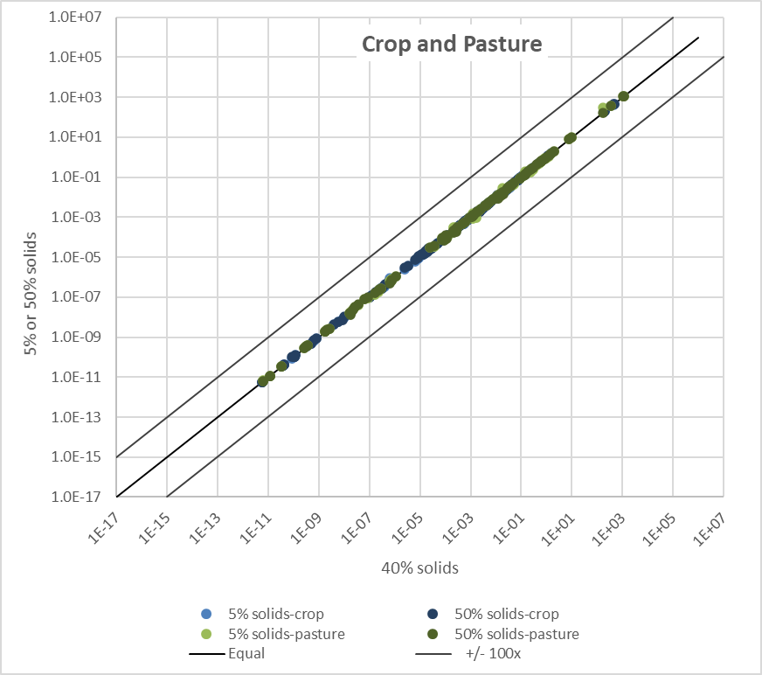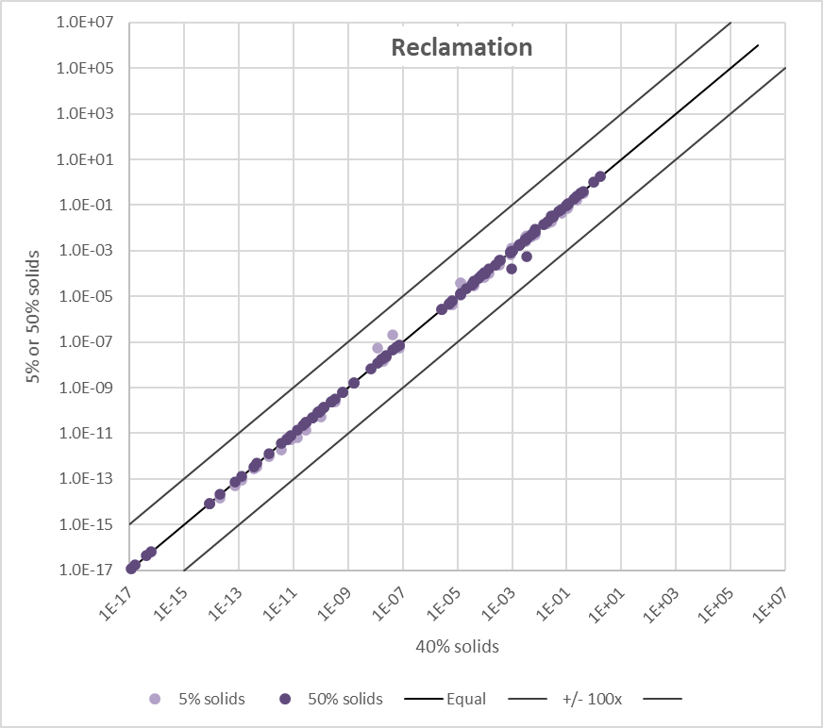
Figure E-1. Sensitivity to percent solids in land-applied biosolids.
Climate Setting: Results are not consistently higher for wet or dry, but which gives the highest results varies by chemical and pathway. For crop and pasture, the air pathway is the most sensitive to climate (see circled values in Figure E-2, left side). The impact of climate appears to be greater for reclamation (Figure E-2, right side). 4-Chloroaniline in groundwater gives considerably lower results for the dry climate than for average.
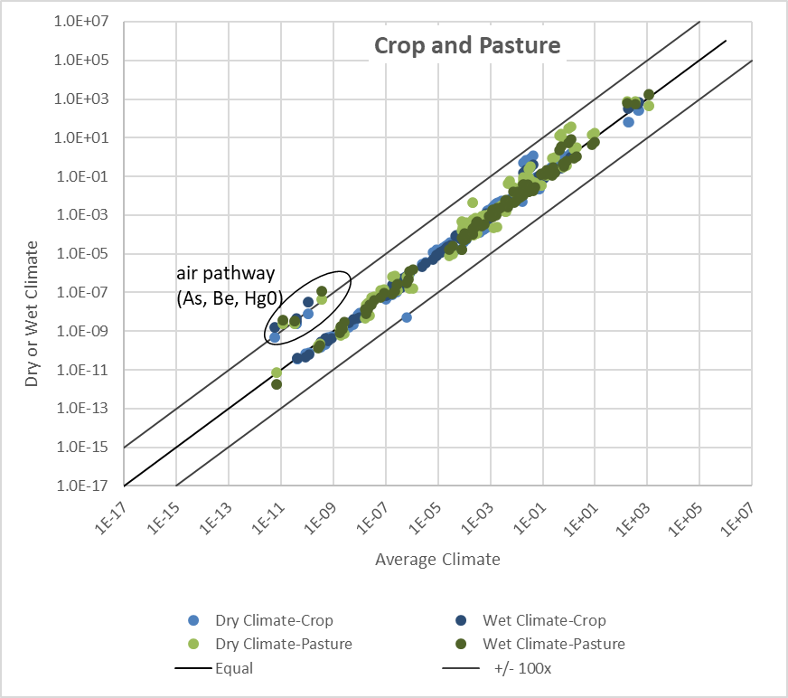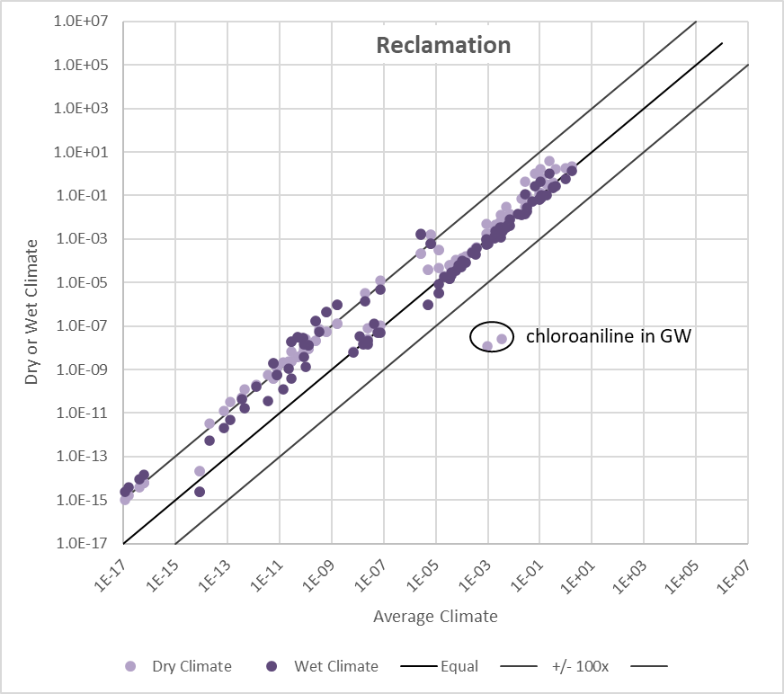
Figure E-2. Sensitivity to climate setting for LAU.
Field Size: Crop and pasture are not very sensitive to field size, and reclamation is almost entirely insensitive (Figure E-3). On the reclamation plot (right), the 30-acre data points are not visible because they are directly under the 180-acre points.
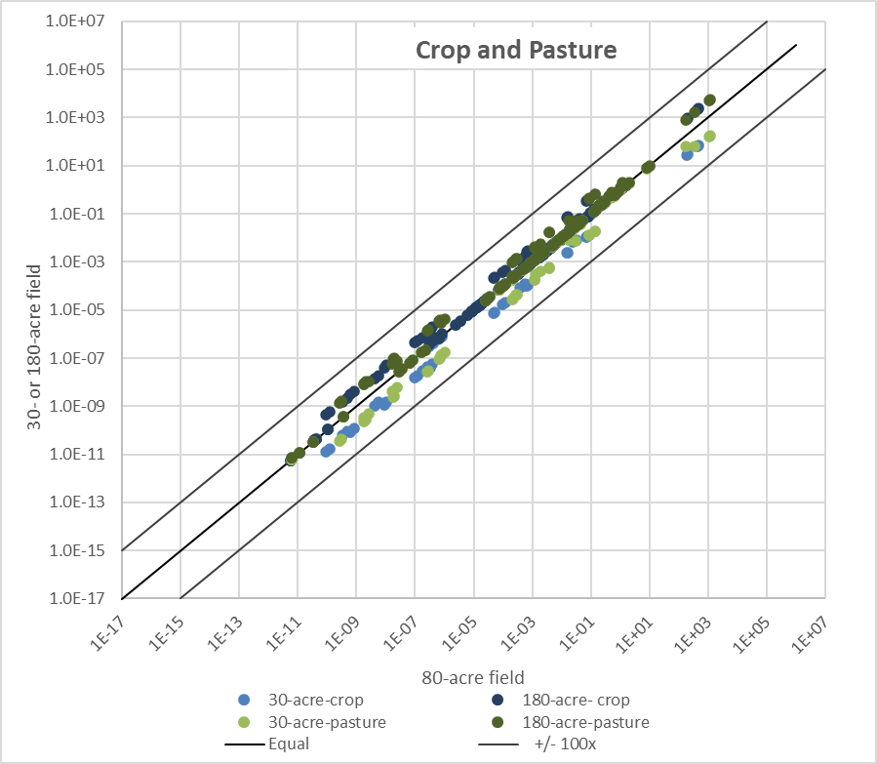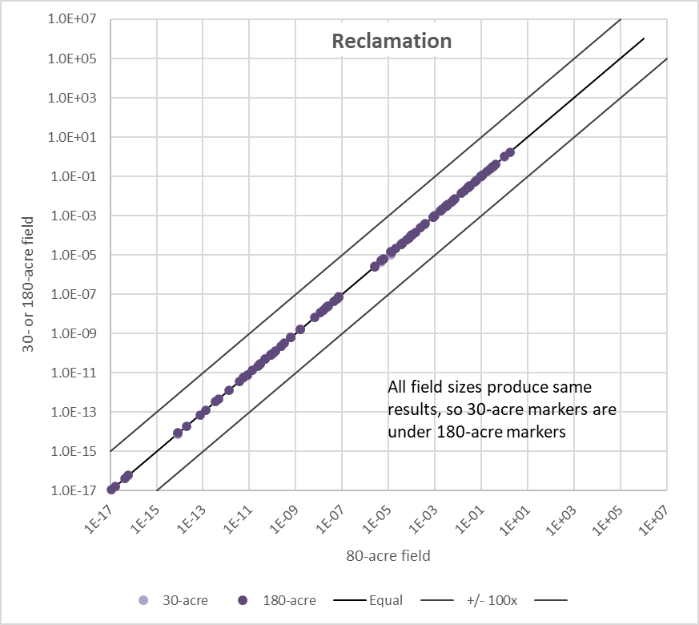
Figure E-3. Sensitivity to field size for LAU.
For crop and pasture, we also plotted results by pathway group (Figures E-4 and E-5). The air pathway is not shown as it is completely insensitive to this parameter. Groundwater pathways (Figure E-4, left) are very insensitive, as are soil and food chain pathways (Figure E-4, right). Surface water pathways (Figure E-5) vary more but remain within an order of magnitude.
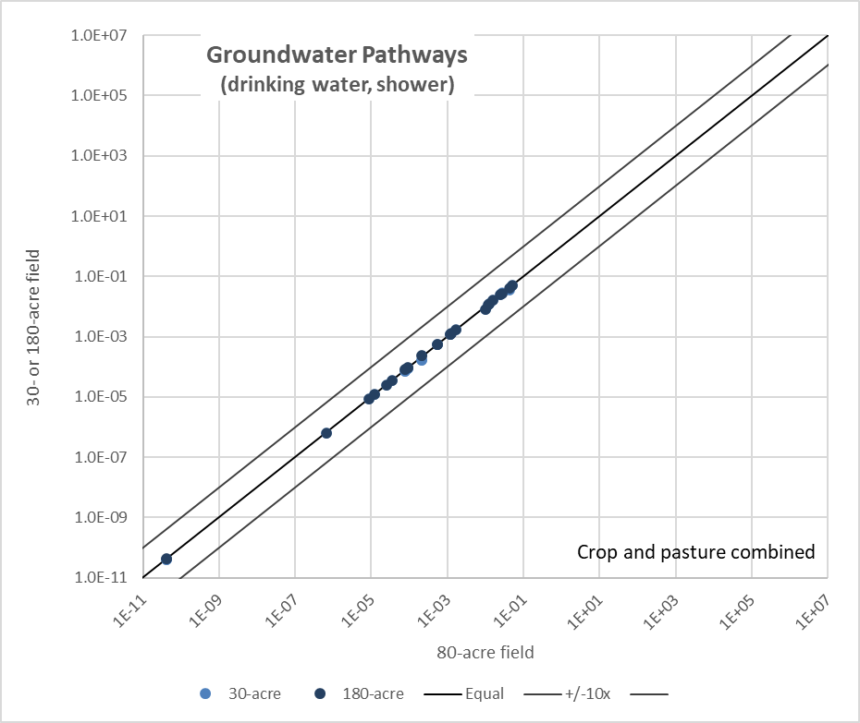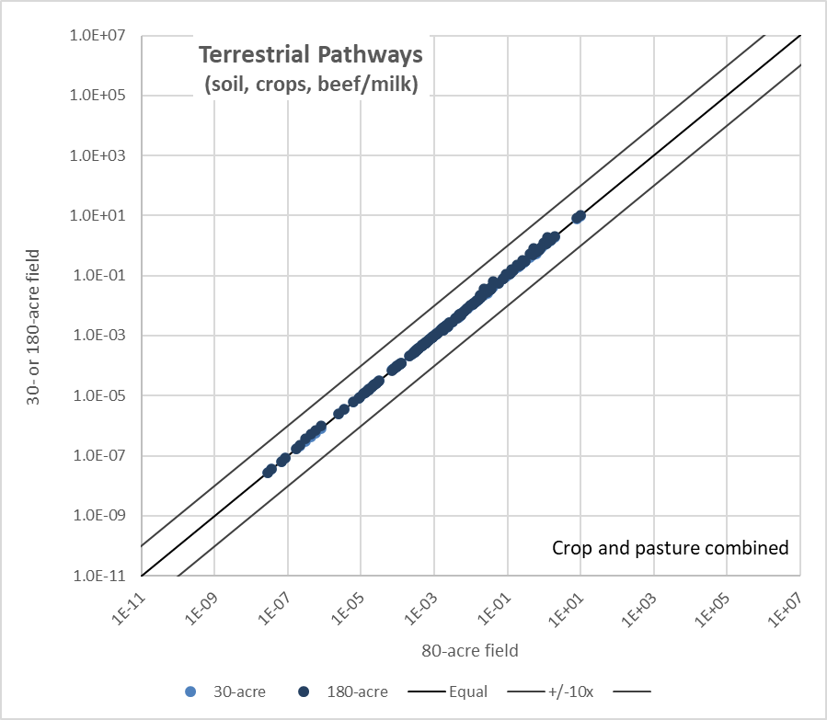
Figure E-4. Sensitivity to field size by pathway group: groundwater and terrestrial pathways.
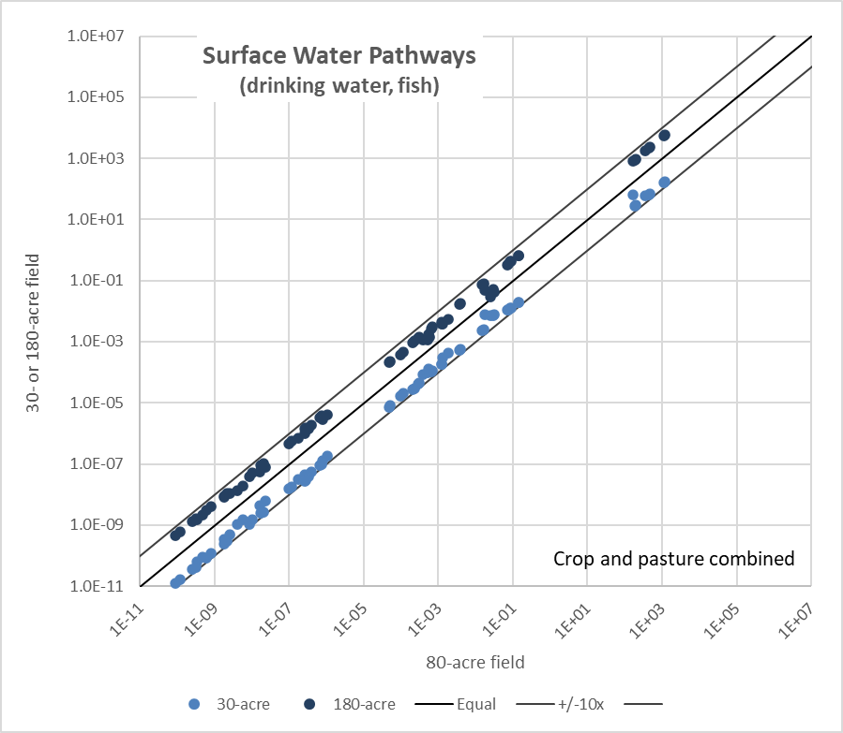
Figure E-5. Sensitivity to field size by pathway group: surface water pathways.
Application Rate: For crop and pasture, the lower the application rate, the lower the media concentration and vice versa; this is as expected (Figure E-6, left). For reclamation media concentration is generally insensitive to application rate (Figure E-6, right); note that for reclamation, the default is the lowest of the application rates tested (40 MT/ha, with alternatives of 70 and 100 MT/ha), whereas for crop and pasture, the default (10 MT/ha) is the middle value (alternatives of 2 and 40 MT/ha).
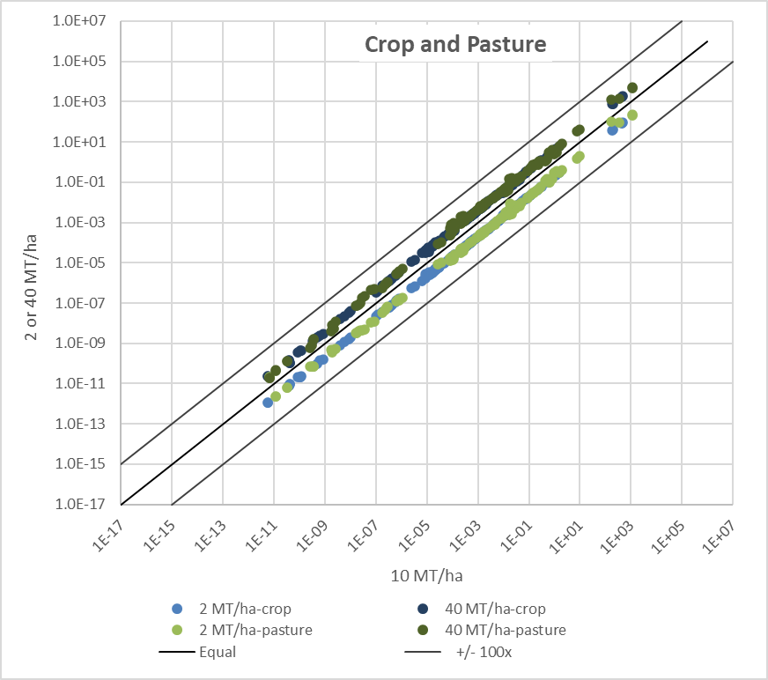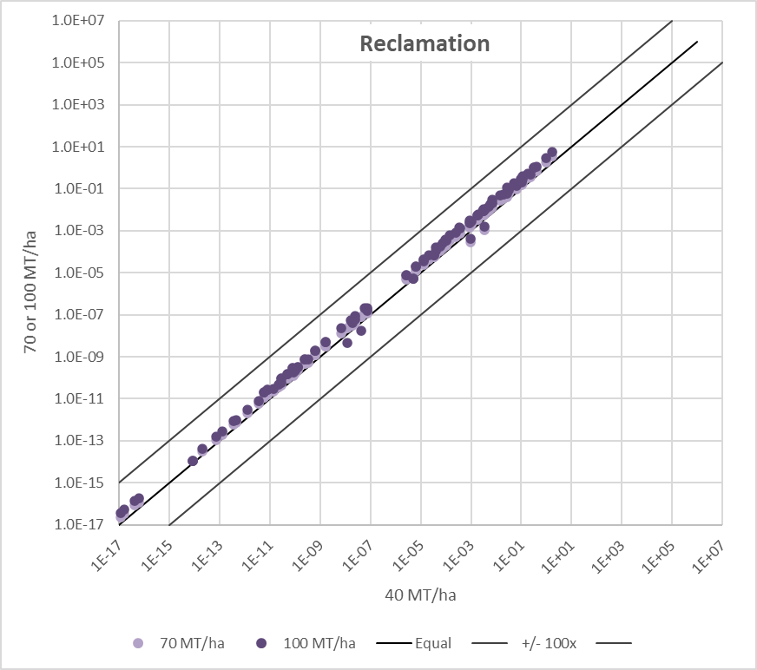
Figure E-6. Sensitivity to application rate for LAU.
Operating Life: The operating life analysis was conducted only for crop and pasture; because only a single application is modeled for reclamation, results are not likely to be sensitive. For both crop and pasture, the media concentrations are insensitive to changes between 20 and 40 yrs (Figure E-7), but an operating life of 1 year produces consistently lower concentrations.
                - 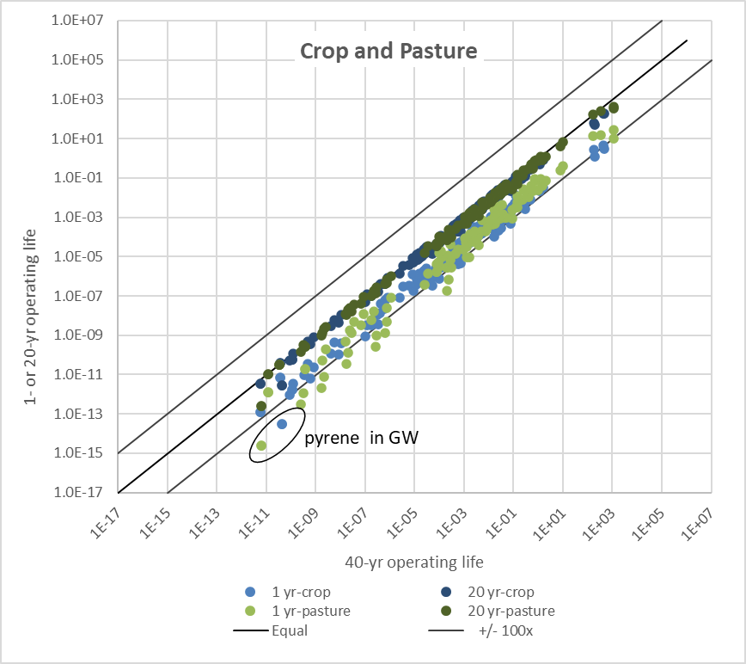
Figure E-7. Sensitivity to operating life for LAU.

E.2.2 Surface Disposal Results
As for LAU, media concentrations were plotted on scatter plots with the result associated with the default values on the x-axis and the results associated with the two other values on the y-axis as two different data series (so they can be distinguished from each other). A line indicating equal values is also plotted, along with lines that define differences of plus or minus two orders of magnitude. Major outliers are identified. Results for each liner type (no liner, clay liner, composite liner) are plotted separately for variables that affect all of them (climate, percent solids, operating life). For liner-specific variables, only results for the relevant liner type are shown. Lighter data points represent the lower of the two alternative values and darker the higher.
Liner Type and Characteristics: Only the two groundwater-related pathways (groundwater ingestion and shower inhalation) are affected by the liner type and characteristics; air pathway results are unaffected by liner types and properties and are not shown. The surface impoundment model employed uses specific liner properties to estimate the mass of leachate reaching groundwater, but these liner parameters have little impact on leachate concentration. The groundwater model is a simple dilution-attenuation factor (DAF) approach applied to the leachate concentration. Thus, we expect the impact of liner type to be essentially linear on the respective DAFs. The DAFs for no liner, clay liner, and composite liner are, respectively, 1, 2, and 1E+7, and as expected, groundwater concentrations for the clay liner are about half the results for no liner, and groundwater concentrations for composite liner are about 7 orders of magnitude lower. Figure E-8 illustrates this, with the light blue dots representing clay liner results plotted against no liner all falling on a line representing values half the no liner values. Similarly, the dark blue composite liner dots fall on a line representing values 7 orders of magnitude lower than the no liner values.
                - 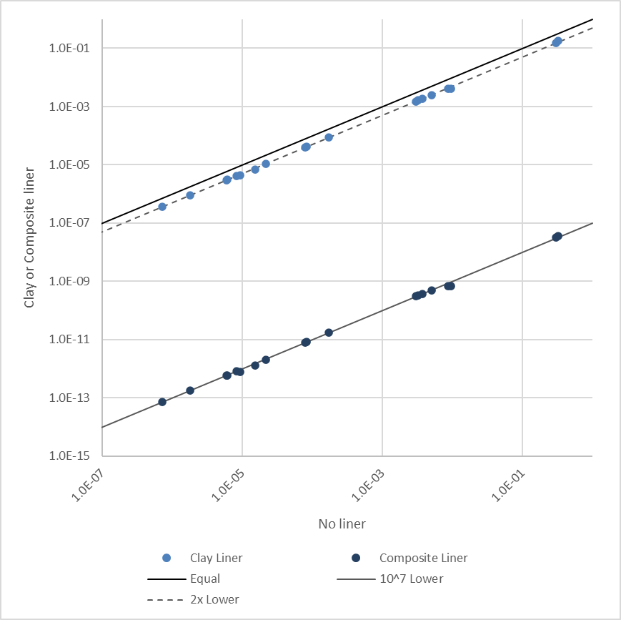
Figure E-8. Sensitivity to liner type.
Percent Solids: The BST is sensitive to percent solids in surface disposal (Figure E-9), with lower percent solids producing lower media concentrations for both groundwater and air pathways. The effect is sub-linear, with a ten-fold reduction in percent solids yielding a decrease of about a factor of 7 in media concentrations. In the other direction, doubling percent solids (i.e., a 100% increase) yields an increase of about 70% in media concentrations.
                - 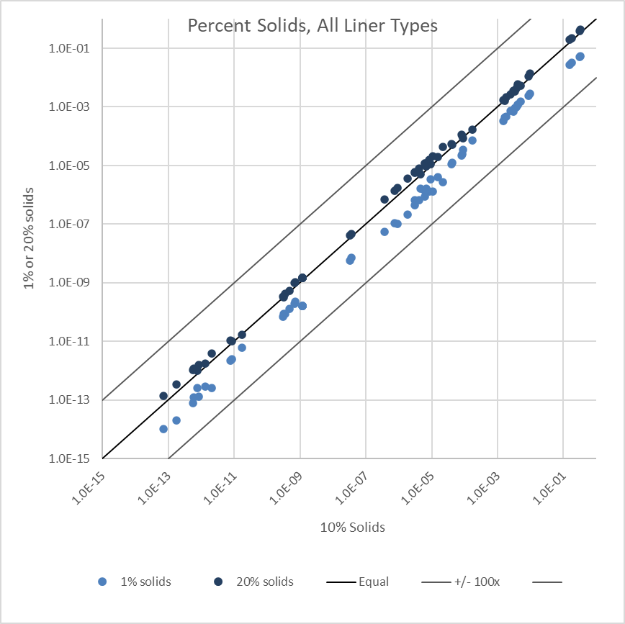
Figure E-9. Sensitivity to percent solids in surface disposal units.
Climate Setting: Results differ for organics vs. inorganics. For organics (Figure E-10, left side), media concentrations are typically lower for wet climate and similar for dry and average climate. The most impacted organics are 4-chloroaniline and sulfathiazole, which also have significantly lower Koc values (both <100 L/kg) than the other organics run for the sensitivity analyses (all >10,000 L/kg). For inorganics (Figure E-10, right side), media concentrations are insensitive to climate.
                - 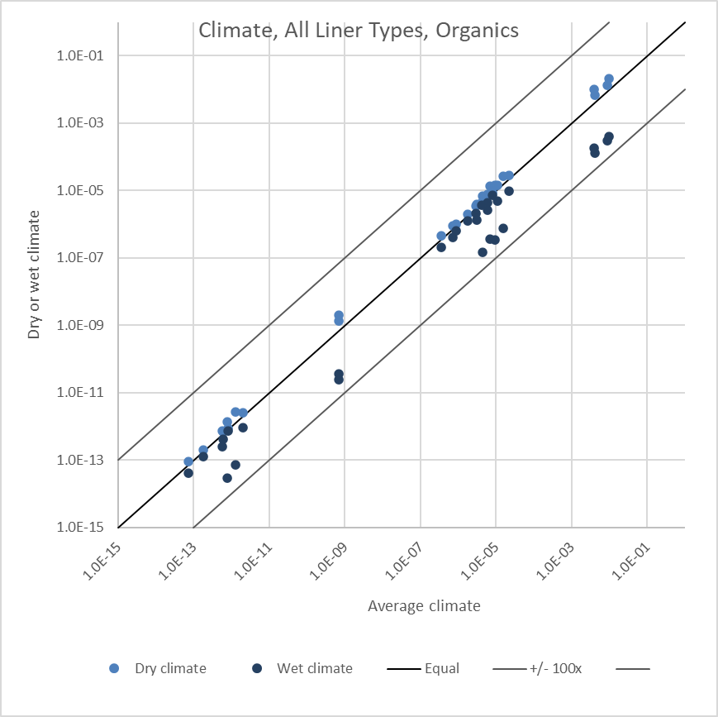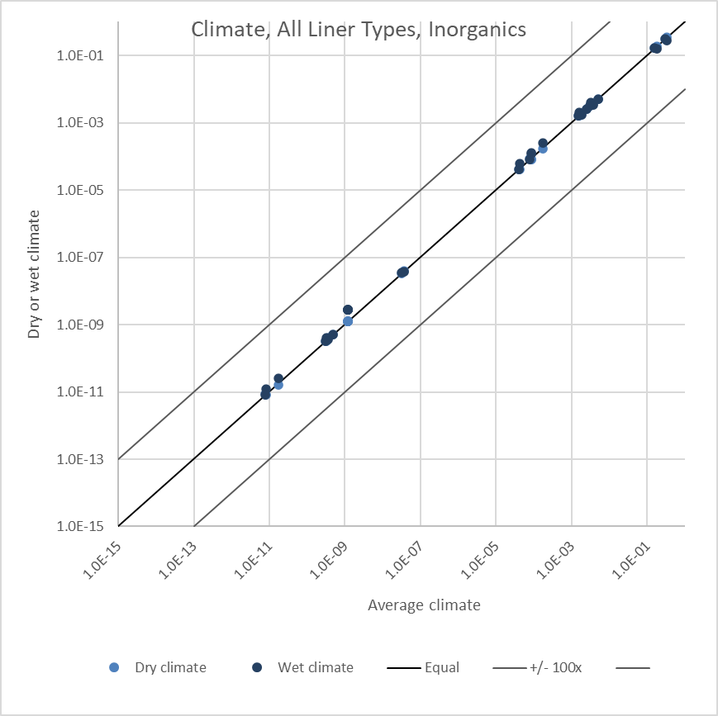
Figure E-10. Sensitivity to climate setting for surface disposal.
Operating Life: The media concentrations are insensitive to changes between 50 and 25 yrs operating life (Figure E-11), but an operating life of 1 year produces consistently lower concentrations. This effect is less pronounced for organics (left side of Figure E-11) than for inorganics (right side).
                - 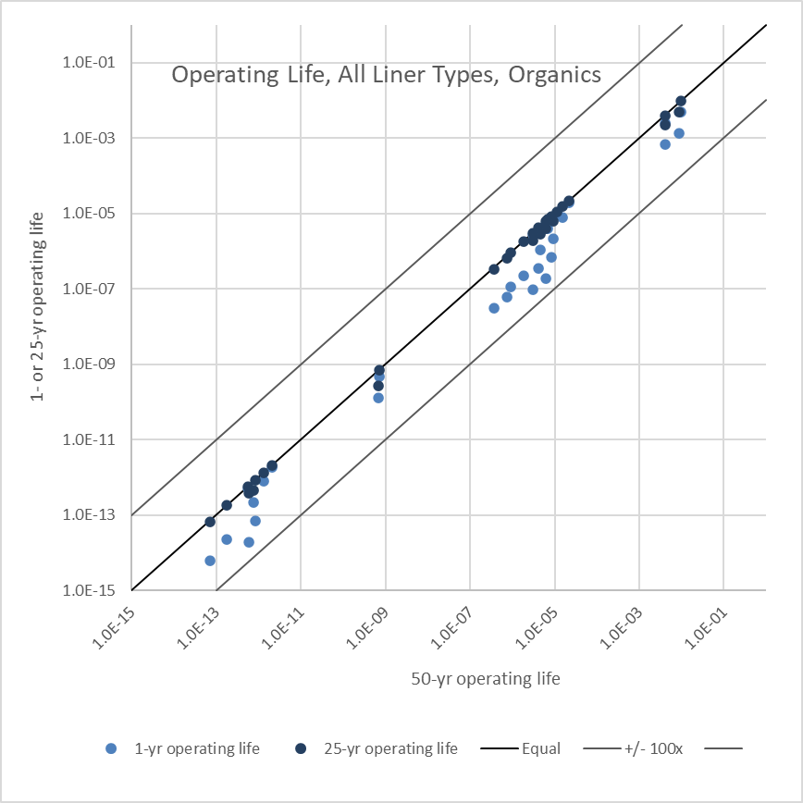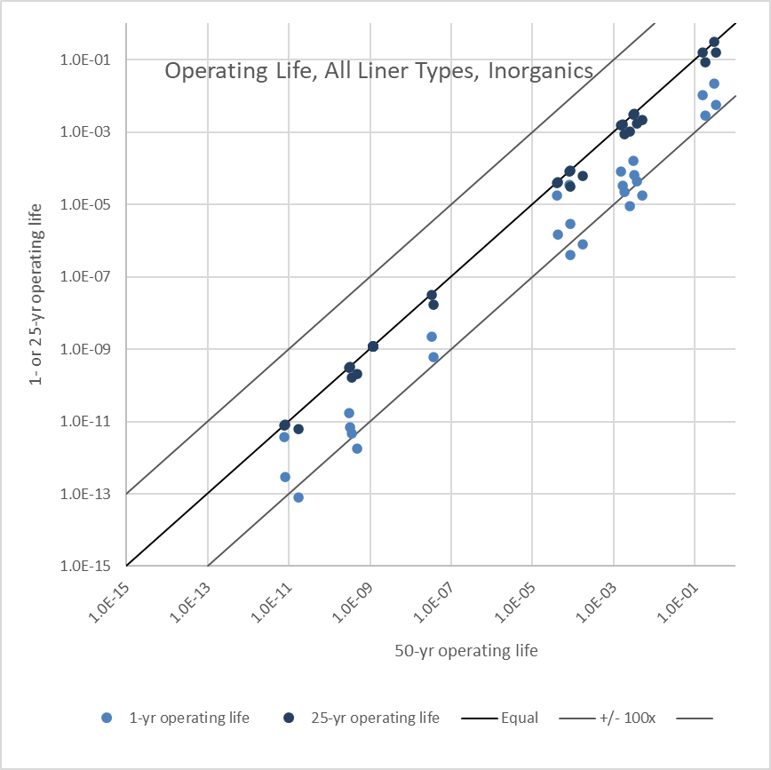
Figure E-11. Sensitivity to operating life for surface disposal.

E.3 Sensitivity to Key Chemical-specific Parameters
The most important chemical-specific drivers of risk in the BST are concentration in biosolids, BCFs, and toxicity values. The BST risk or hazard results are either directly or inversely proportional to these inputs: if you double the concentration, relevant BCF, or cancer slope factor, the estimated risk or HQ will also double (directly proportional); if you halve the Reference Dose, the hazard will double (inversely proportional). BCFs have a double impact on the beef and milk pathways, because these depend on two BCFs: one that estimates uptake from soil or air into feed plants, and one that estimates uptake from feed into beef or milk.
Other chemical-specific properties can influence the fate and transport of pollutants as well, although not to the same extent as those mentioned above. To evaluate the impact of those other chemical-specific parameters on risk, EPA conducted a sensitivity analysis. We started with the chemical properties of 4-chloroaniline and barium, which represent an organic and a metal constituent with non-extreme properties. This ensured that the set of properties was internally consistent as we varied individual properties. We added typical values for some of the degradation rates for 4-chloroaniline, which did not have data for all of them. These two constituents were then run as the “control” runs for organics and metals, respectively. The individual properties applicable to each type of constituent were then varied in turn using the control value divided by 10 as the “Low” value and the control value times 10 for the “High” value. This range of variation accounts for a significant portion of the overall variation of these parameters, which have ranges from smallest to largest value among the TNSSS constituents of 2 to 4 orders of magnitude. Well characterized parameters not expected to vary, such as molecular weight, were omitted.
Results that responded to a one order of magnitude change in the parameter of interest with a change of less than 10% to the media concentration were considered insensitive to the parameter. The rest were categorized as low, moderate, or high sensitivity if the results changed by, respectively, 10% to 100% (factor of 2), a factor of 2 to 5, or a factor of 5 to 10 (a value of 10 would indicate that the model is linear on that parameter). We used media concentrations for simplicity: given a media concentration, risk and hazard do not depend at all on chemical-specific properties other than toxicity.
Different pathways use and are sensitive to different chemical properties, so the results are reported by pathway group:
- Air: direct inhalation of air (either vapors or particles)
- Shower: inhalation of constituents that volatilize from groundwater during showering (not applicable to inorganics)
- GW: ingestion of groundwater
- SW/fish: ingestion of surface water and recreationally caught fish (not modeled for surface disposal)
- Soil: ingestion of soil (not modeled for surface disposal)
- Foodchain (crop): ingestion of protected and exposed fruits and vegetables, and root vegetables (not modeled for surface disposal)
- Foodchain (pasture): ingestion of beef and milk (not modeled for surface disposal).
Table E-5 summarizes the sensitivity of the BST to the various chemical-specific properties that may vary or be estimated for organics. The BST is at least moderately sensitive to Koc/Kd (for organics, Koc is input and Kd is calculated from Koc and fraction organic carbon) for most pathway groups. Kd determines how constituents partition between solids and water, thus, it has a significant impact on media concentrations for both LAU and surface disposal. The BST is also highly sensitive to Henry’s law constant for air and shower pathways for both LAU and surface disposal. Henry’s law constant determines how constituents partition between water and air; therefore, is has a significant impact on air concentrations. The BST is not particularly sensitive to diffusivity in air and water, with the exception of the air pathway. It is entirely insensitive to boiling point with the exception of the air pathway for surface disposal.
The LAU is moderately to highly sensitive to the degradation rate in soil (ksoil) for organics; the remaining degradation rates are used only in the surface water pathways, and although the BST is highly sensitive to hydrolysis rate in the surface water pathways, it is insensitive to aerobic and anaerobic degradation in the water column and sediment. Conversely, the surface disposal unit is at least slightly to moderately sensitive to the water-related degradation rates (the soil degradation rate is not used).
Table E-5. Sensitivity of the 2023 BST to Physical/Chemical Properties: Organics
Pathway | Chemical Properties |  |  |  |  | Degradation Rates
 | Diffusivity Air | Diffusivity Water | Henry’s Law | Koc/Kd | Boiling point | Soil | Water (aerobic) | Water (hydrolysis) | Sediment (anaerobic)
LAU
Air | high | moderate | high | low | insens. | mod | NA | NA | NA
Shower | insens. | insens. | high | moderate | insens. | high | NA | NA | NA
Groundwater | insens. | insens. | insens. | moderate | insens. | high | NA | NA | NA
Surface Water/Fish | low | low | low | moderate | insens. | mod | insens. | high | insens.
Soil (Crop) | low | low | low | low | insens. | mod | NA | NA | NA
Soil (Pasture) | low | low | low | moderate | insens. | mod | NA | NA | NA
Foodchain (Crop) | insens. | insens. | insens. | low* | insens. | high | NA | NA | NA
Foodchain (Pasture) | insens. | insens. | insens. | moderate | insens. | mod | NA | NA | NA
Surface Disposal
Air | moderate | low | high | moderate | high | NA | moderate | insens. | low
Shower | insens. | low | high | high | insens. | NA | low | insens. | low
Groundwater | low | low | low | moderate | insens. | NA | moderate | low | moderate
* except for root vegetables, which are highly sensitive to Koc/Kd NA Not applicable (property not used in pathway)
Insens. 10x change in input has <10% effect on result Moderate 10x change in input has 2x–5x effect on result
Low 10x change in input has 10%–100% (2x) effect on result High 10x change in input has >5x effect on result
Table E-6 summarizes the sensitivity of the BST to diffusivity in water and Kd, the only chemical-specific properties that are applicable to inorganics and may vary or be estimated. The BST is largely insensitive to diffusivity in water, regardless of source type or pathway group. However, it is highly sensitive to Kd (which is a direct input for inorganics) for both source types and most pathway groups. The impact is only moderate for crop scenario soil and foodchain pathways, where the biosolids are tilled to a greater depth than in the pasture scenario.
For the more sensitive properties—concentration, BCFs, Koc or Kd, and HLC (if inhalation pathways are of interest)—EPA encourages you to use the Edit Chemical Properties feature to update parameter values with reported data in the peer-reviewed literature if it becomes available to reduce uncertainties in the exposure and risk estimates. For other, insensitive properties, it is still important to enter a value when adding chemicals, as a zero value may be nonsensical or otherwise produce unexpected results.
Table E-6. Sensitivity of the 2023 BST to Physical/Chemical Properties: Inorganics
Pathway | Diffusivity Water | Kd
LAU
Air | insensitive | high
Groundwater | insensitive | high
Surface Water/Fish | insensitive | high
Soil (Crop) | low | moderate
Soil (Pasture) | insensitive | high
Foodchain (Crop) | insensitive | moderate
Foodchain (Pasture) | insensitive | high
Surface Disposal*
Groundwater | insensitive | high
* Air and shower pathways were not modeled for inorganics in surface disposal units, as these constituents do not volatilize.
Insens. 10x change in input has <10% effect on result
Low 10x change in input has 10%–100% (2x) effect on result
Moderate 10x change in input has 2x–5x effect on result
High 10x change in input has >5x effect on result

E.4 References
Brobst, R. 2018. Email from Robert Brobst, Colorado State University, to Donna Womack, RTI International. February 26, 2018. Five attachments: 2008 CO N Data.xlsx, Biosolids Crop.xlsx, MacDonald 2013 ERS farm size rpt.pdf, PANworksheet.xls, and USDA 2015 Crop Production.pdf.
CDPHE (Colorado Department of Public Health & Environment). 2018. Biosolids plant available nitrogen (PAN) and agronomic rate calculation tool. Excel spreadsheet. Available at https://www.colorado.gov/pacific/cdphe/wq-biosolids-permits.
IPNI, 2014. International Plant Nutrition Institute Estimates of Nutrient Uptake and Removal. http://www.ipni.net/article/IPNI-3296. Accessed April 9, 2018.
MacDonald, J.M., P. Korb, R.A. Hoppe. 2103. Farm Size and the Organization of U.S. Crop Farming. U.S. Department of Agriculture. Economic Research Service, Economic Research Report Number 152. August.
MSU (Michigan State University). 2009. Nutrient Recommendations for Field Crops in Michigan. Michigan State University Extension Bulletin E2904. August.
OH EPA (Ohio Environmental Protection Agency). 2018. Biosolids Compliance Tools: Agronomic Rate Calculation Spreadsheet. https://epa.ohio.gov/dsw/sludge/biosolid (Compliance Tools tab)
PA DEP (Pennsylvania Department of Environmental Protection). 2016. Biosolids Supplemental Worksheets. https://www.dep.pa.gov/Business/Water/CleanWater/WastewaterMgmt/Biosolids/‌Pages/Permits.aspx
U.S. EPA (U.S. Environmental Protection Agency). 2000. Biosolids Technology Fact Sheet: Land Application of Biosolids. EPA 832-F-00-064. Office of Water, Washington, DC. September.
U.S. EPA (Environmental Protection Agency). 2003. EPA’s Composite Model for Leachate Migration with Transformation Products (EPACMTP): Parameters/Data Background Document. Office of Solid Waste, Washington, DC. April.
USDA (U.S. Department of Agriculture). 2014. 2012 Census of Agriculture. United States Summary and State Data. Volume 1-Geographic Area Series-Part 51. May.
USDA (U.S. Department of Agriculture). 2016. Crop Production 2015 Summary. U.S. Department of Agriculture. National Agriculture Statistics Service. January.
USDA (U.S. Department of Agriculture). 2018. Plants Database: Nutrient Content of Crops Tool. Natural Resources Conservation Service. https://plantsorig.sc.egov.usda.gov/npk/main. Accessed April 9, 2018.
VT DEC (Vermont Department of Environmental Conservation). 2017. Application Rate Calculator. December. https://dec.vermont.gov/waste-management/residuals-management/guidance-documents
WSU (Washington State University). 2007. Worksheet for Calculating Biosolids Application Rates in Agriculture. PNW0511e. March. https://catalog.extension.oregonstate.edu/pnw511.

The field size is based on the 75th percentile from the 2012 Census of Agriculture (USDA, 2014).
The index reservoir is based on the standard waterbody parameters for Variable Volume Water Model (VVWM), the waterbody model used to estimate concentrations in surface water (U.S. EPA, 2019; 2020); see Section A.2.3.2.
The Part 503 regulations state that “bulk sewage sludge shall not be applied to agricultural land, forest, or a reclamation site that is 10 meters or less from waters of the United States.” The buffer for the index reservoir has been set to 10 m in accordance with this standard.
The farm pond would not in most cases be considered a “water of the United States” under the Clean Water Act (see 40 CFR 230.3 (t) (5) (ii), which specifically states that “Artificial lakes or ponds created by excavating and/or diking dry land and used exclusively for such purposes as stock watering, irrigation, settling basins, or rice growing” are not “waters of the United States.”). Therefore, no buffer is modeled for the farm pond.
For bioaccumulation: Focus on the use of bioaccumulation factors (BAFs), instead of bioconcentration factors (BCFs) for estimating potential human exposure to contaminants via the consumption of contaminated fish and shellfish. Use high quality field data over laboratory or model-derived estimates for deriving BAFs, since field data best reflect factors which can affect the extent of bioaccumulation (e.g., chemical metabolism, food web structure).
Note that very few fish fall into trophic level 2, which would indicate they eat only plants; most fish are omnivores, making them at least trophic level 3. Therefore, T2 fish are not included for simplicity.
The 2011 EFH incorporates data for children from the 2008 Child-Specific Exposure Factors Handbook (U.S. EPA, 2008). Some chapters have been updated and reissued separately; those were used, see Appendix B for details.
When applied for mercury, the emission rate, Q, must be multiplied by a fraction appropriate to the species: 0.0002 for elemental mercury and 0.48 for divalent mercury (mercuric chloride). Similarly, the fraction of the emission rate that is in the vapor phase, Fv, is fixed at 1 for elemental mercury and 0.85 for divalent mercury (mercuric chloride).These values follow the guidance in HHRAP (U.S. EPA, 2005).
Mercury, which is one of the TNSSS analytes, is a special case and is not discussed here. It uses a combination of the parameters for organics and those for inorganics. Generally, chemical data for mercury was sourced from the Mercury Study Report to Congress (MRTC; U.S. EPA, 1997a) if possible and otherwise from similar sources as described here. Mercury is not one of the preloaded chemicals.
The HHRAP conversion factor of 2×10⁹ g/hectare soil was derived using the U.S. EPA (1992) assumed soil bulk density of 1.33 g/cm³, an incorporation depth of 15 cm, and a conversion factor of 10⁸ cm²/hectare (1.33×15×10⁸=2×10⁹).
The biomagnification factor (BMF), defined as the ratio of the concentration of the chemical found in an organism to the concentration of the chemical found in the organism’s diet, has become the preferred measure of bioaccumulation from diet in terrestrial organisms; however, it is a measure of accumulation from diet alone and does not include any other environmental source of the chemical such as air or soil. The BST continues to use the BAF, which does include other environmental sources, as this is both more suited to screening risk assessments and more often found in accepted and available databases.
For more information about these toxicity values, see https://www.epa.gov/iris/basic-information-about-integrated-risk-information-system.
Mineau et al. present the scaling equation as MATL_{t} x (bw_{w}/bw_{t})^{(b-1);}; this is mathematically equivalent to the form shown here from U.S. EPA (2005).
Elemental mercury for air and shower pathways; methyl mercury for fish pathway; mercuric chloride for all other pathways.

